Day 1
HTML, CSS & SASS/SCSS
HTML: Hyper Text Markup Language - Display the content
CSS - Cascading Style Sheet - Style
HTML file
Lists & headings
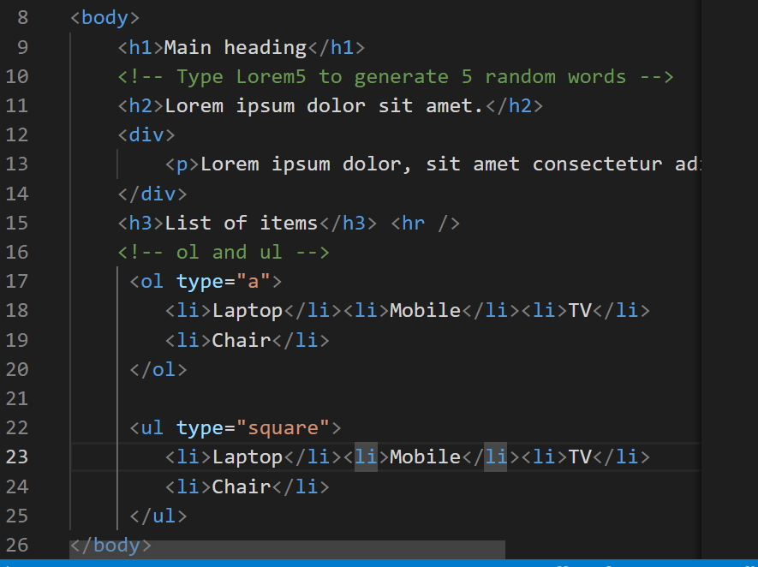
Output:
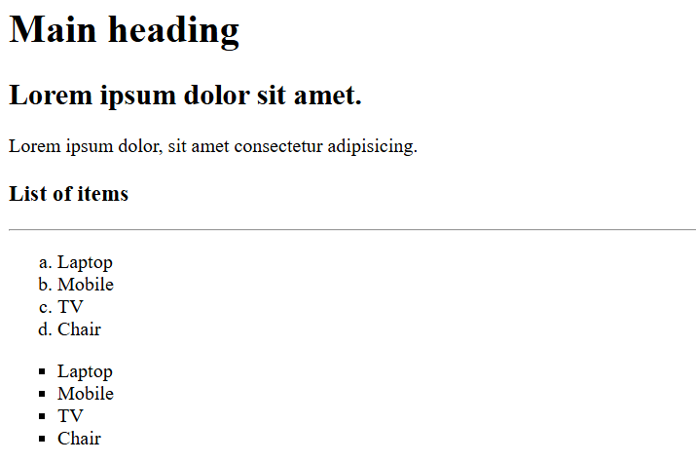
You can create HTML tables, forms and other elements
CSS:
It is used mainly to add the styles to HTML elements
RWD
It helps to fit your web page to all types of devices it could be desktop, mobiles, printing devices, tablets
Same HTML content to render differently in different devices
Medi Query: it applies the styles based on the conditions.
Grid: It arranges the elements in row & column format
Flex: It automatically arranges the elements based on the size like horizontally or vertically.
{display: flex }
SASS
Syntactically Awesome Style sheets
It avoids lot of boiler plate code which you write in CSS
SASS -> SCSS (this resembles css syntax), but sass follows indentation syntax
SASS syntax
$font-style: arial;
$color: blue
h1
color: $color;
font-family: $font-style
SCSS syntax:
$color: blue;
$font-style: arial;
h1 {
color: $color;
font-family: $font-style;
}
Install sass
npm install -g sass
To compile scss to css
sass input.scss output.css
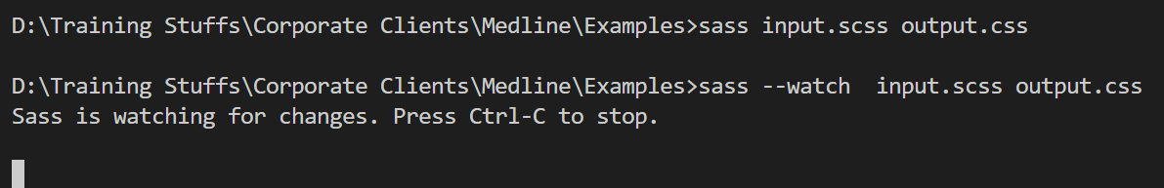
--watch lets you to automatically compile scss to css
Mixins
These allow you to reuse the group of CSS declarations.
@mixin shape($color, $width, $height) {
width: $width;
height: $height;
background-color: $color;
}
.square {
@include shape(blue, 400px, 400px);
}
.rectangle {
@include shape(red, 400px, 200px);
}
Parent selector
It is used in nested selector to refer the outer selector
.alert {
&:hover { color: red }
}
In CSS you write
alert : hover { color: red; }
Placeholder
It is to reuse some selectors using inheritance
%name {
// css selectors
}
.primary {
@extend %name;
color: blue;
}
.secondary {
@extend %name;
color: grey;
}

How to compile multiple SASS files
sass --watch file1.scss : file1.css file2.scss : file2.css
day2/mystyle.scss
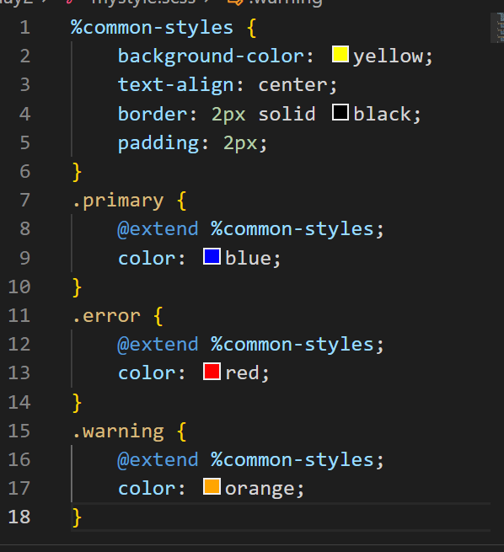
index.html
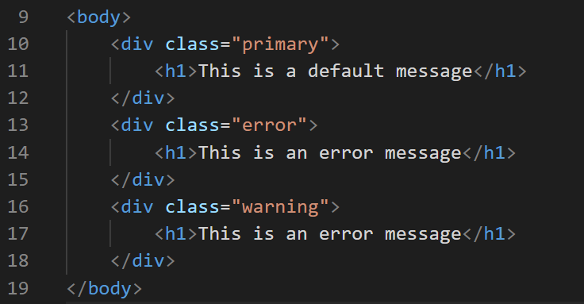
Output:
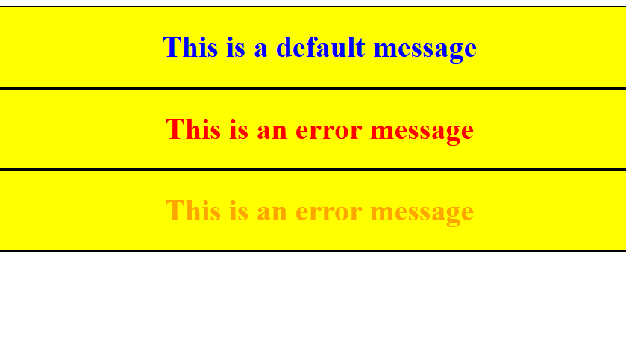
Special functions:
SCSS provides various functions to perform complex operations
$colors: red, green, blue;
.error { color : nth($colors, 1) }
.warning { color: nth($colors, 2) }
Mixing colors using mix()
.mixed-color { color: mix(red, green, 60%) }
Here 60% red & 40% green
Note: You can only mix two colors, however you can get the reference of two colors and pass the color again to the mix
mix(mix(red, green, 60%), blue, 50%)
Round up the numbers
font-size: round(19.6px); // font-size: 20px
scss
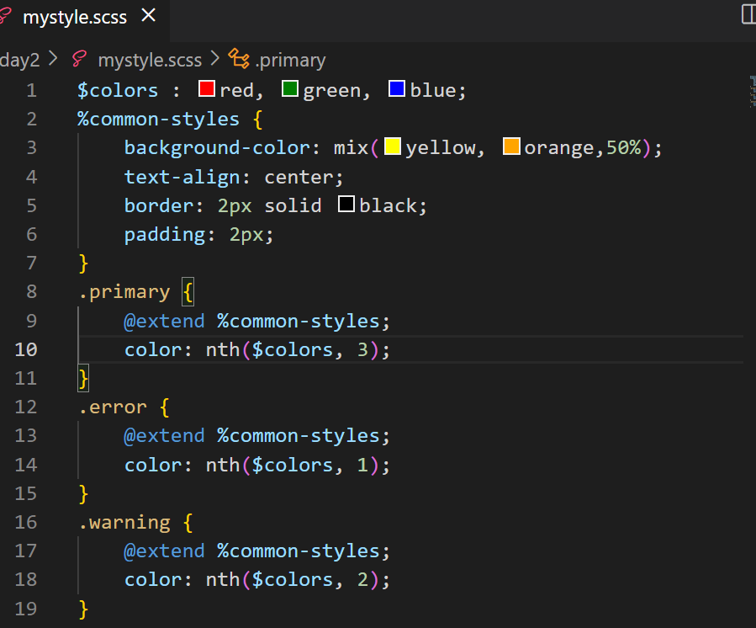
Output:
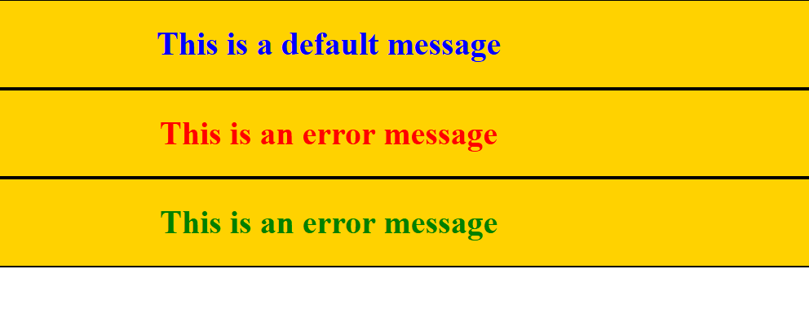
SASS official document
@if & @else if : these are used to apply the CSS on a conditional based
!default: to provide a default values when the property doesn’t have a value
https://sass-lang.com/guide/

Javascript
HTML - displaying the content
CSS - styling the HTML
Javascript - It adds effects the web page by dynamically accessing HTML & CSS, it has various features like
- variables
- operators
- datatypes
- functions
- objects
- arrays
- conditional statement
- loops
- form validations
There are two ways you can execute Javascript
- Using browser at the front-end
- Using Node.js at the backend
Strings in Javascript: You can either use single or double quotes
Note: single quote is not treated as character it is treated as string itself
Note: semicolon is optional in Javascript as long as you keep the statements in the new line
JS hello world program
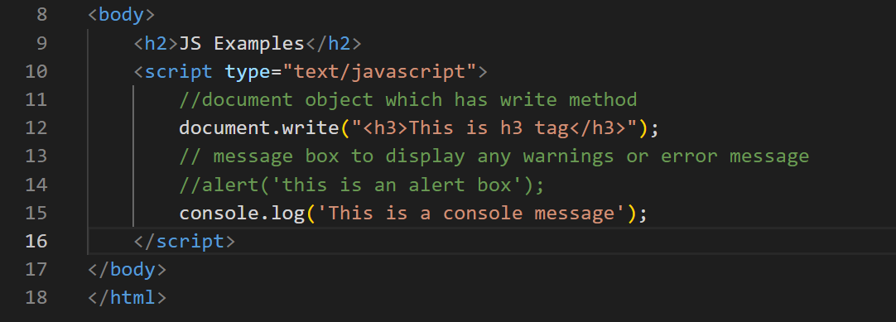
Output:
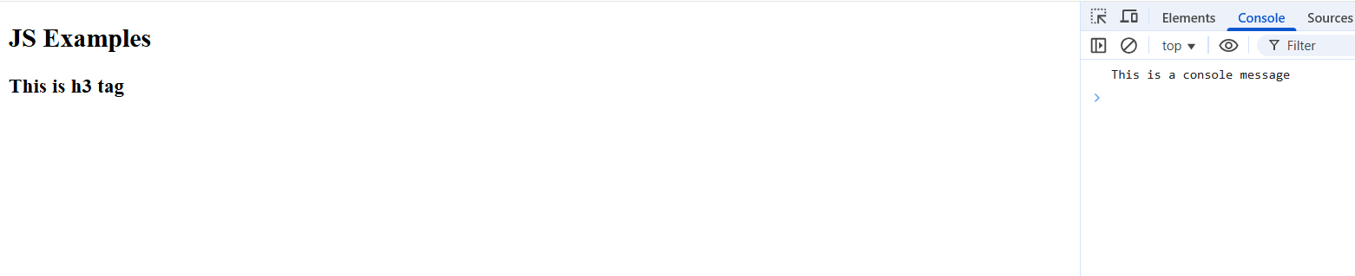
Fundamentals of Javascript
- Variables
- Datatypes
- Operators
- Conditional Statements
- Loops
Variables: It is to store the data in Javascript
old approach is to use var keyword
var employeeId = 1234;
var employeeName = “Siddharth”;
I can assign different values to the same variable with different types
employeeId = “12345” or employeeId = true
Datatypes in Javascript
In Javascript variables get the types based on the type of value, you can use an inbuilt function in javascript typeof(variableName) to get the datatype
document.write(typeof(employeeId); // number or string or boolean
jsdemo.html
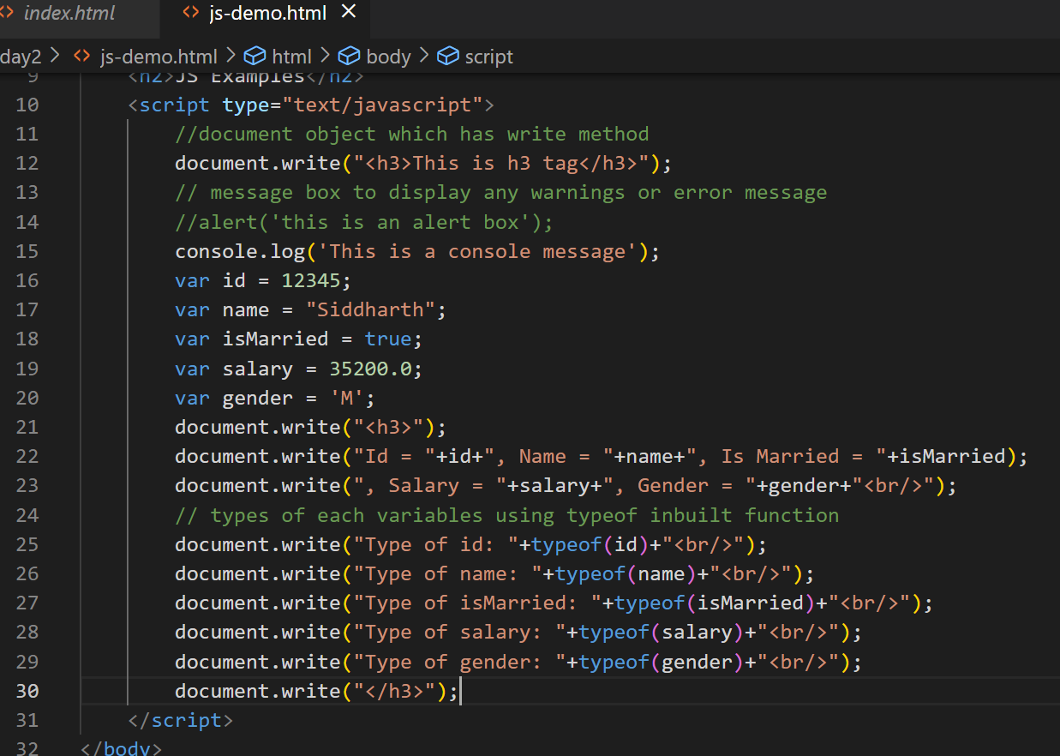
Output:
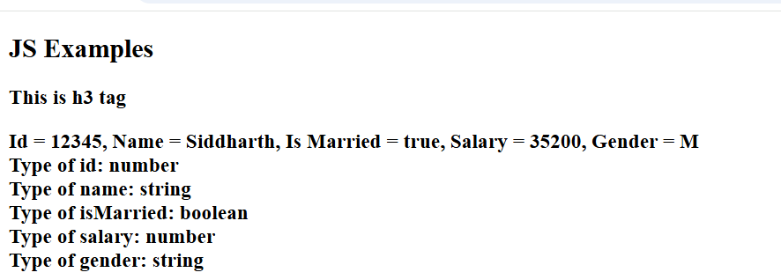
Javascript operators
Arithmetic operators: +, -, *, /, %
Assignment operator: =
Comparison operators: <, >, <=, >=, !=, ==, ===
Increment & Decrement operators: ++, --
Logical operators: &&, ||
Operators Demo
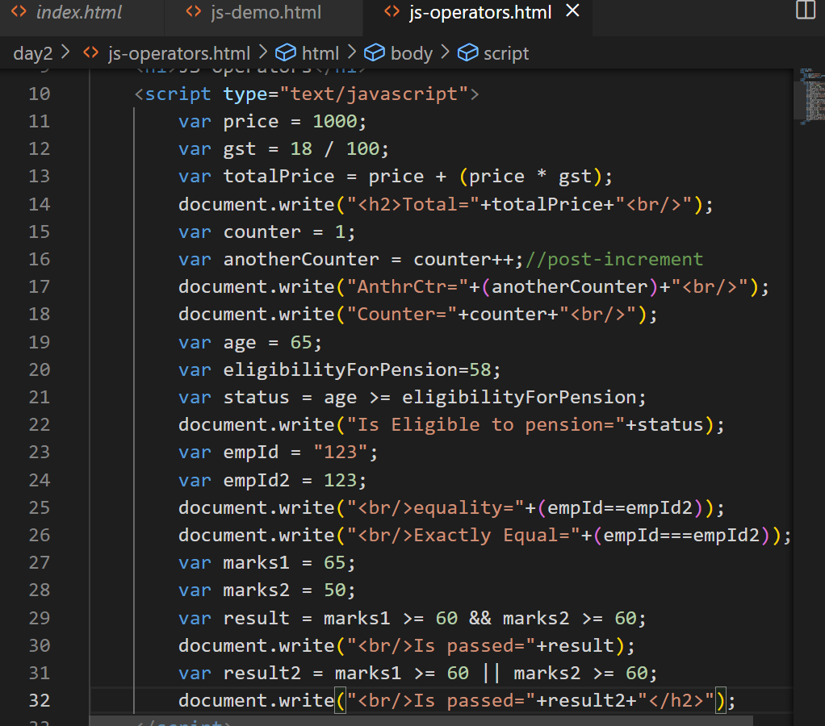
Output:
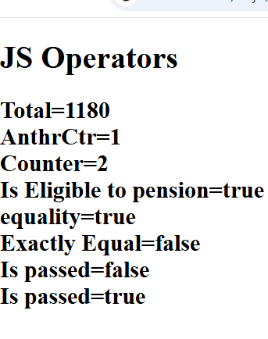
Conditional statements:
Statements that you want to execute only if its true or false
In Javascript we have following conditional statements
- if
- if else
- if else if else if … else
- switch
Conditional Statements demo
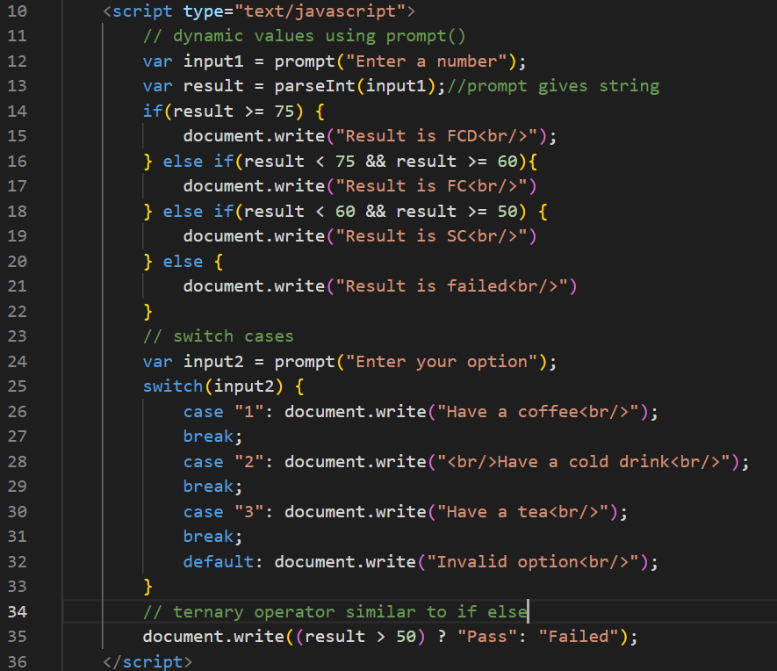
Output:
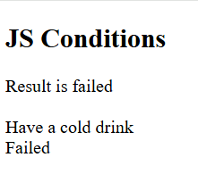

Day 3 agenda
Loops
- While Loop
- For Loop
- For...In Loop
- Loop Control
JavaScript Functions & Objects
- JavaScript Functions
- The Object Constructor
- Defining Methods for an Object
- JavaScript Boolean
- JavaScript String
- JavaScript Arrays
- JavaScript Arrays Method
- JavaScript Arrays Sort

Loops: Same statements to execute until certain condition is true, there 3 types of loops
- for loop
- while
- do-while
for loop: When you want to iterate fixed set of iterations then you can use for loops, it is used while reading array elements also.
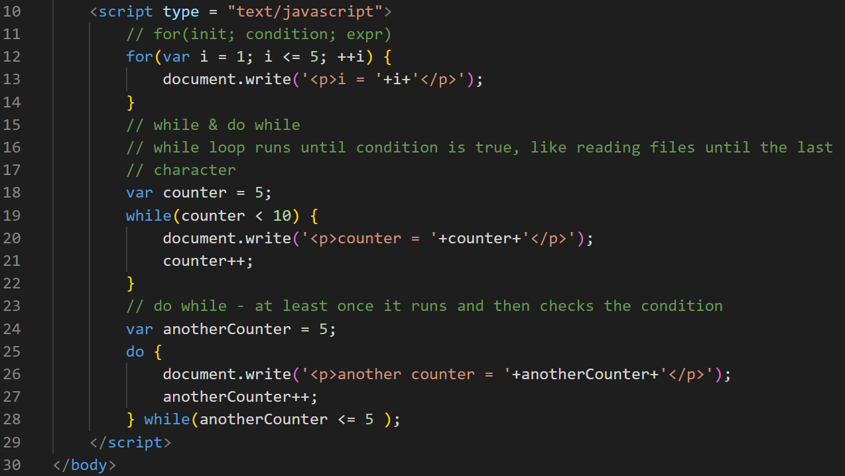
Output:
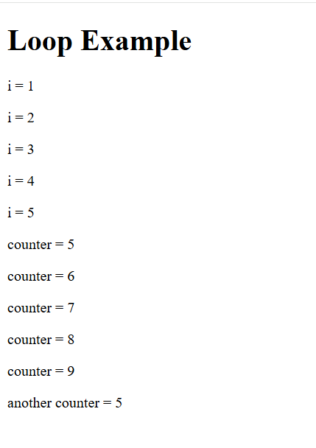
Objects in Javascript
In Javascript you can create objects that will have properties & functions/methods, there are many ways you can create objects in Javascript
- Literal style
- functional style with object constructor
- class style (modern syntax)

Literal style: This is better when you want one or two objects to be created or when you want some mock objects to be created
{ property : value, property : value, property : function() { } }
Function style: When you want multiple objects to be created with the same template then this is better, this style is more preferred in Javascript
function FunctionName(parameters) { … }
js-objects.html
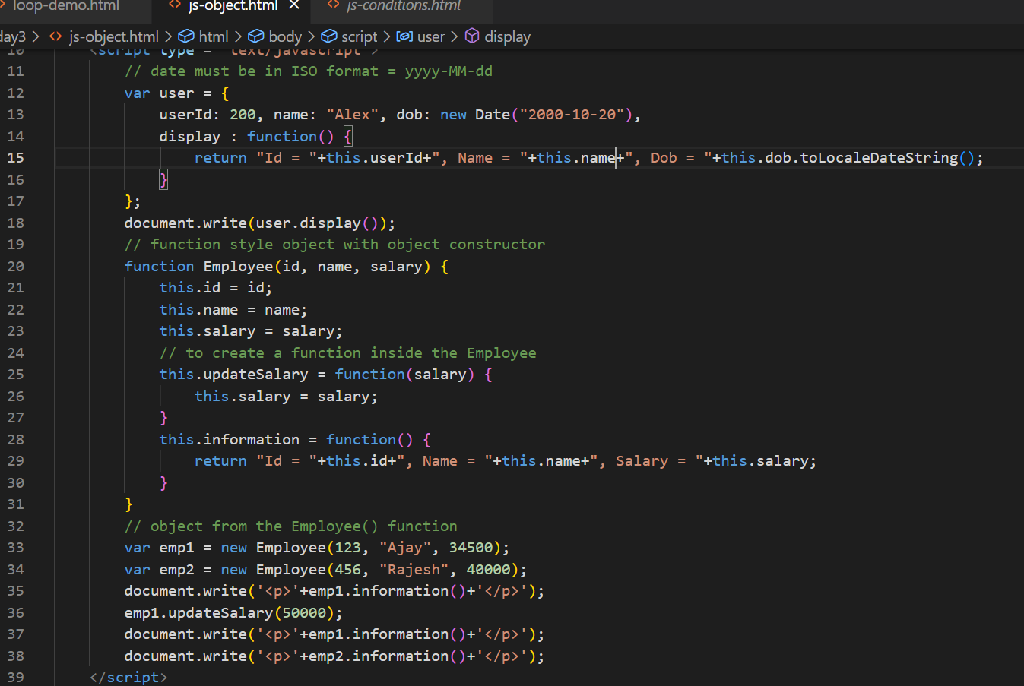
Output:
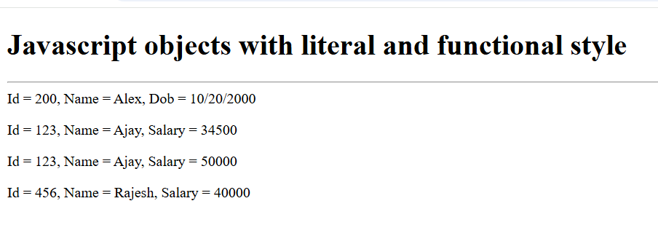
How to achieve inheritance in javascript
We can achieve inheritance with prototype if you are using old syntax, and a newer syntax uses classes & extends keyword
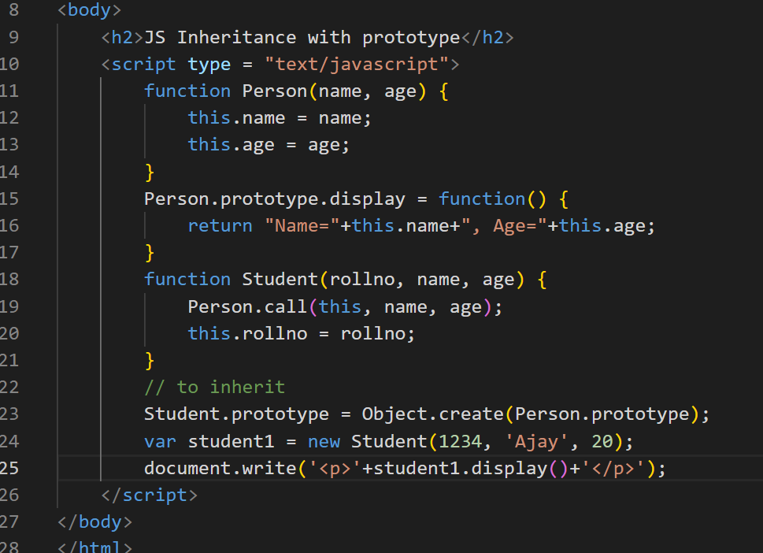
Output:
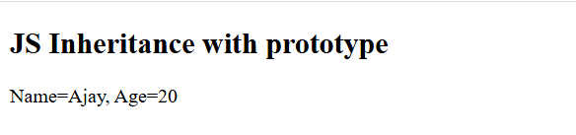
Arrays: It is a container object to store multiple values of same types or different types (in javascript it is allowed)
You can create simple to complex arrays
In Javascript you have lot of inbuilt functions in arrays like
push(): to add the element in the array
pop(): to delete the element from the array
sort(): to sort the elements
slice()
splice()
sort(): by default it sorts in ascending order, to sort in descending order you must use a function as a parameter that returns an int value to the sort to arrange the elements
sort(function(x, y){
return
})
Arrays methods & sorting with comparator anonymous function
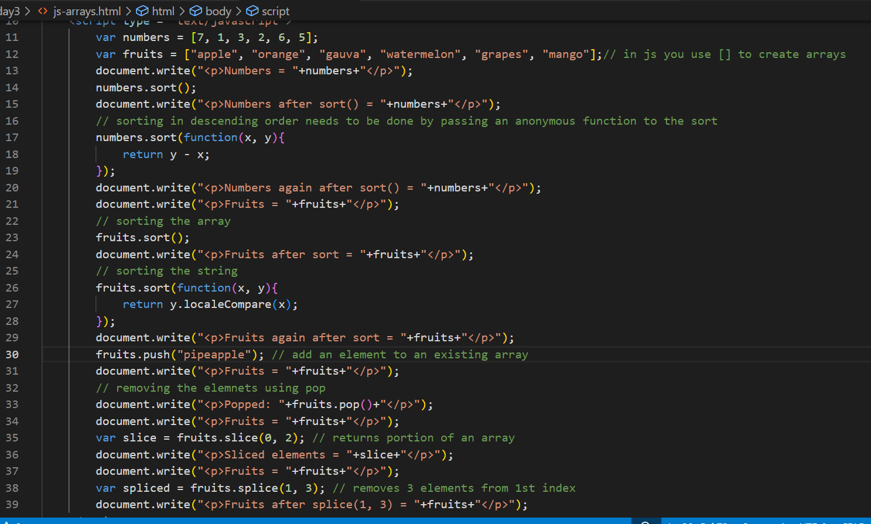
Output:
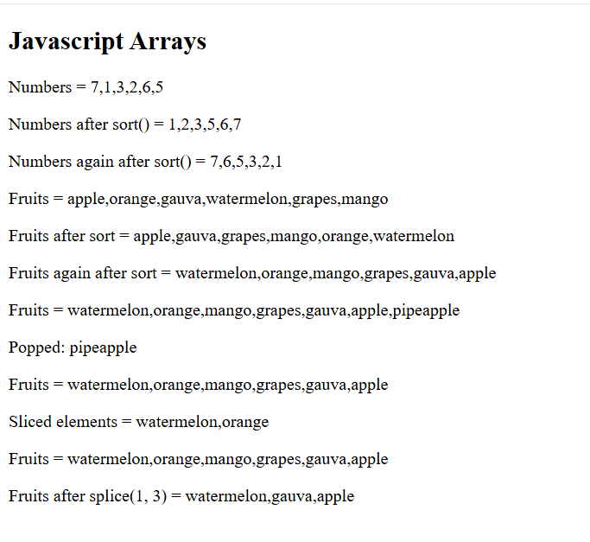
How to sort complex objects
You must use the same anonymous function and access the property of the objects and compare them.
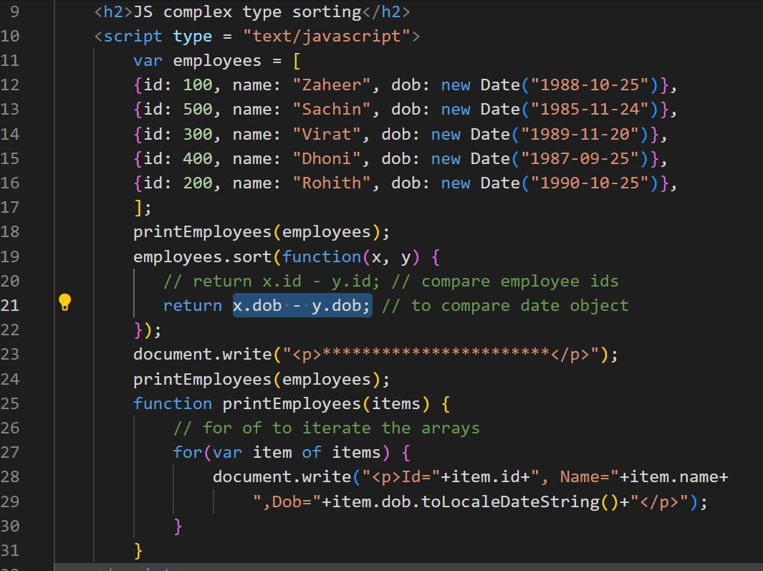
Output:
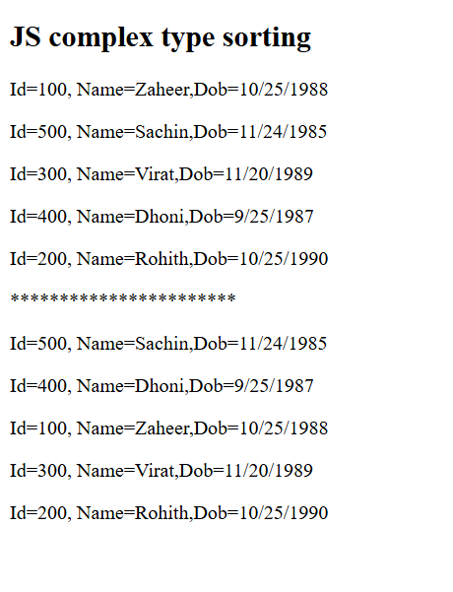
String methods:
In String there are various inbuilt methods like-
toUpperCase(), substring(), concat(), indexOf(), lastIndexOf()
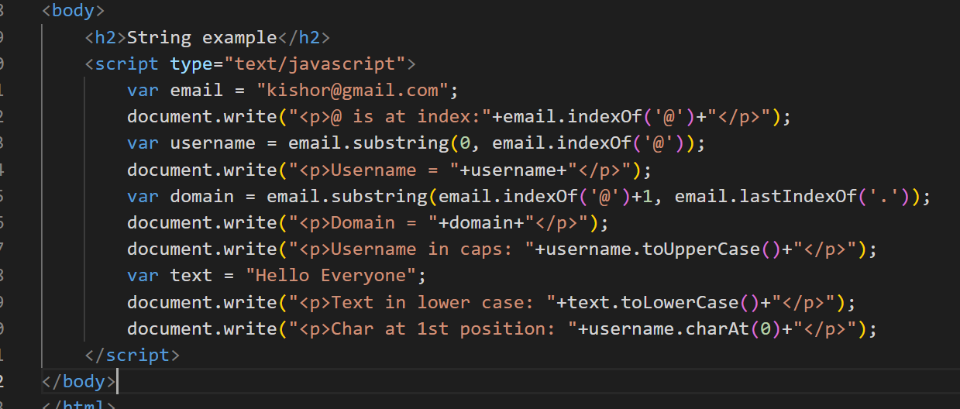
Output:
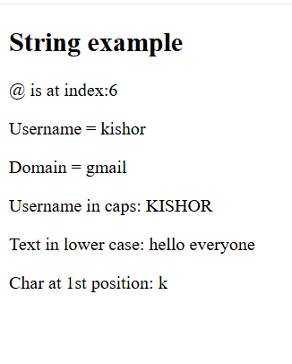
Day 4 Agenda
JavaScript HTML DOM
- Introduction
- DOM Elements
- DOM EventListener
JavaScript Form Validation
- Create Form
- Styling Form
- Validate Username Input
- Validate E-Mail Input
- Validate Password & Radio Button
For in Loop
It is used to iterate the properties of an object.
let employee = { id:101, name:”Raj”, phone:939933, dob:”2004-10-22” };
let name = employee[“name”];
for(var key in employee) {
// key will be the property of an object
employee[key]
}
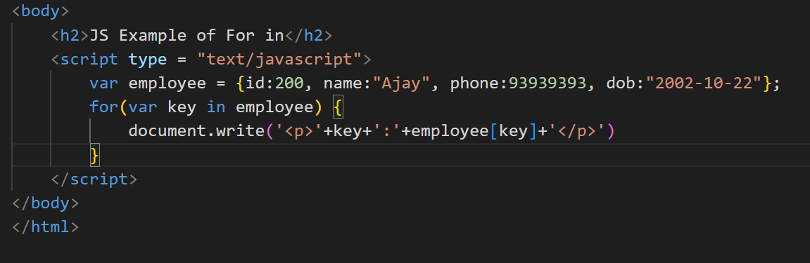
DOM events
DOM stands for Document Object Model, it is a tree structure of HTML elements loaded in the browser, HTML elements would generate events when you do something with the element like mouseover, click, onchange, onsubmit
<button onclick=”fun()”>Click</button>
js-event-demo.html
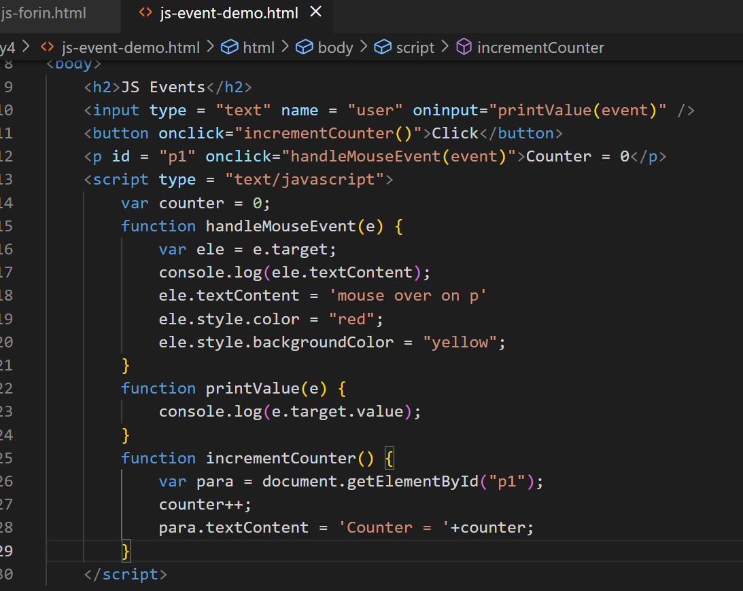
Output:
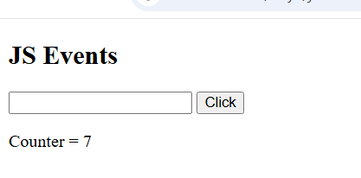
Changing the images based on the image you select
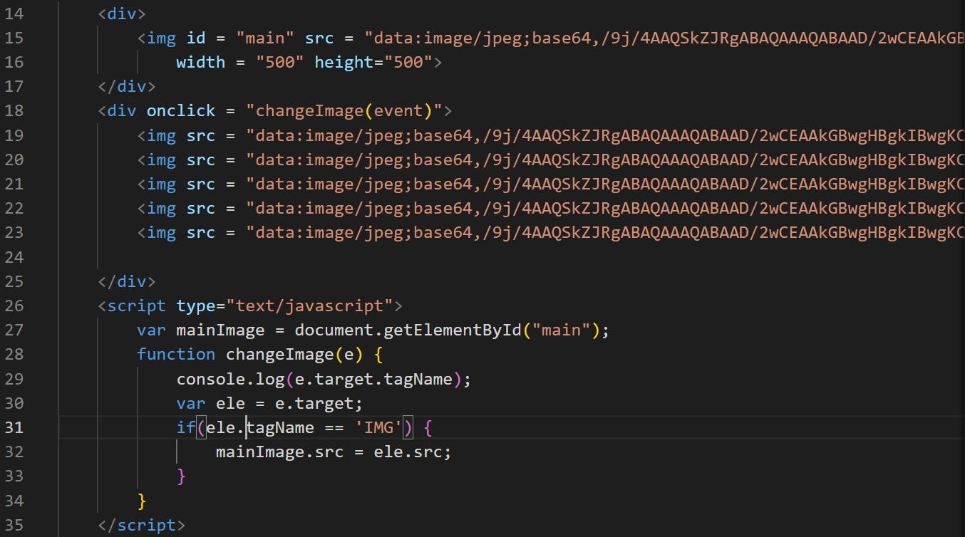
Output;

List of ways to access the element
- document.getElementById(“id”): Pass the id to get the element
- event.target: Get the element who generated the event
- document.getElementsByTagName(“tag”): You get all the elements having the tag name in the form array
- document.getElementsByClassName(“className”): You get all the elements having the class name in the form array
- document.querySelector(“selector”): You can use a single method to get the elements by passing the id or class name or tag name.
- document.querySelectorAll(“selector”): You can get all the elements having the same selector
ex: document.querySelector(“#p1”): gets the element whose id is p1d
ex: document.querySelector(“.p1”): gets the elements which has the class name p1
ex: document.querySelectorAll(“.p1”): get array of elements using the same class name
ex: document.querySelectorAll(“p”): gets all the p
ex: document.querySelector(“p”): gets the first p element in the DOM
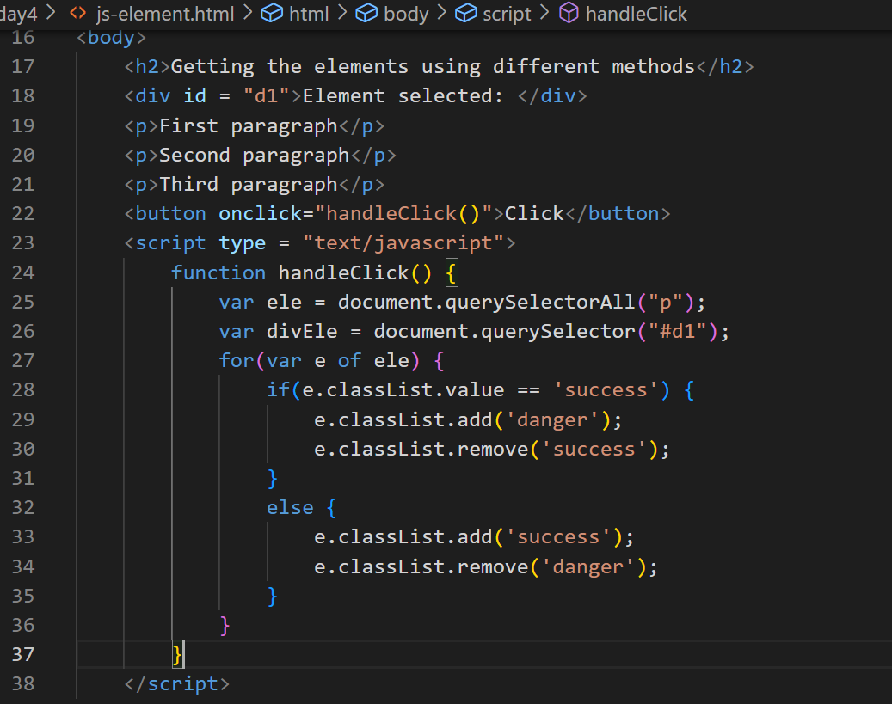
Output:
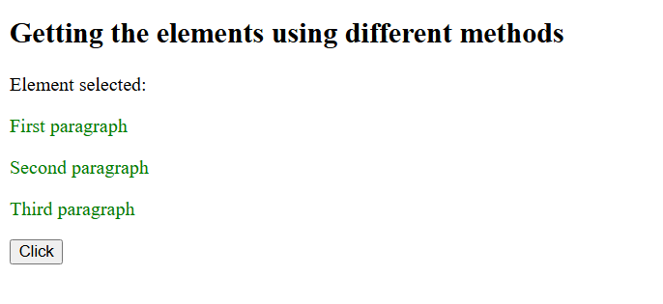

Form Validation
When user enters input sometimes he/she can enter invalid inputs like empty username or weak password, not selecting the gender or entering an invalid email in that case you don’t have to submit the form to the server, you can do a client side validation and prevent the form submission.
Activity:
Create password input box and validate for stronger password it must have digits, lowercase, uppercase, special character
Create radio button and mandatorily one should be selected
Create an input box for the email and validate for the valid email
Day 5
Modern Javascript (ES6, ES7 and others)
- Classes
- Let & Const
- Template String literals
- Arrow Functions
- Spread syntax & Rest parameters
- Destructuring
- Promises
- Async/Await
- Generators
- Optional Chain
- Nullish coalescing
- String padding
Modern Javascript simplifies the Javascript syntax so that most of the codes looks easy to understand.
Old Javascript syntax
var name = “Ajay”;
var age = 35;
var phone = 993920393;
var gender = “Male”;
var information = “Name = “+name+”, Age = “+age+”, Phone = “+phone+”, Gender = “+gender;
Modern Javascript syntax
information = `Name = ${name}, Age = ${age}, Phone = ${phone}, Gender = ${gender}`;
Javascript is derived from a specification called EcmaScript, it has released ES6 version which changed Javascript syntax to look much easier to understand, following are the features introduced in ES6 or later.
- let, const, class, extends, super keywords
- Template strings
- Arrow functions
- Spread & Rest parameters
- Destructuring
- Promises
- Exponential operator
- async/await
- Generators
- Trailing commas
- Optional chain
- Nullish coalescing

let & const: These allow you to create block scoped variables, which you can use instead of the var keyword, because var is not block scoped
if(…) {
var price = amount * total;
var price = amount * total; // you are allowed to declare more than once
}
console.log(price); // but it will be accessible
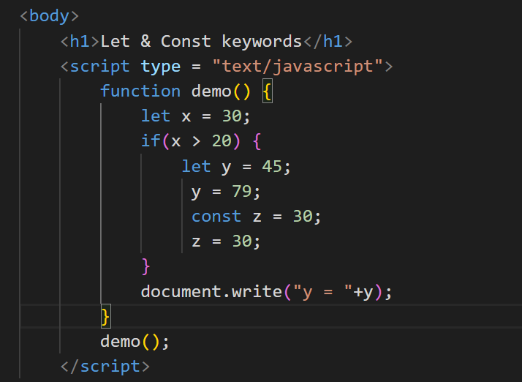
Output:
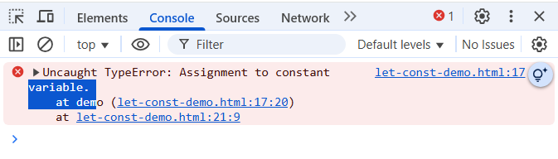
Achieving inheritance
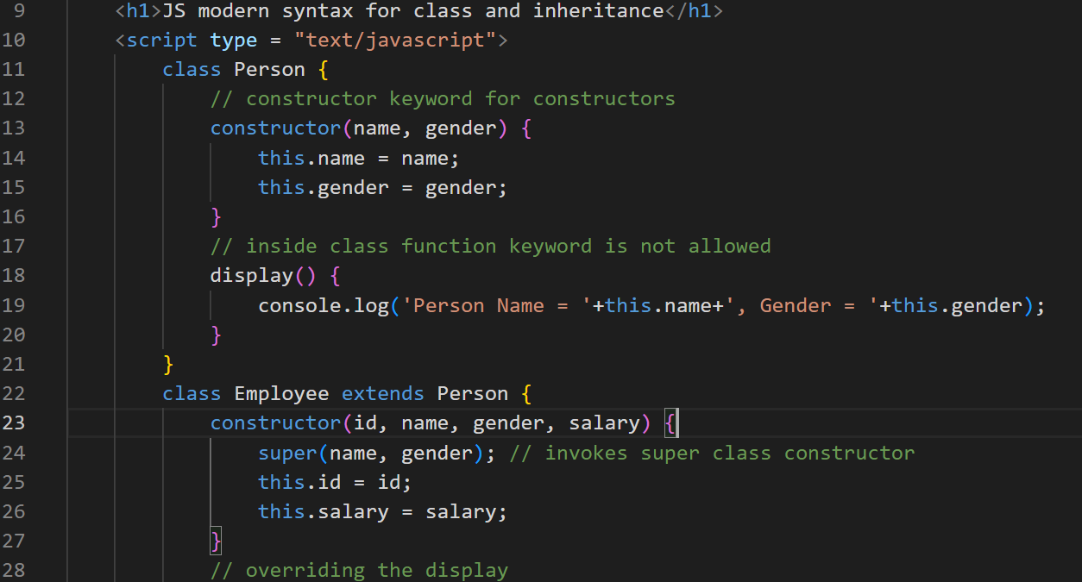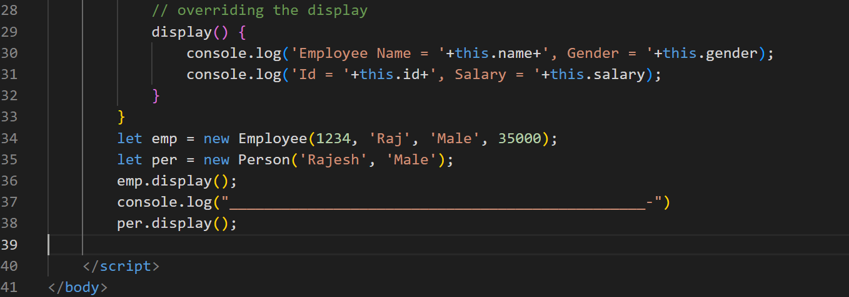
Output:
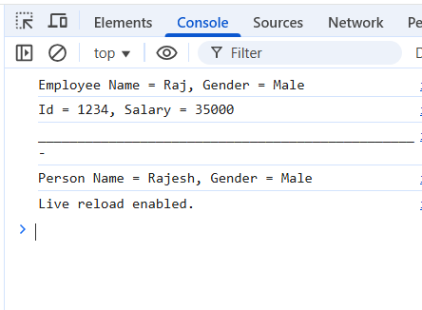

Template Strings
It helps to create strings with js expressions in a simple without breaking with + operator
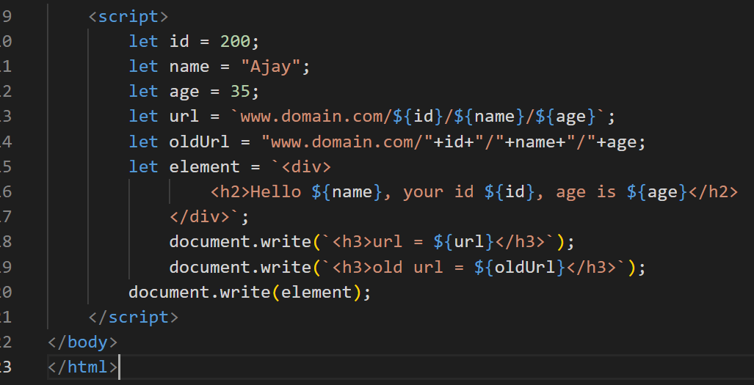
Output:
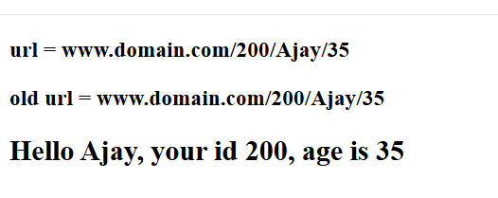
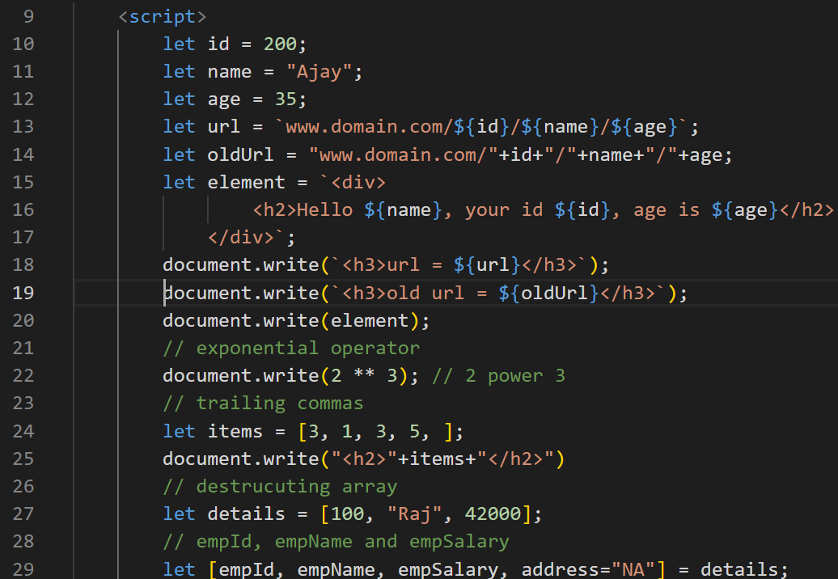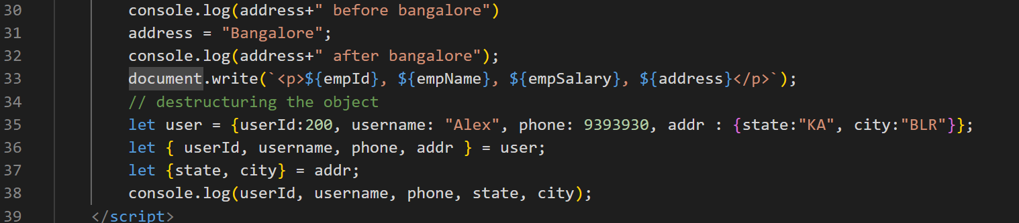

Day 6
Rest & Spread parameters
In order to avoid a function losing the data we have these parameters
Rest: You can create a function that can accept any number of parameters
function sum(x, y) { }
sum(2, 3, 4, 5); // error or takes only few parameters
Since 4, 5 is lost we can create a Rest parameter that will be … (3 dots) before the variable name
function sum(x, …y) { }
sum(2, 3, 4, 5); // x = 2, y = 3, 4, 5
Rest parameter
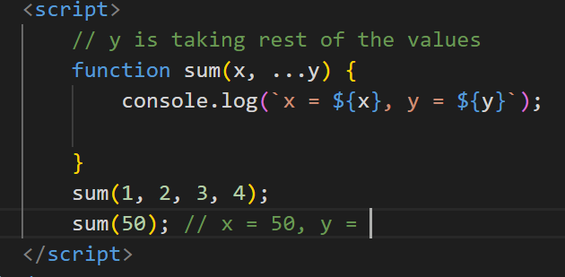
Output
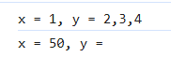
Spread operator
You want to distribute the array of values to multiple parameter, then you can use spread operator, it is used at the time of invoking the function, even spread also uses 3 dots
let items = [2, 3, 5];
function max(a, b, c) {
}
max(items); // a = [2, 3, 5]
max(…items); // a = 2, b = 3, c = 5
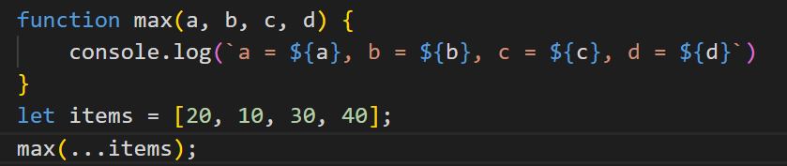
Output:
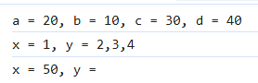
We can combine rest & spread both as below
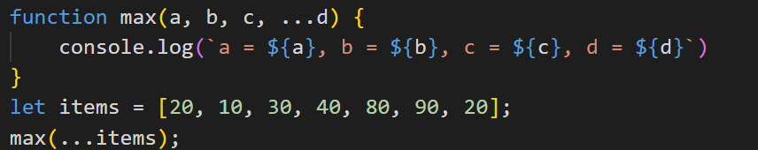
Output:
Optional Chain & Nullish coalescing
Optional chain
This is used to avoid errors while accessing the deeply nested properties
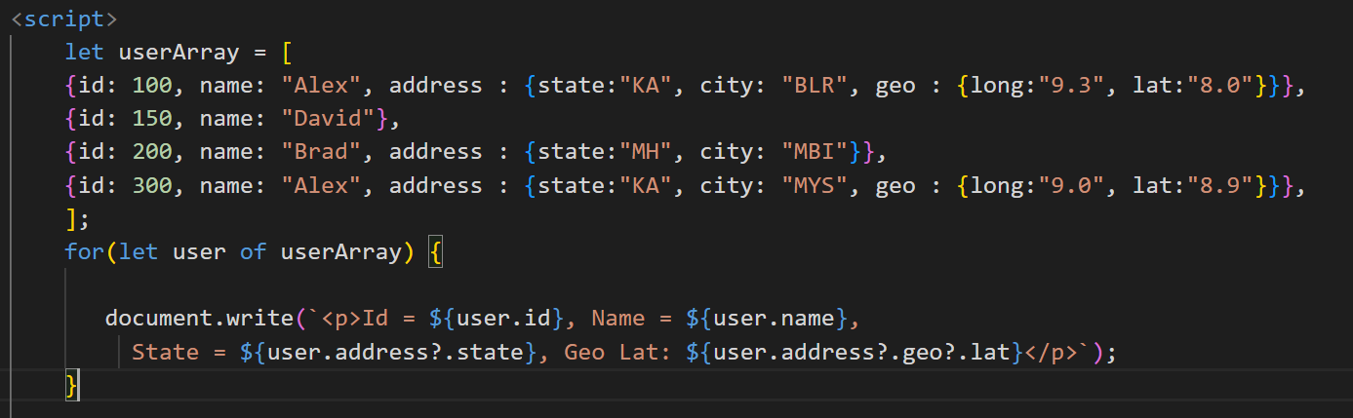
Output:
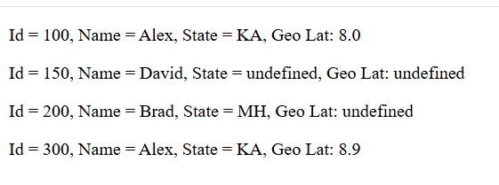
Nullish coalescing ??
You want to check the value is undefined or null & assign a different value when it is null or undefined
let x;
let y;
let z = x ?? y ?? ‘Anonymous’;
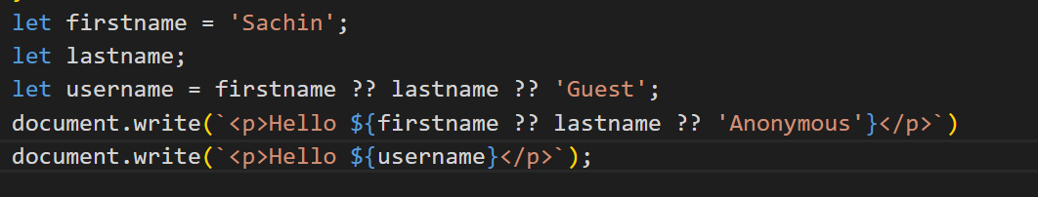
Output:
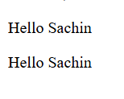
Generators
These are special type of functions which can pause the execution of the function and resume, when it pauses it can return a value as well using the yield keyword
function* generateNumbers() {
yield 1;
yield 2;
…
}
let gen = generateNumbers();
gen.next() // it executes until it finds the yield & pauses there
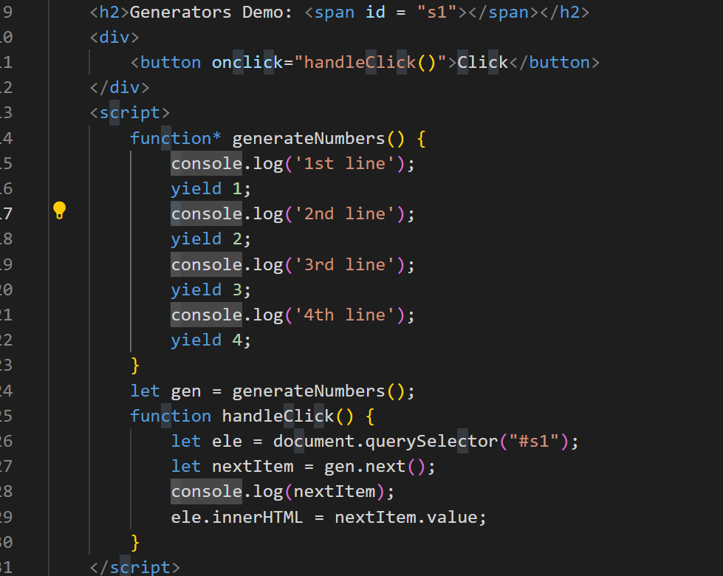
Output:
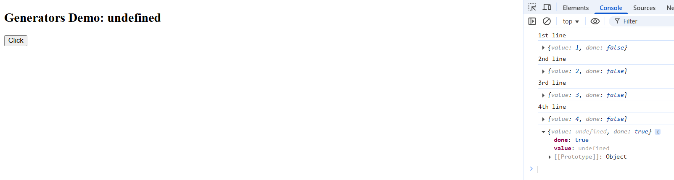
We can yield some other type of values also
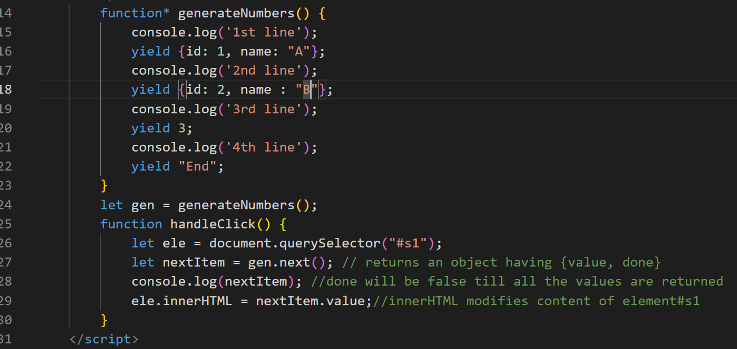
Output:
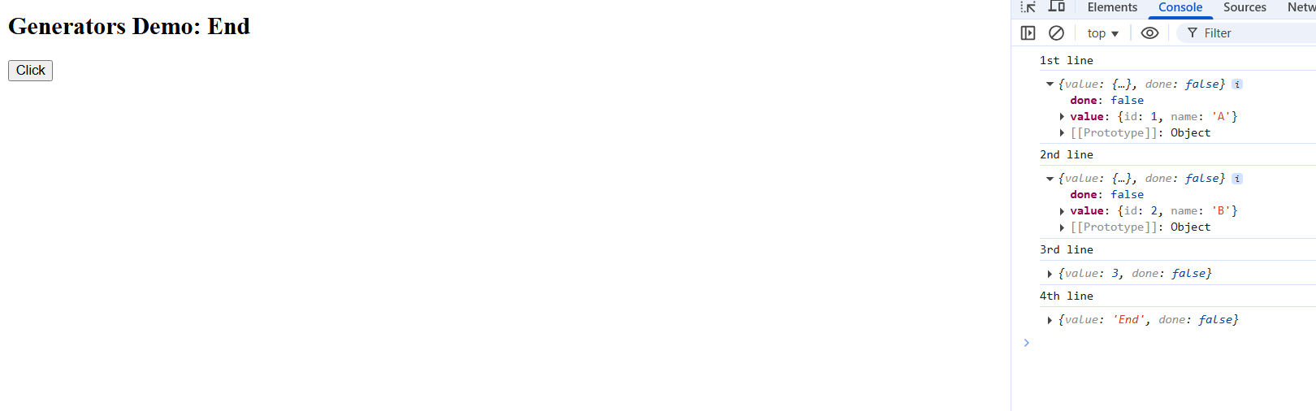
Arrow functions
These are the simplified functions for anonymous functions or callbacks
Callback functions are not immediately executed, they will be initiated immediately but will be called later.
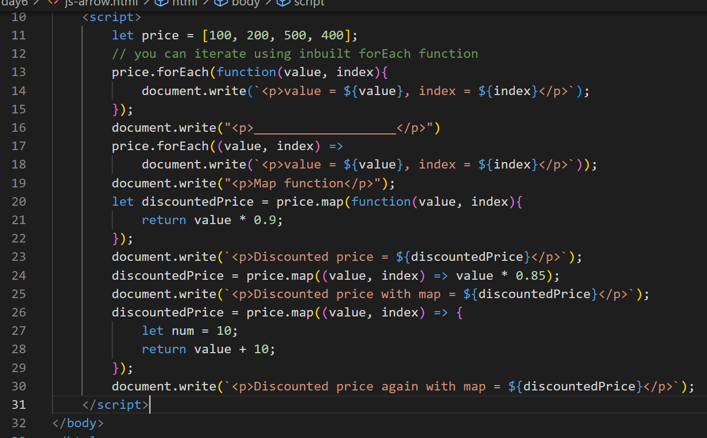
Output:
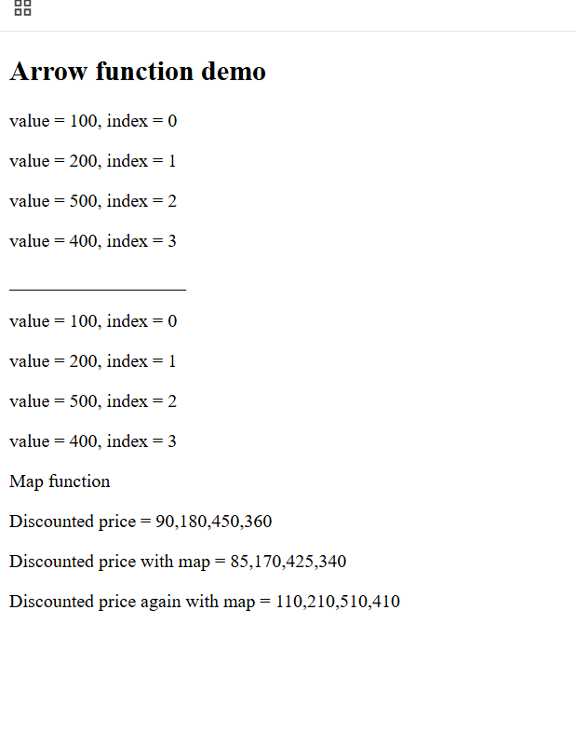

Day 7
- Promises
- Async/Await
- String padding
- NPM basics
- Installing packages
- package.json
- Node Event Loop
- Core Module
- Local Module
- Reading & Writing Files
- Third party Module
Asynchronous actions:
These are the operations which you initiate but they are finish later, they should not block the user when the operations are performing behind the scene
ex: timeouts, event handling, calling the backend apis
XMLHttpRequest: This is used to make an HTTP requests.
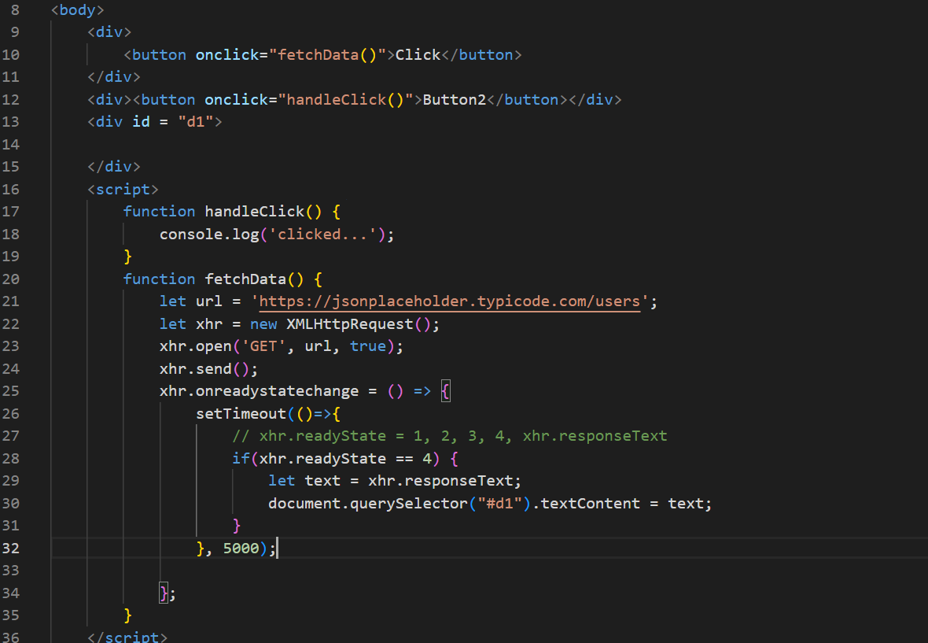
Output:
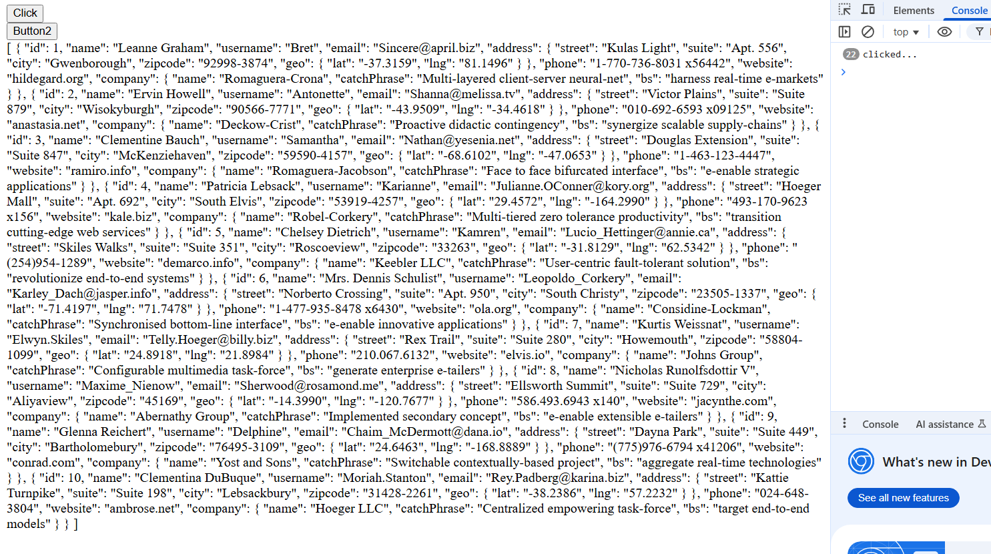
Promises:
They can perform asynchronous operations by providing separate functions to handle success and failures, it also avoids nesting the callbacks when current result is dependent on the previous result, Promise has 2 states
- Pending state: Initial state, neither successful(resolved) nor failed (rejected)
- Settled state: Resolved or Rejected
ex: axios library in React.js, fetch() which is supported in Javascript & Node.js (21 or later)
We can create our own Promise using the Promise constructor
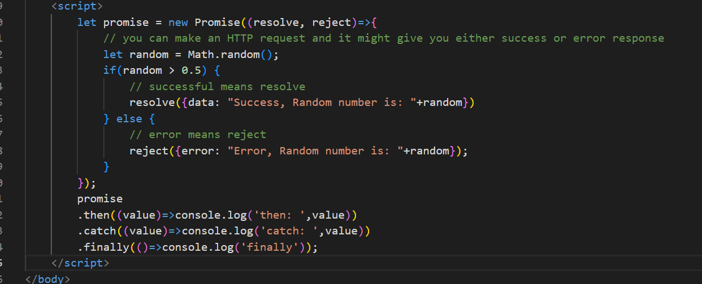
Output:
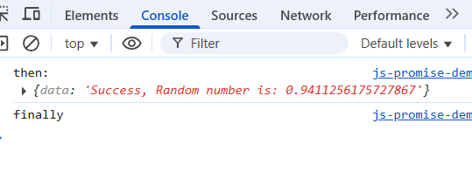
Previously we sent the request using XMLHttpRequest, but modern javascript provides an inbuilt method called fetch() that can send the Http Request but it returns the promise
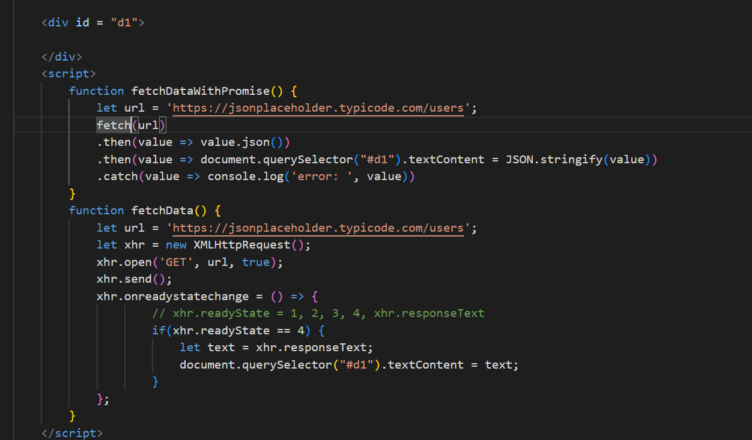
Output:
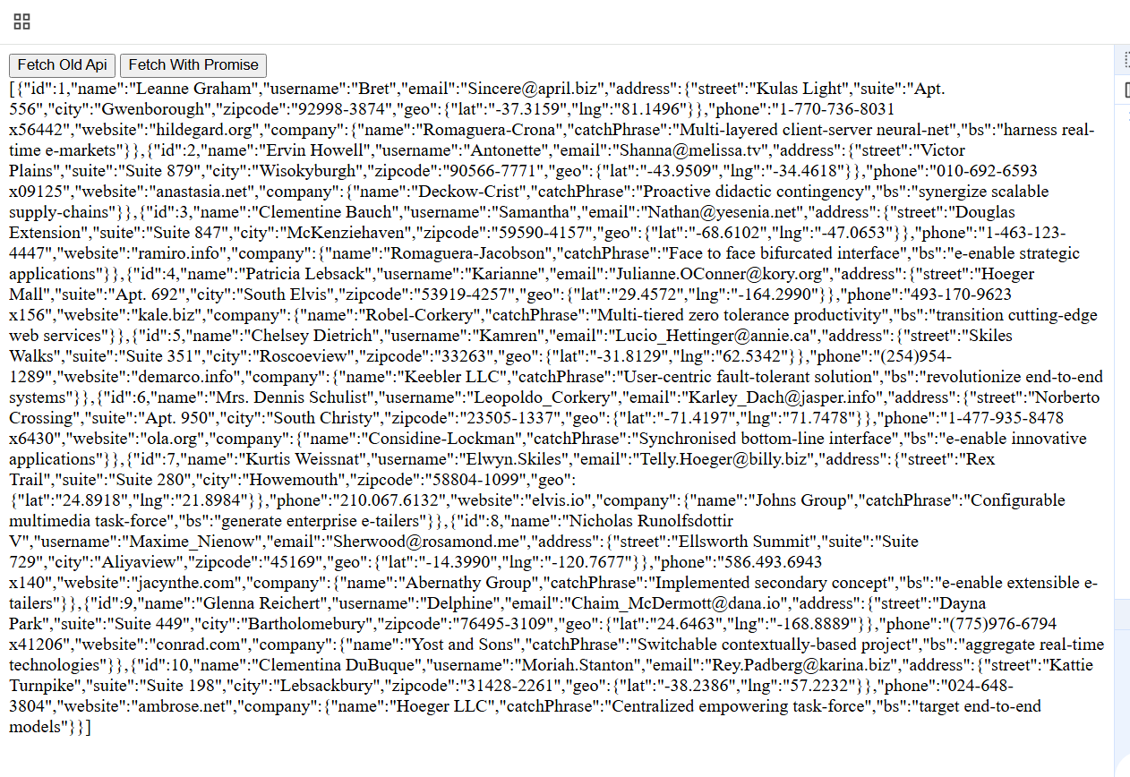
Promise can also perform multiple asynchronous operations and settle these operations in many ways, it provides various methods to take multiple promises in the form an array and settles based on the methods you use, below are the Promise methods which are static
- Promise.all([p1, p2, p3])
- Promise.allSettled([p1, p2, p3])
- Promise.race([p1, p2, p3])
- Promise.any([p1, p2, p3])
- Promise.resolve()
- Promise.reject()
Promise.all([p1, p2, p3]): It takes multiple promises & returns a promise only if all are successful, but if any one fails it will return the failed promise and rejects the remaining promise
ex: Loading the restaurant details, menu details, ratings and so on
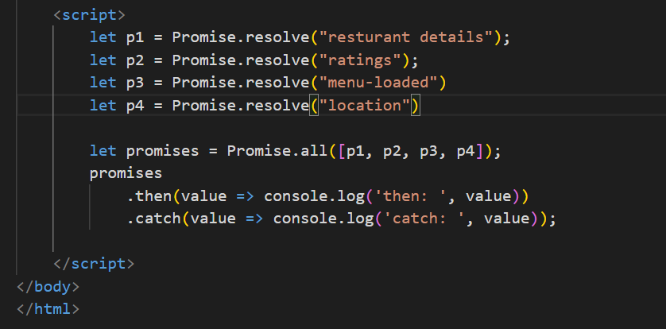
Output: Since all are successful you get all the fulfilled promise
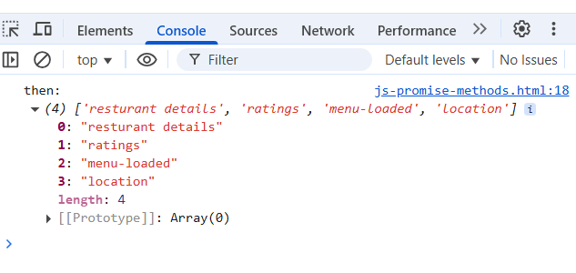
Change the Promise.resovle to Promise.reject you will see it only gives the rejected promise even though other promises are fulfilled, it gives the very first promise that is rejected & ignores the other promises
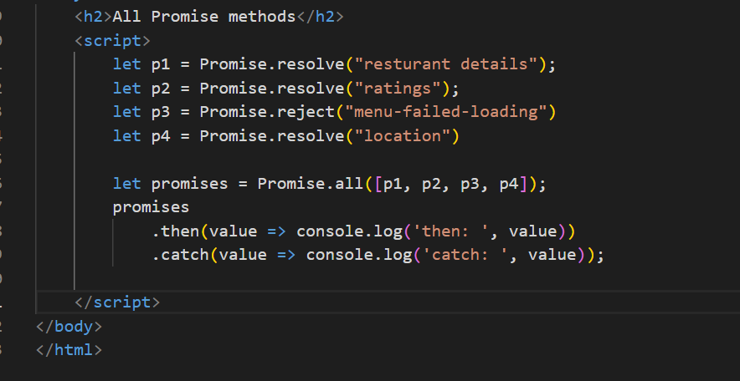
Output:
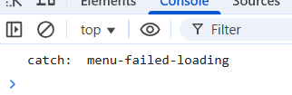
Promise.allSettled([…]): It settles all the promises both resolved & rejected one and returns a promise that will have all the promises result with which is resolved & rejected status
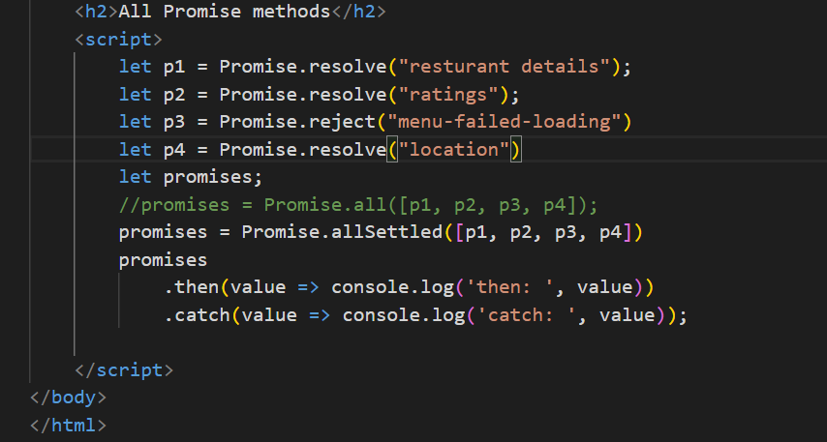
Output:
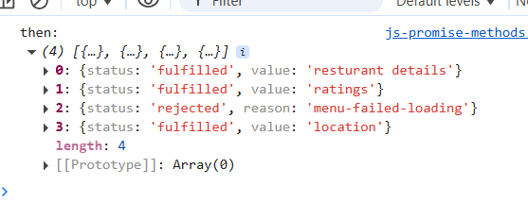
ex: You want multiple async operations to perform like rating the food, rating the delivery guy, rating restaurant
Promise.race([…]): Gives the promise whichever is settled first either rejected or resolved

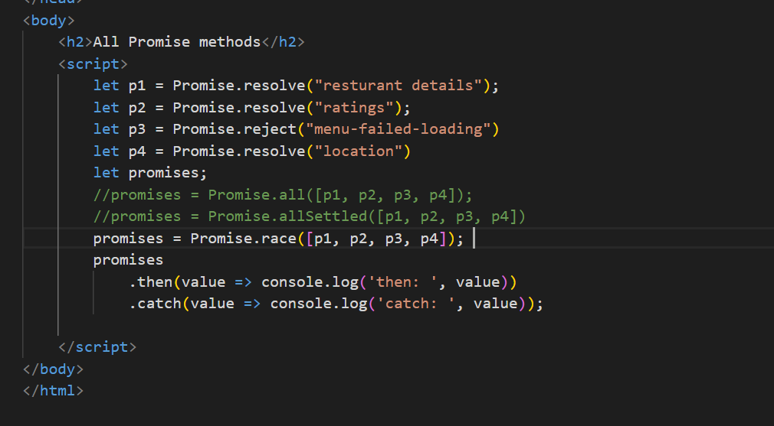
Output:
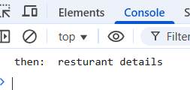
Here always the first promise itself will be the output, but in real time, when you pass multiple promises which might finish first we will not have an idea, use race() when you want the earlier one to finish first and it doesn’t matter it fails or succeeds
ex: You want to make an API call and also you want a timer to run, then whichever is finished first you want to consider
Promise.any([..]): This always gives the promise that is resolved by ignoring any failed promise
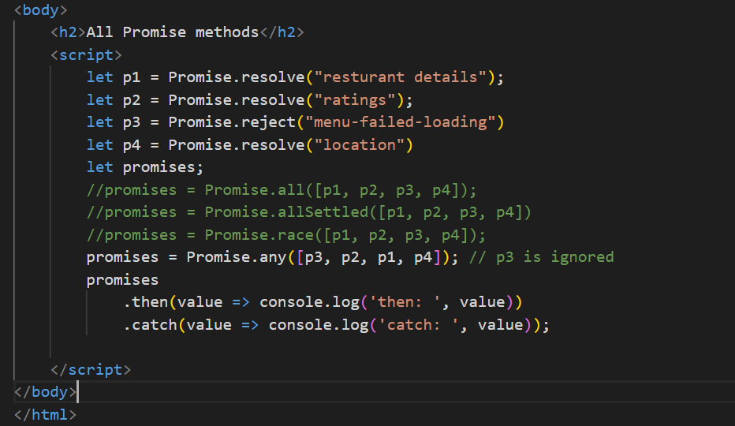
Output: Since p3 is rejected it is ignored & p2 is resolved it is considered and rest of the promise is ignored
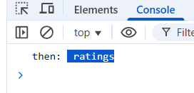
Ex: When you have some common resource getting from multiple end points, you can consider the first promise that resolves
Async/Await:
This is built on top promise to wait for the promise to settle and proceed with the next task, a function with async keyword can return a promise so that while calling you can use .then & .catch.
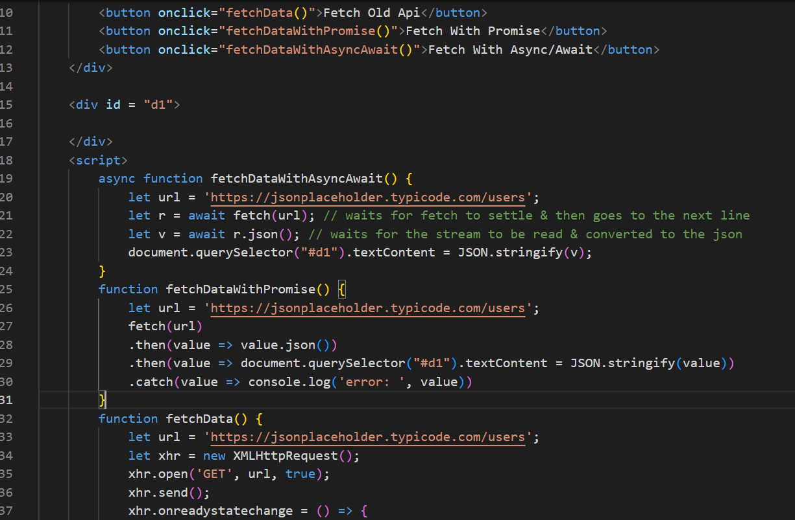
Output:
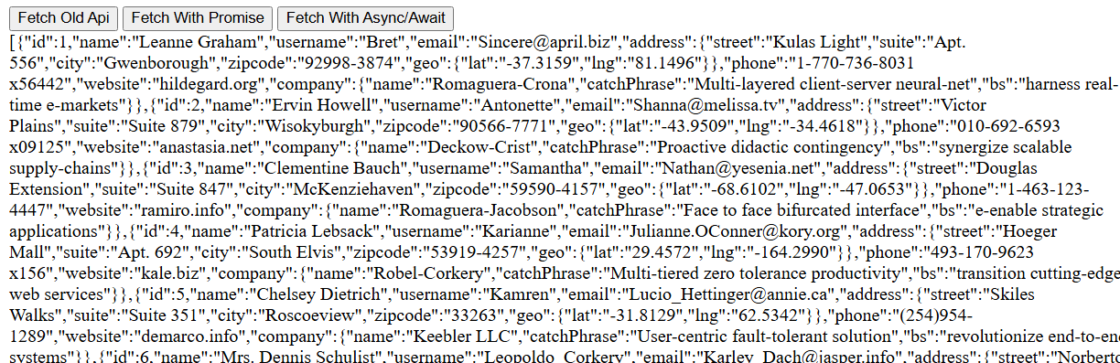
String padding
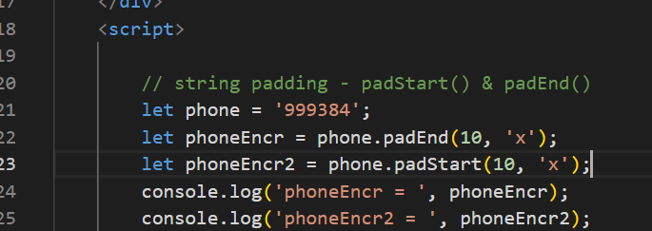
output:
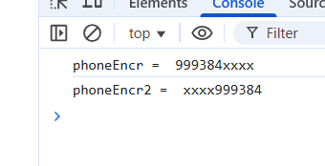
Day 8
- Node.js
- Typescript
Node.js is a runtime environment to run JavaScript’s at the backend so that you can do more operations related to backend services like connecting to DB, access files, working with OS related resources
node.js gives two commands
- node: This is used to run the javascript files and also gives you REPL terminal, where you can test javascripts & also many tools that supports JS integrates REPL ex: mongodb shell
- npm: Node Package Manager this is used to manage the modules which are libraries
basics.js
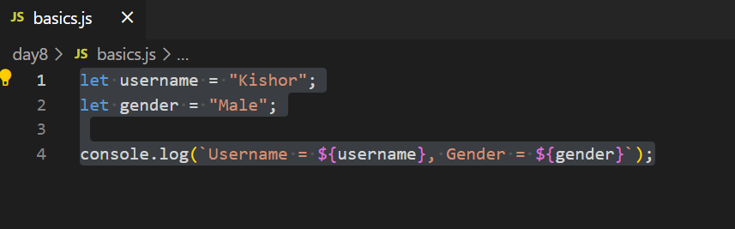
Output:
package.json
It is the heart of node.js it will have all the project meta-data like versioning, dependencies, scripts
Java -> pom.xml
Node.js -> package.json
To create the package.json you can enter npm init command or npm init -y
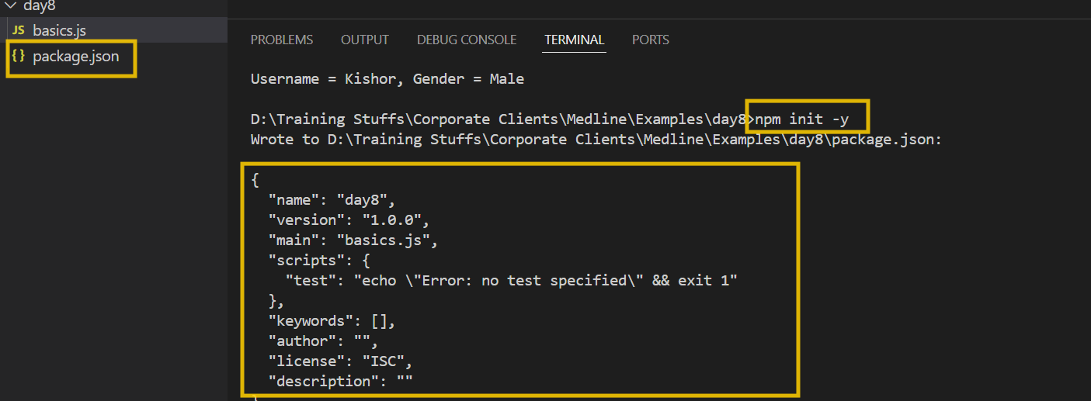
You can add start script & run using npm
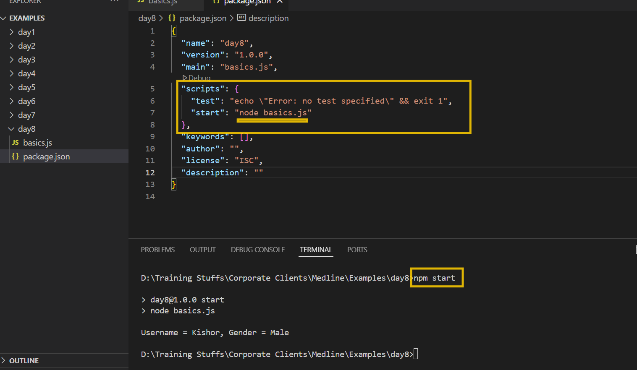
Importing & Exporting the modules
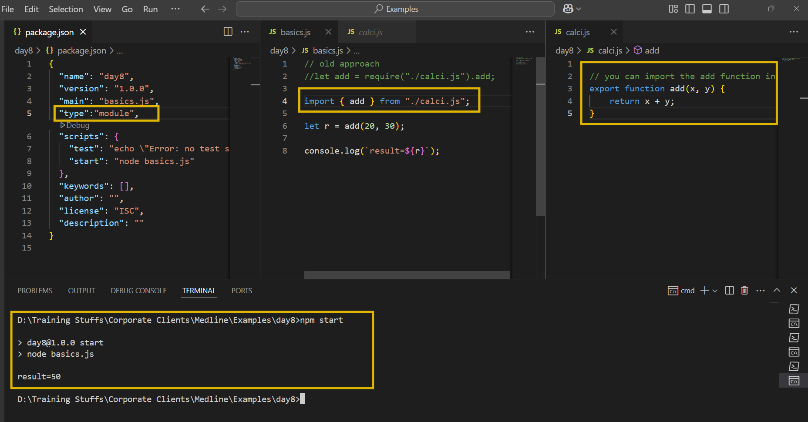
Node.js uses Event loop mechanism to run the script
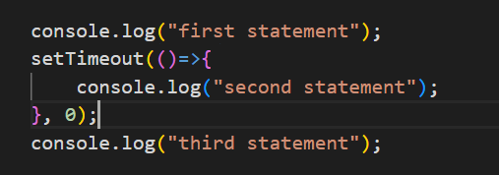

Local modules:
These are inbuilt modules part of the node.js, which can perform various operations like
reading files/ writing files
creating web application using http
os module
fs-demo.js to read & write files
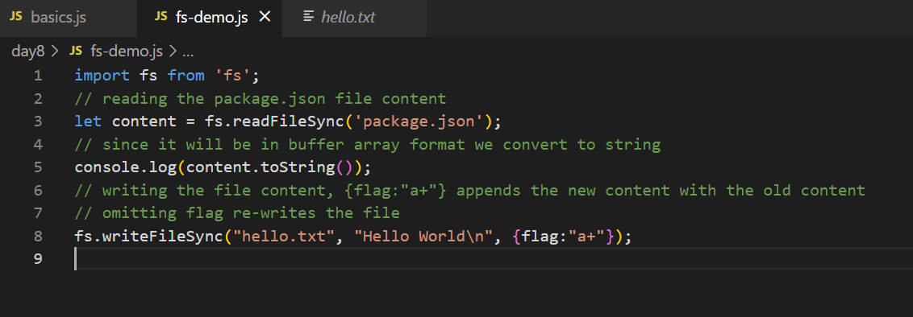
os-module
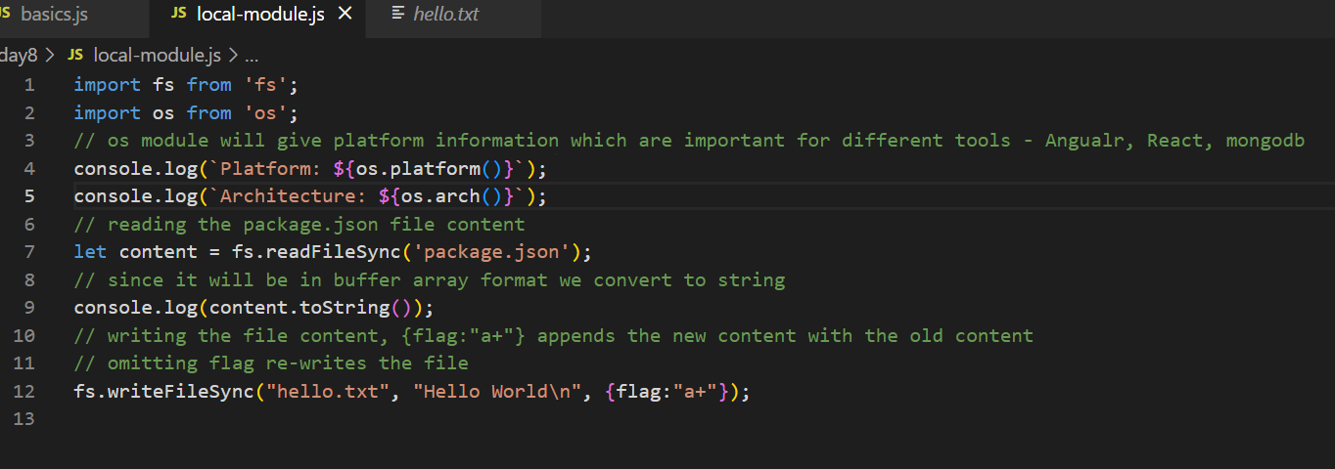
Output:
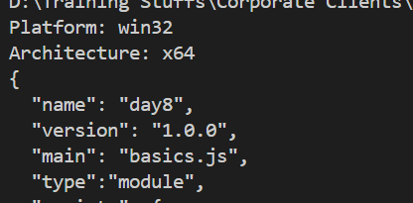
You can install 3rd party modules using npm, npm maintains libraries in a node repository you must use following command like
npm install library-name library-name library-name [or]
npm i library-name library-name # local installation
npm install -g library-name # for global installation
Typescript
It is a programming language which is a super set of javascript, it supports everything of javascript & extra features, it makes code more reliable & predictable because it adds types to the data
function add(x, y) { } // add(“hello”, “world”), add(true, false), add(20, “hello”);
function add(x : number, y: number) { } // add(30, 40);
To install typescript
npm install -g typescript
npm i -g typescript
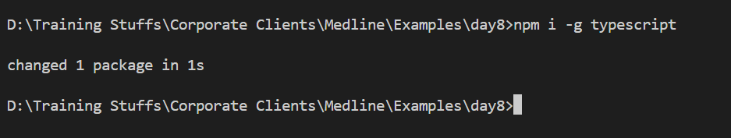

Types in typescript
- number
- string
- boolean
- custom type
- arrays
- union
- intersection
- generics
- void
- conditional & mapped types
Compiling & running
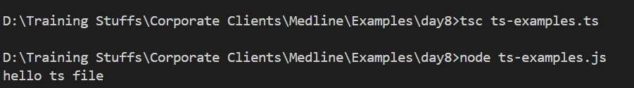
you will write all the code in ts file but run the js file by using tsc filename.ts you will compile.
Using some types in typescript
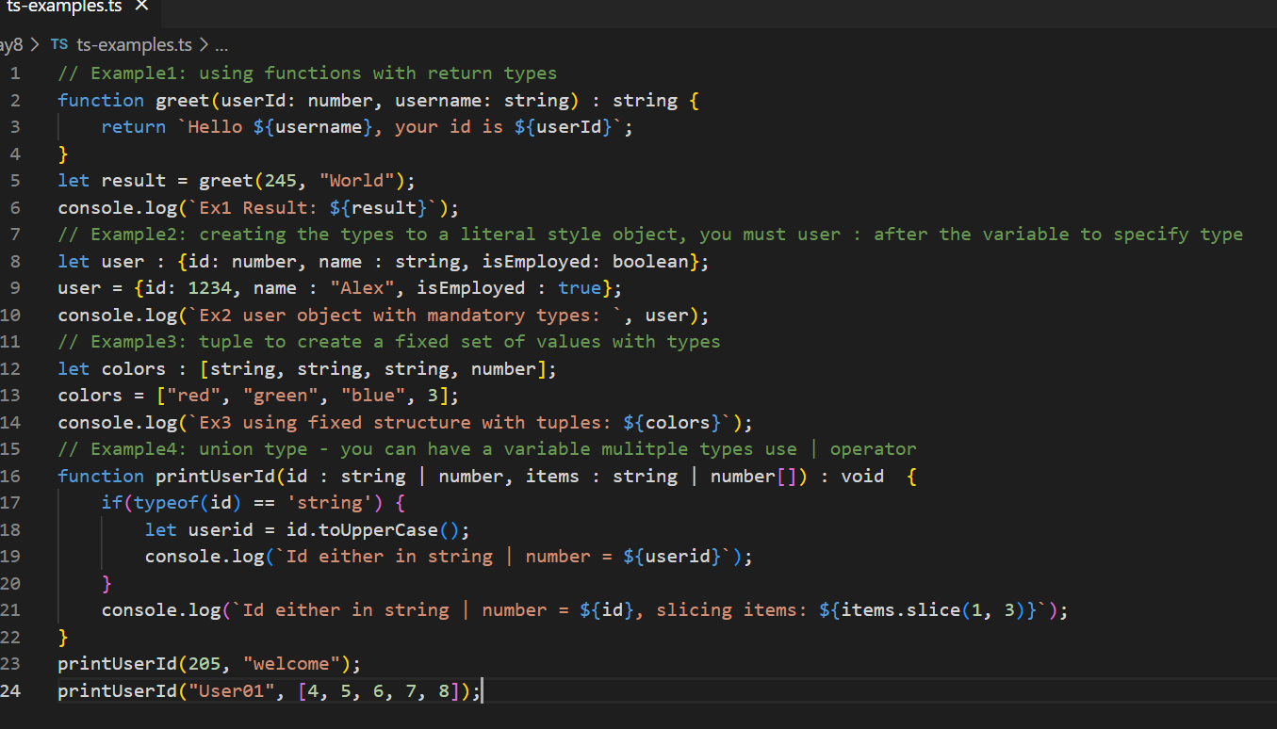
Output:
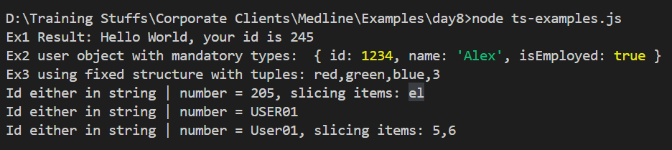
Type aliases
type Point = { x : number, y : number};
let pt : Point = { x : 40, y : 50}
interfaces
interface Person {
name : string;
age : number;
}
interface Employee extends Person {
salary : number;
id : number;
}
let emp : Employee = {name, age, salary, id }
interface A {
test() : void;
}
class X implements A {
void test() { .. }
}
classes:
class Employee {
//
}
private, public, protected & optional parameters
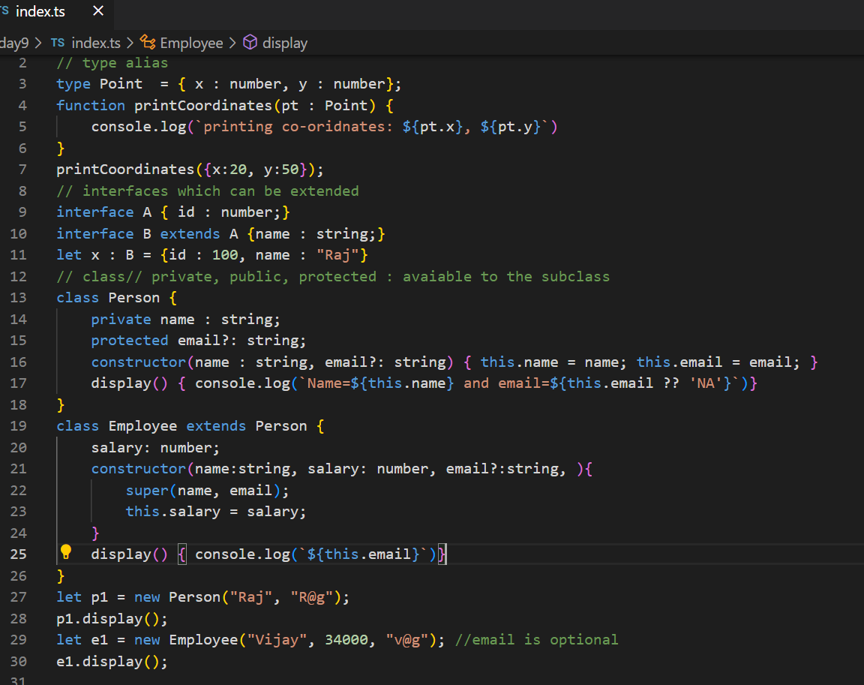
We have other features in typescripts like
- short-cut constructor initialization
- generic types
- promises for the function return types
- conditional types
- mapped types
Promises: Before ES6 i.e., ES2015 there was no promise, hence the typescript compiler doesn’t compile it because by default it converts the TS to ES5 compatible Javascript
We must use --target flag to say typescript compiler that compile to ES6 Javascript
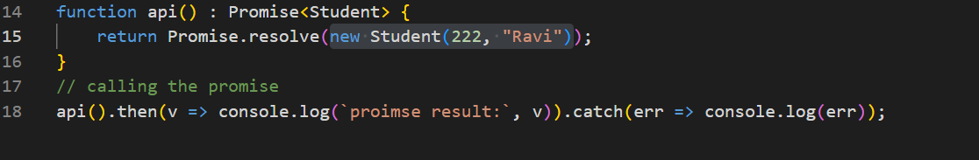
Compiling this without --target ES6 gives error.
Short-cut constructor syntax & Promises
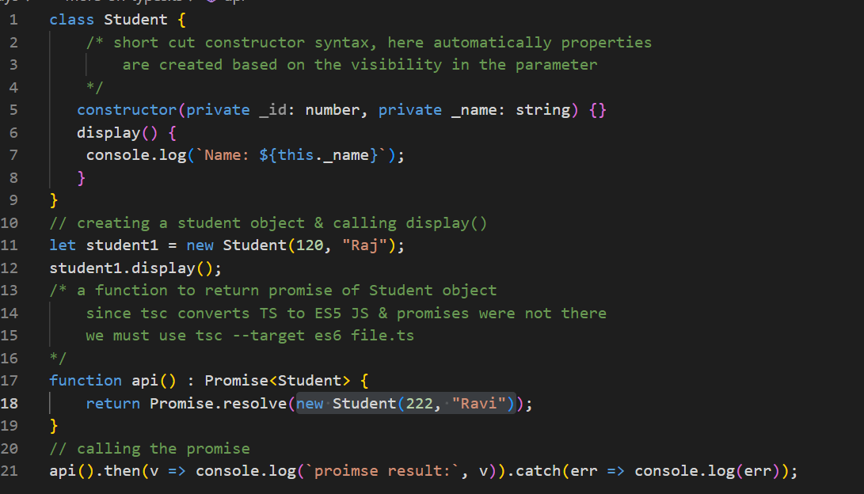
Output:
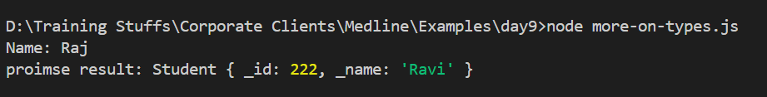

Decorator: It is mainly used to provide meta information on a class or variable or a method
Angular has many decorators to change the behavior of the class or a variable or a method.
ex:
@Component ({})
class App { }
Mapped types
You want to create new types by transforming the properties of an existing type
ex:
age : number >> transform this to age : string
or
age : number >> transform this to age ?: number

RxJs
Reactive programming allows you to react to the events or for asynchronous tasks, RxJS is nothing but ReactiveX for Javascript, it is a library for composing asynchronous & event based programs by using Observables.
Promise for asynchronous tasks, but it will only get one data at a time & it executes always for completion, it doesn’t wait for continuous data, to the receive the data continuously we need to use Reactive programming which provides Observables.
Key components in RxJS are:
- Observable
- Observer
- Subscriber
- Subject
- Operators
Observable
These define the stream of data or collection of future values that can be emitted overtime.
Subscribers: These can subscribe to the observables to receive the emitted values
Observer: It is an object that defines the callback or handlers which are called when an observable emit an event
Install the rxjs
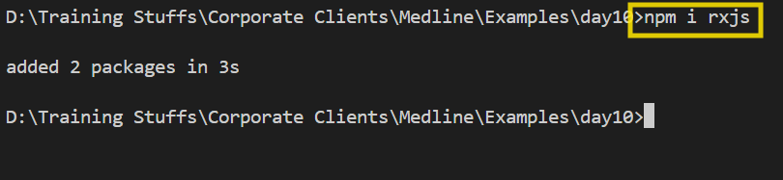
How to create observables
let myObs = new Observable( (observer) => {
observer.next(“Emit 1”); // success value
observer.error(“Emit error”) // error values & no more data is emitted
observer.complete(); // to notify its done & no more data is emitted
} );
myObs.subscribe( {
next: (value) => {…. } , error : (error) => {… }, complete: () => {… }
});
Note: change the package.json to have “type”:”module” to use modern import syntax
package.json
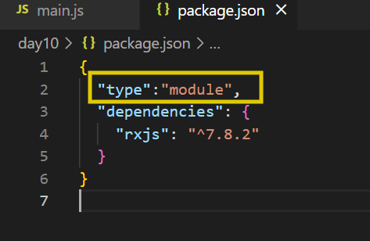

main.js
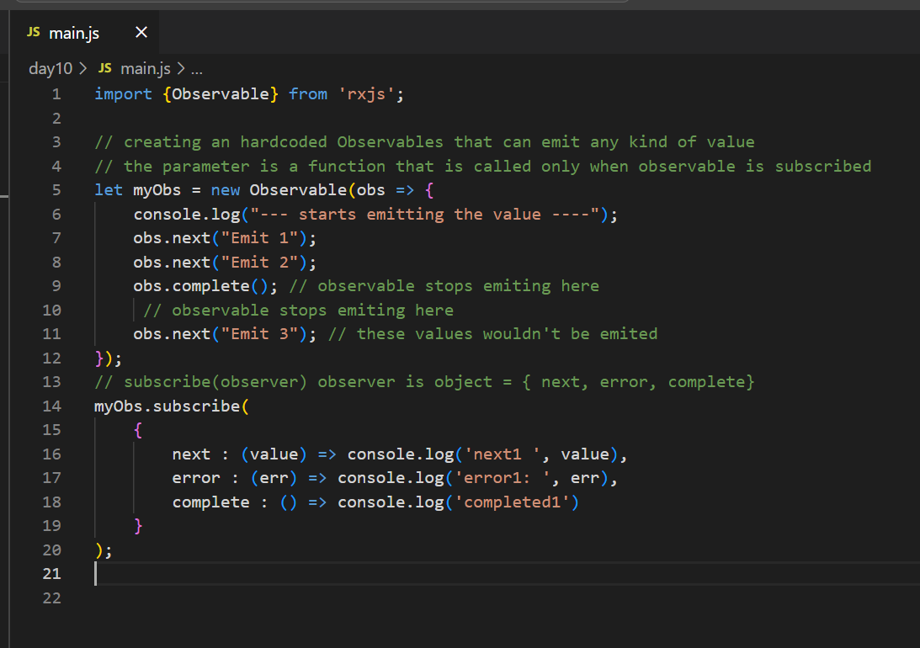
Output:
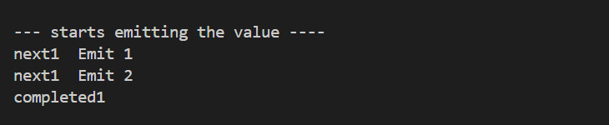
Operators:
Manipulate the data emitted by observables before they react the subscribers
map()
filter()
catchError()
Subject: To share the same data to multiple subscribers
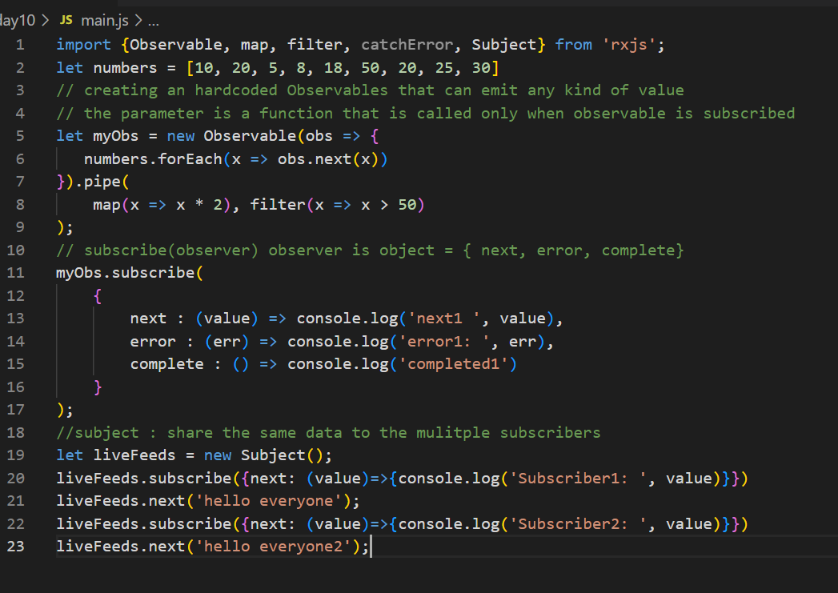
Angular Framework: It is used to develop single page applications
Components: These are reusable UI’s which you can see, these are independent that you can develop and then integrate with other components to create a complex UI
Two technologies angular use for developing the applications
- HTML
- Typescript
npm install @angular/cli
ng --version >> 19
ng new app-name
Summary
ng new my-app --no-standalone --routing=false
npm start >> ng serve
ng serve --port=4201

Angular CLI: ng generate component component-name
[or]
ng g c component-name
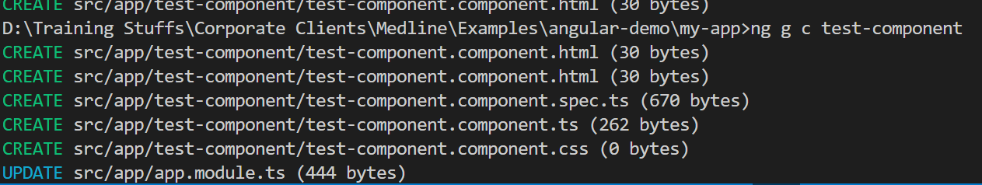
Add the test-component to the root component
app.component.html
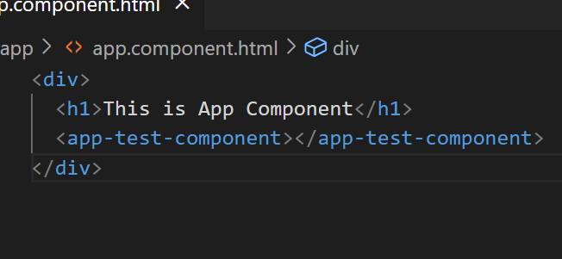
Output:
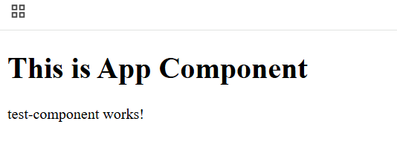
How to display different types of data like simple type, complex type
demo.component.ts
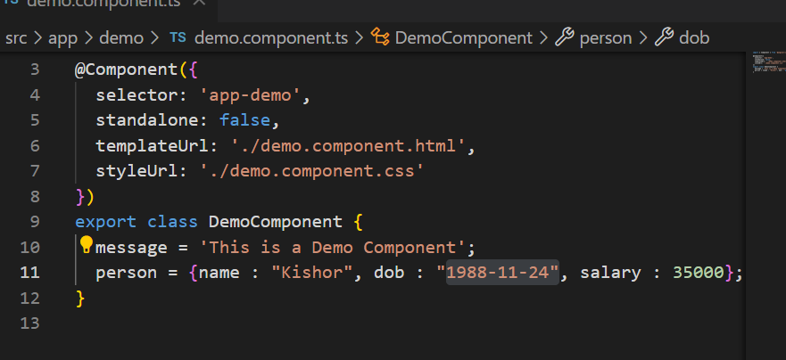
demo.component.html
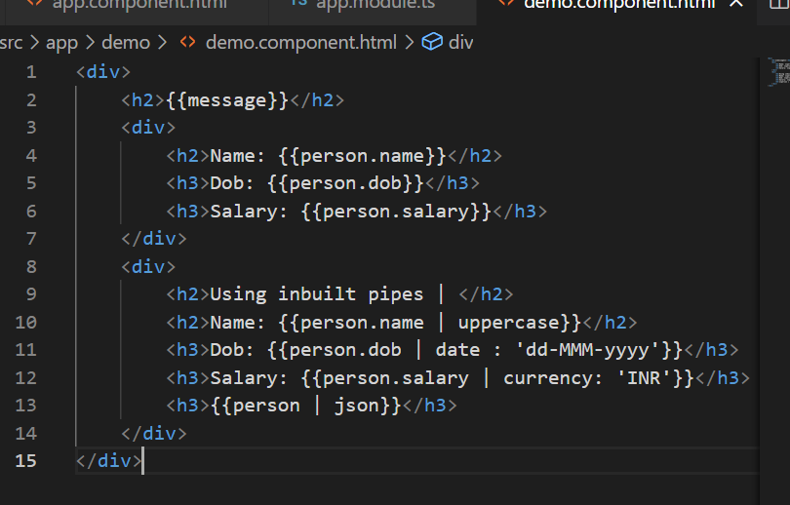
Output:
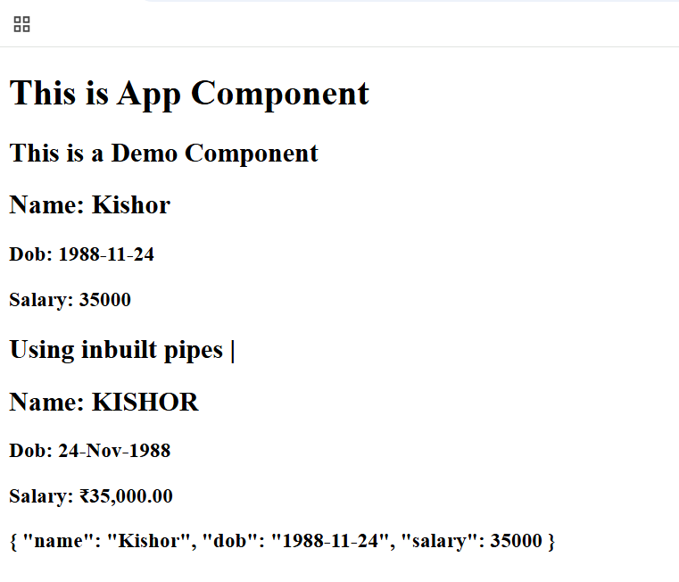

Pipe: These are mainly use for transformation, we have inbuilt pipes like
- uppercase, lowercase, date, currency, json

Custom Pipe: We can create our own pipes in angular that would do some job when you use its name
ng generate pipe pipe-name or ng g p pipe-name
Note: Once you generate the pipes it must be part of AppModule to recognize, the command automatically updates the app.module.ts
name-formatter.pipe.ts
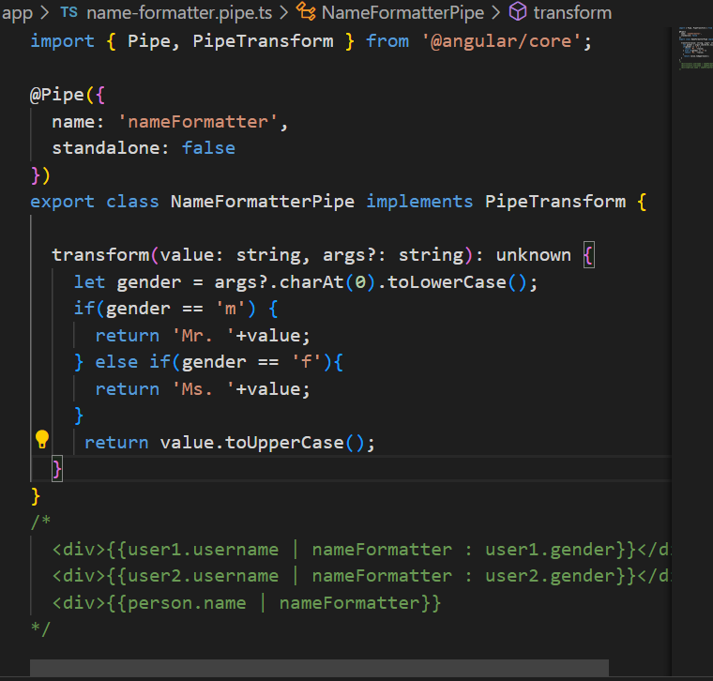
demo.component.ts
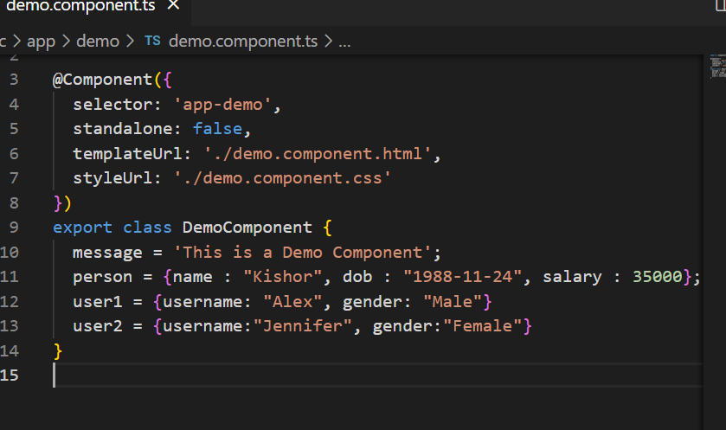
demo.component.html
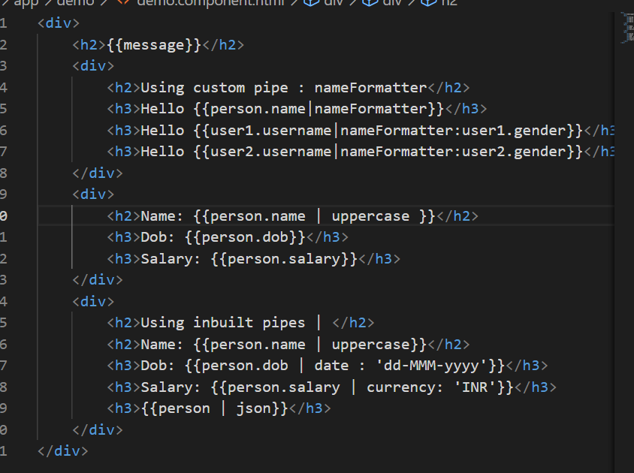
Output:
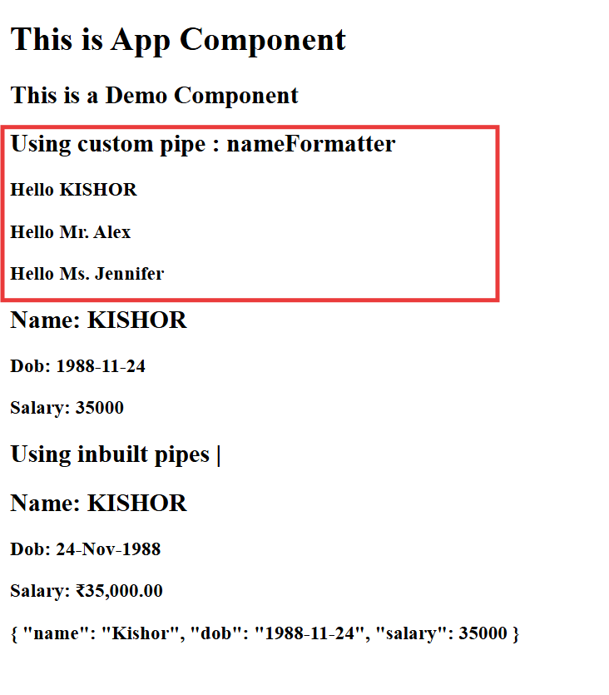
Databinding:
When you want to share the data from the view to the component or vice versa you need to do a data binding, there are following types of data binding
- Interpolation {{ }}}: Here the data present in the component class shared to view
- Event binding (eventName): Here the data present in the view is shared to the component class
- Property binding [ ]: Here the data present in the component class shared to the view, similar to interpolation, but this is mainly used to update the DOM property
- Two way data binding [(ngModel)]: Here the data flows in both the direction, it will be in sync, but you need to import FormsModule to support the ngModel
Event Binding & Property Binding
TS
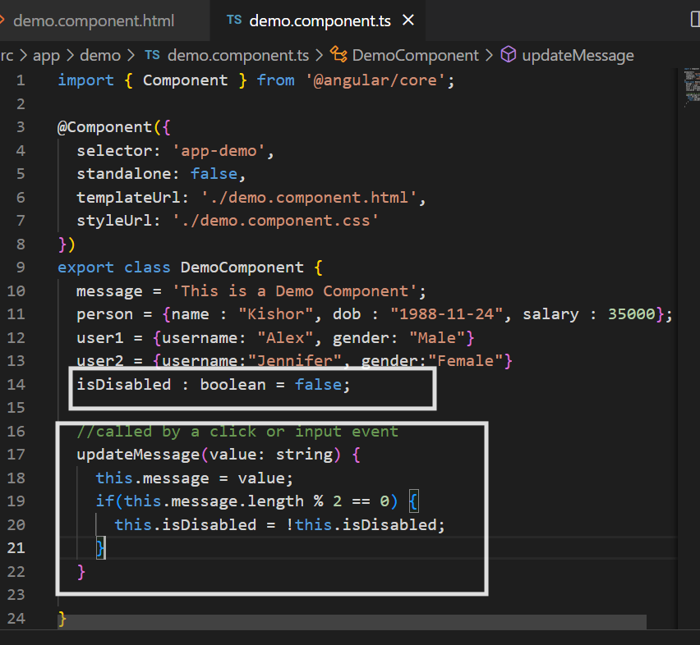
HTML
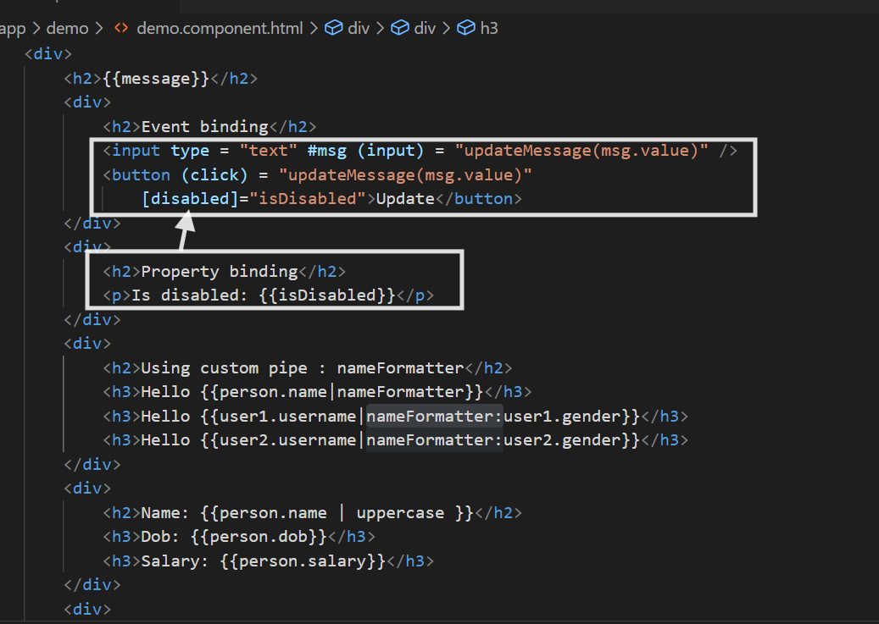
Output:
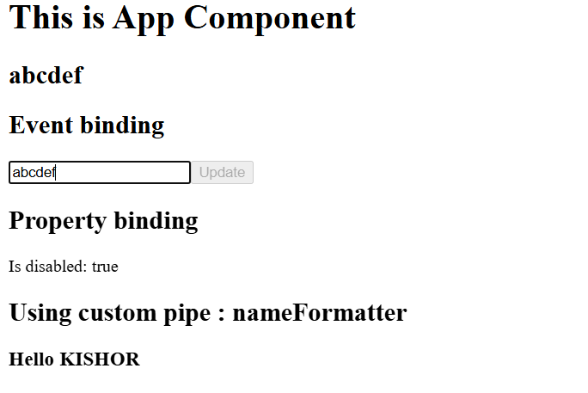
Two way data binding
[(ngModel)]: it shares data from view to component class & vice versa, but it works only if you add FormsModule in the app.module.ts
If you use [(ngModel)] in the html element without importing FormsModule
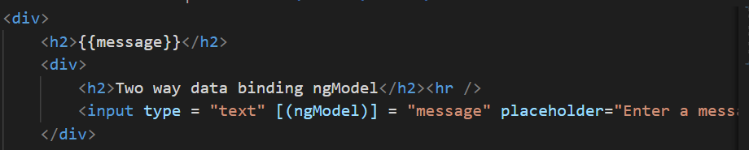
You get below error
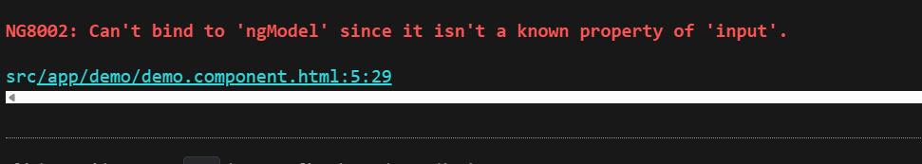
Importing the FormsModule from @angular/forms
app.module.ts
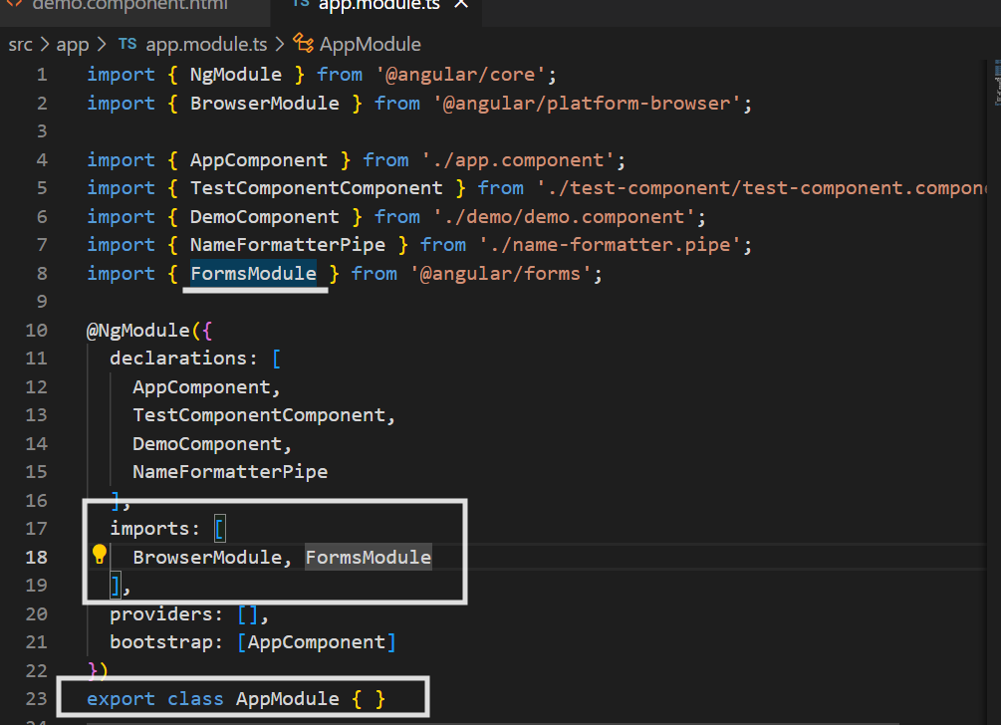
Output:
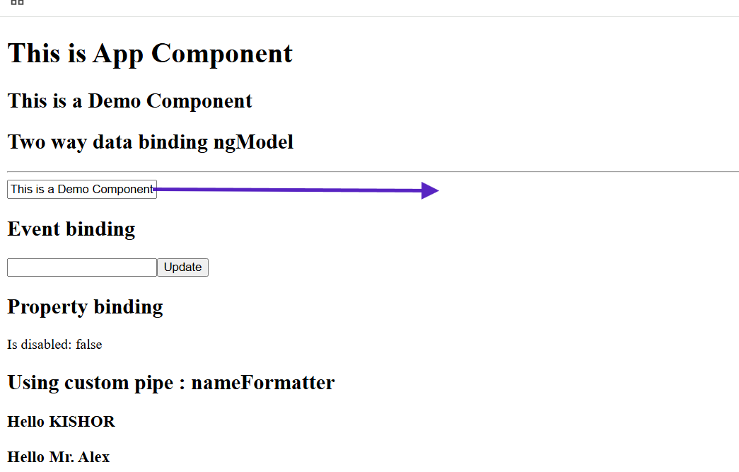
Notice the input box already has the value of message variable

Class & Style binding
Suppose a component has a css style value or a property to add/remove a class then you can use style or class binding
<p [style] = “myStyles”>Hello World</p>
myStyles = { color : blue }
addClass = true / false;
<style>
.text-danger : red;
</style>
<p [class.text-danger] = “addClass”>Hello World </p>
You have a separate css file to specify the classes.
demo.component.css
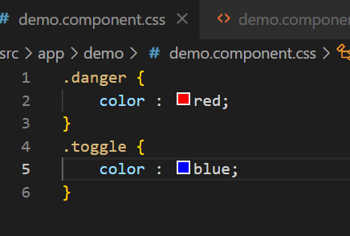
HTML
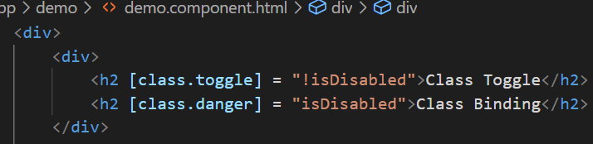
Output:

Since you are using !isDisabled the Class Toggle content adding the style
Style binding
TS
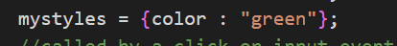
HTML
Output:

Summary:
Created pipes : ng g p pipe-name : logic must be inside a transform() method
Inbuilt pipes : currency, date, uppercase, lowercase
Bindings - interpolation {{ }}, property binding [ ], event binding ( ), two-way data binding [()], class binding [class.className], style binding [style]
Note: class, style binding are part of property binding itself
Directives in Angular
Directives are kind of instructions to the DOM element to have some extra behavior, we have following directives
- Component directive: @Component and you can use <component-name>
- Attribute directive: ngModel, ngStyle, ngClass
- Structural directive: *ngFor, *ngIf, *ngSwitchCase
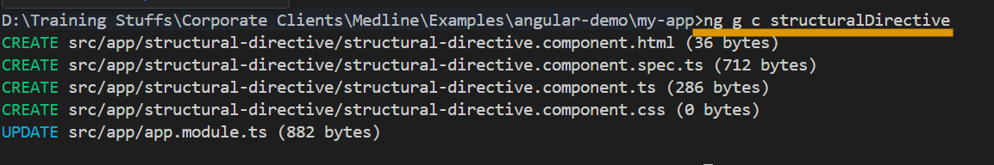

*ngIf: It is a conditional based directive which helps to render the DOM elements when condition is true or condition has a value, undefined properties evaluates to false
<div *ngIf = “username”>
Hello {{username}}
</div>
<div *ngIf = “status”>
</div>
ngSwitch: it is used to apply multiple conditions and render a component or an HTML element when the option is true.
ts
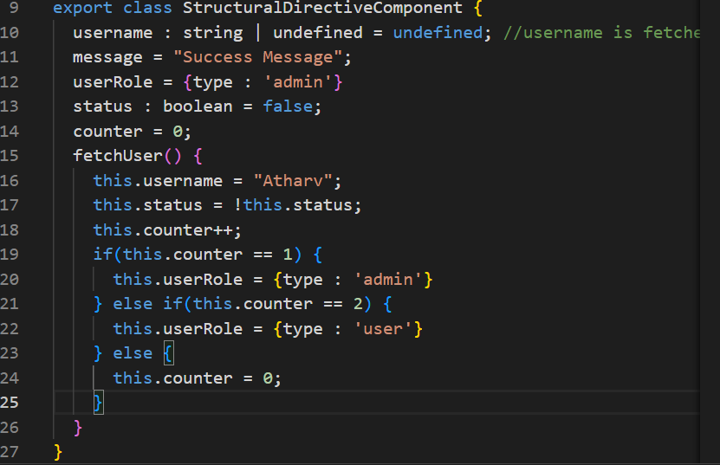
HTML
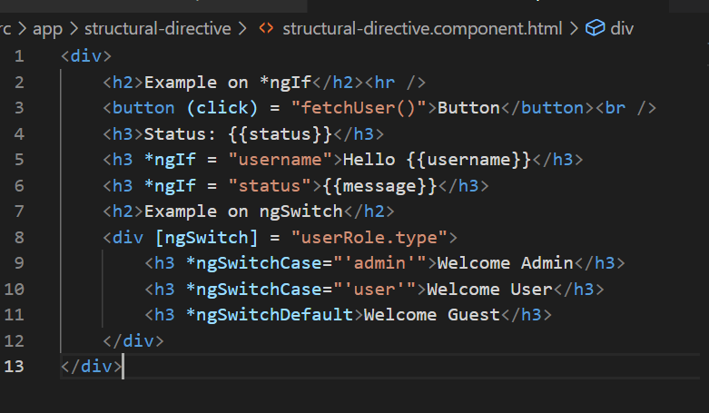
Output:
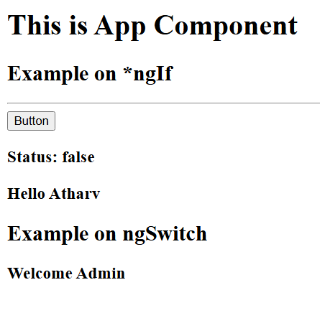

*ngFor: It is used to iterate over the array elements, helps to dynamically create HTML elements
<div *ngFor = “let item of items”>{{item}}</div>
TS
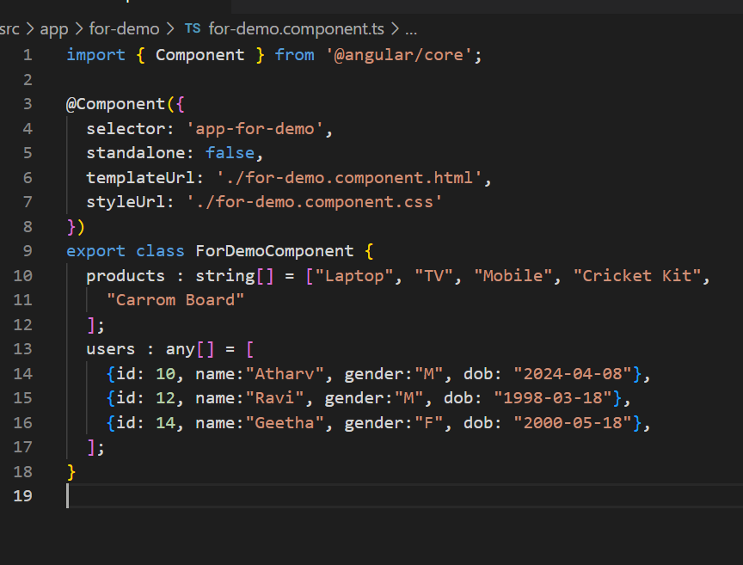
HTML
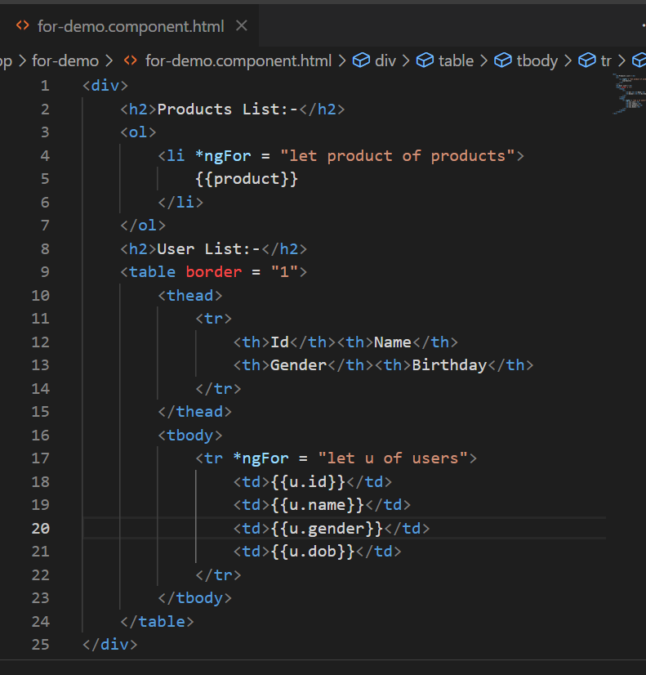
Output
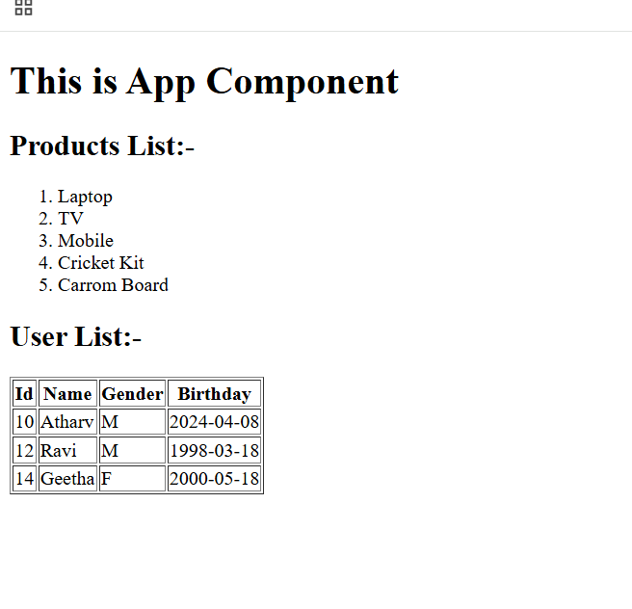
View Encapsulation:
It is to avoid leakage of CSS from a child component to parent or parent to child component, using view encapsulation CSS leakage can be avoided, once you build the application all the CSS will be wrapped into a single css file
By default Angular uses ViewEncapsulation when you apply CSS for each component because of that CSS doesn’t leak to other components, there are 3 types of ViewEncapsulation
- Emulated - default one - that is supported in all the browsers even in legacy browsers
- ShadowDom - each component will have its own CSS with a host element
- None - no view encapsulation done for the styles
TS
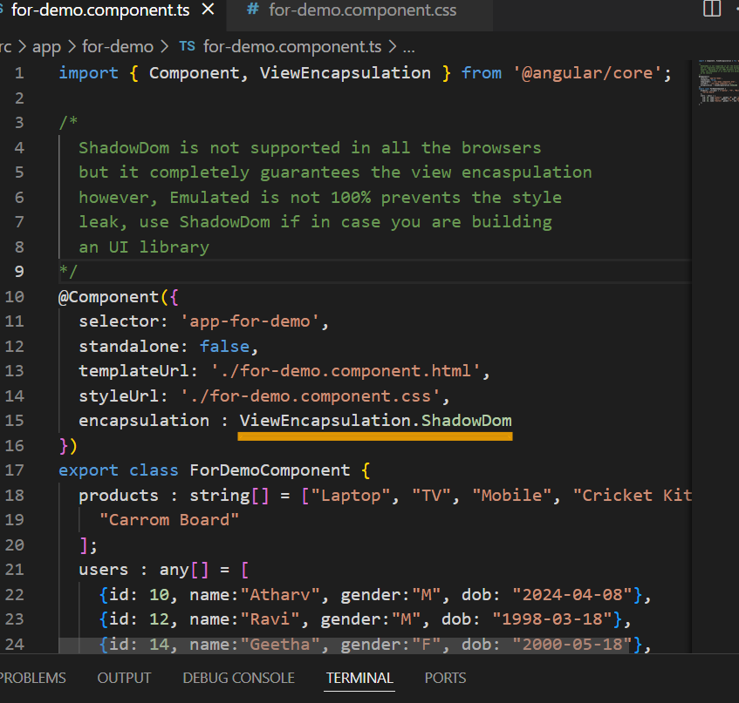
Output:
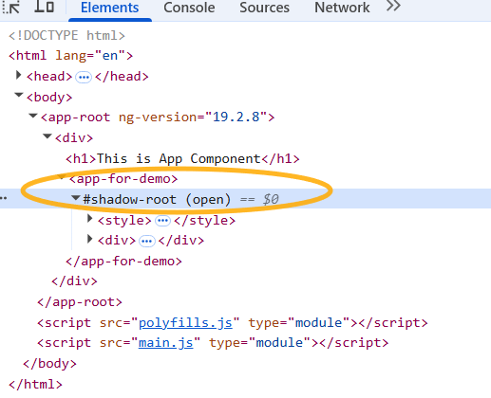

Changing the encapsulation to None i.e, ViewEncapsulation.None will leak the styles from app-for-demo to app-root
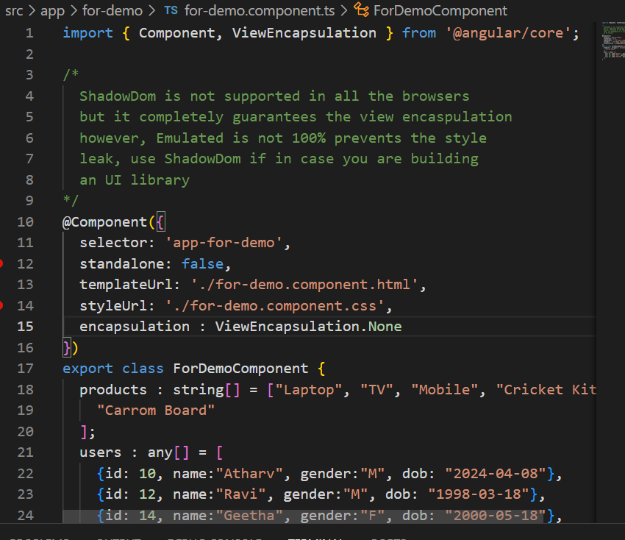
Output:
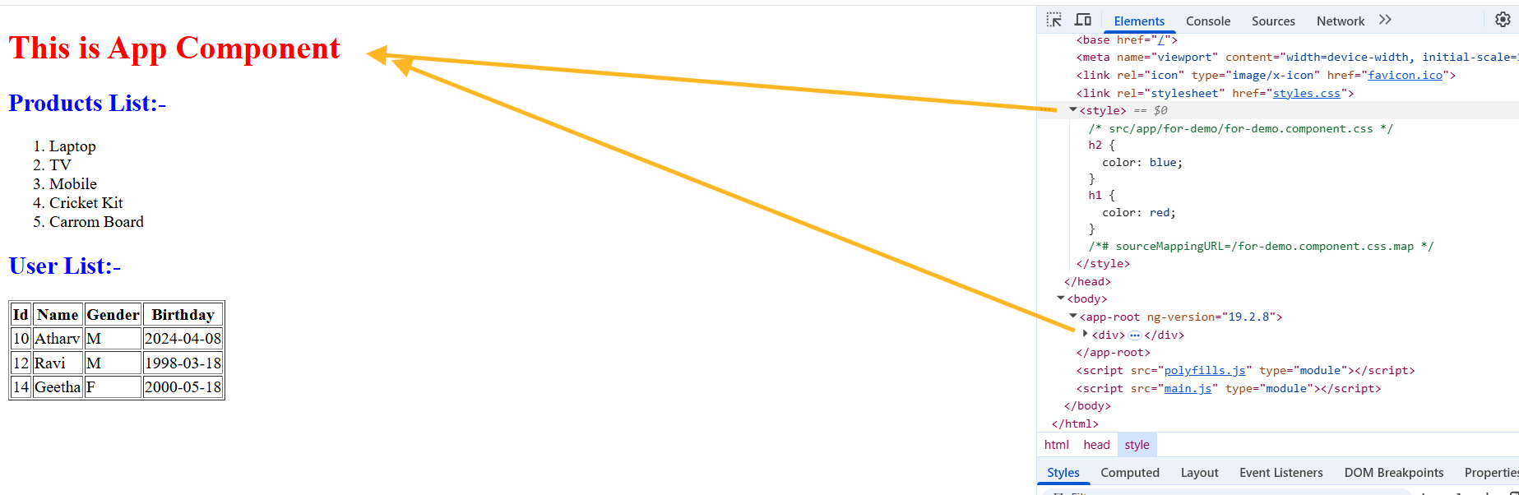
Notice the h1 color is red which is defined in the for-demo component,
Pure & Impure pipes
By default pipe is pure, however you can use pure: false to create an impure pipes
Change detection:
it is one of the mechanism angular uses to sync the result based on the changes happening in the code, it runs when the component is updated & also when the view is updated i.e., twice to keep the things in sync.
For Pure pipes the change detection runs only once when the component data is updated, but for impure pipes it runs for both the updates (component & view)
Impure Pipes: the transform() function called even if some other data of a component is updated, & its called twice
Pure pipes: the transform() function is called only if the data that is transforming is updated, however it is called only on the first phase (component updates) & in second phase (view updates) it is not called

Pipe
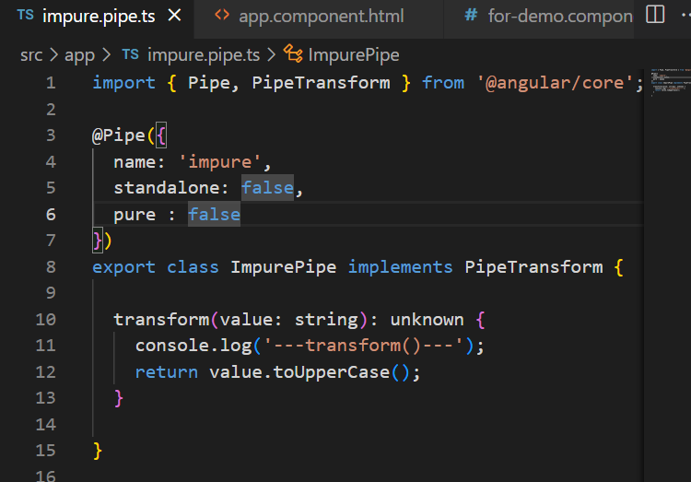
component
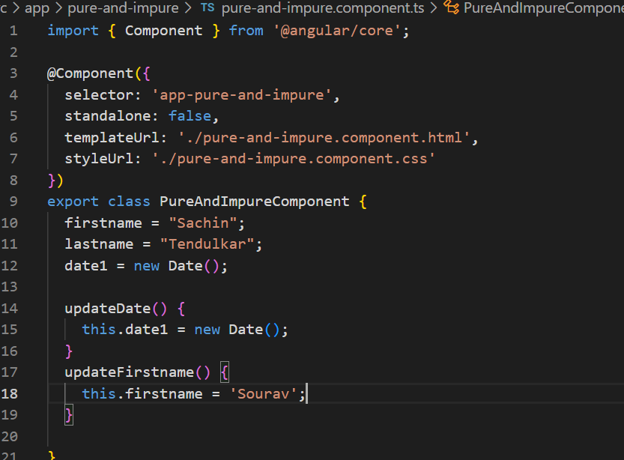
HTML
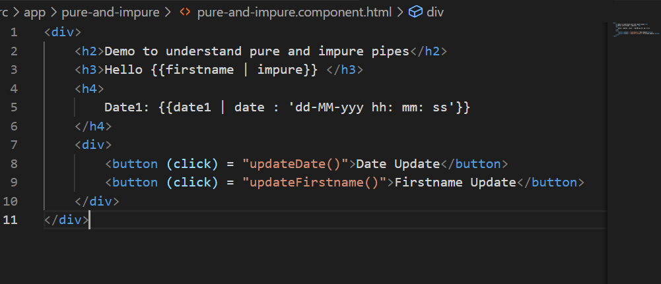
Output:
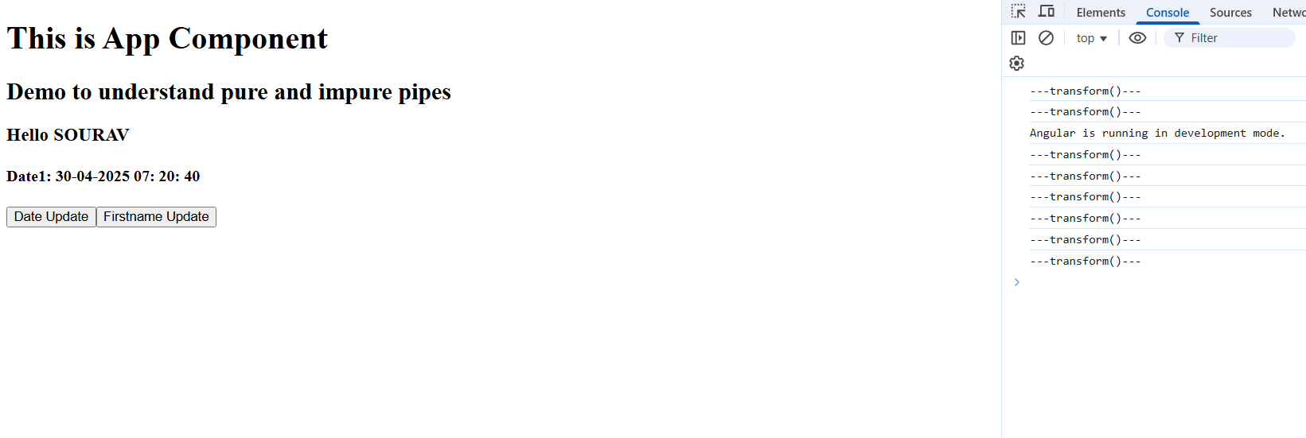
Notice the transform() getting called twice by the change detection for impure pipes
Note: using impure pipes can impact the performance hence you must use it carefully
Note: By default pipes are pure
Pipe precedence
| will not always have a higher priority, you must know the pipe precedence to understand whether the transform is applied correctly or not, else you get an unexpected output.
{{ 10 > 5 ? ‘hello world’ : ‘thank you’ | uppercase}}
This will give an unexpected output because pipe is always applied on thank you not on hello world
You must wrap the entire expression on which you want to apply pipe
i.e.,
{{ (10 > 5 ? “hello world” : “thank you”) | uppercase }}
Precedence without wrapping condition in ()
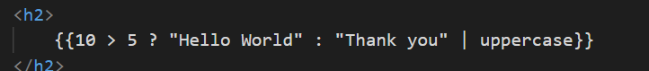
Output:

Precedence that works properly when condition is wrapped in ()
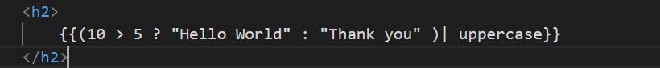
Output:


Custom Directives
When you want to create your own directive and use it in your app which must do some job on the Dom
To generate directive you must use
ng g d directive-name
Note: The directive will be auto-declared in the NgModule of app.module.ts
Generating the directive
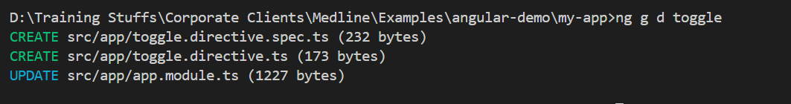
toggle.directive.ts
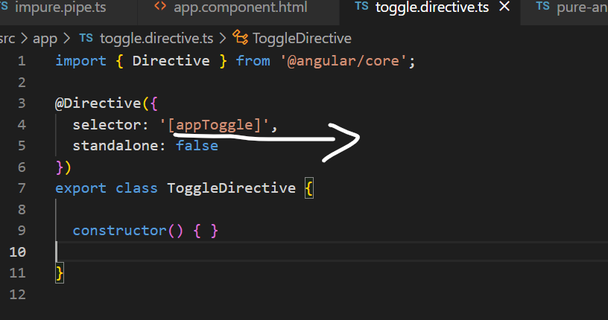
you can use that selector in any HTML element and automatically perform some Operations based on the events.
ex: <button appToggle>Button</button>
You can change this name to ClickMe or any other names when any event occurs on this button.
<video appVideo>
<source src = “…” />
</video>
Now when you place mouse you want to auto-play the video & pause when you move out the mouse
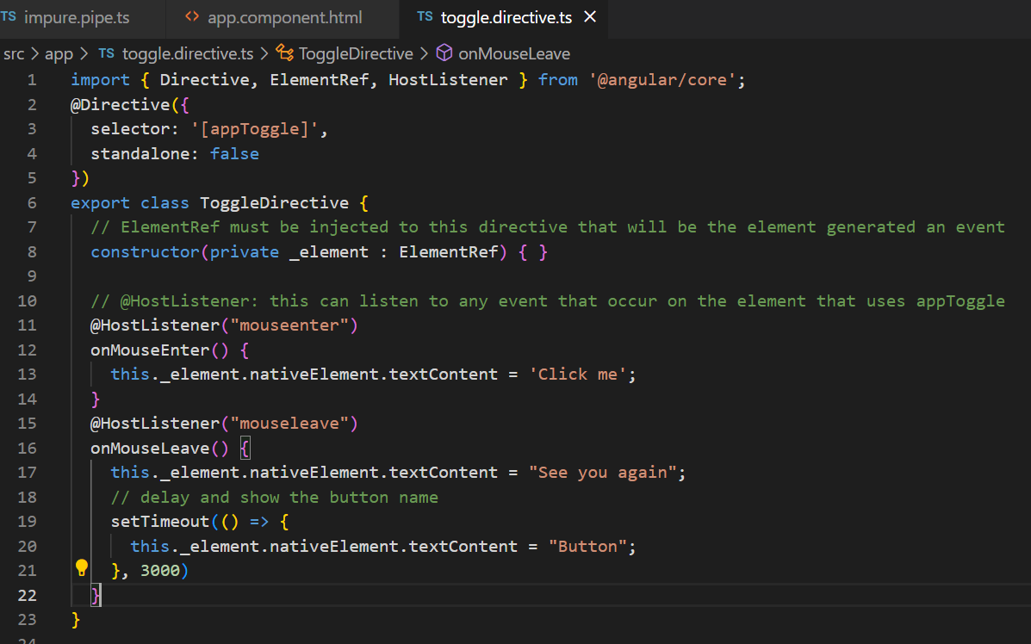
app.component.html
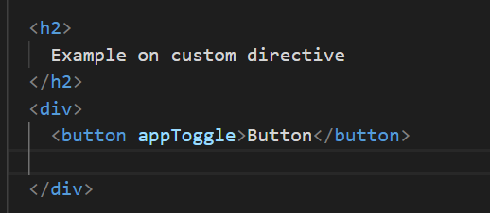
Output:
Button changes to click me when placed mouse on it
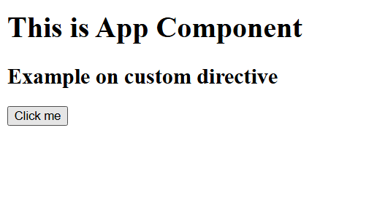
Toggle video play & pause
app.component.html
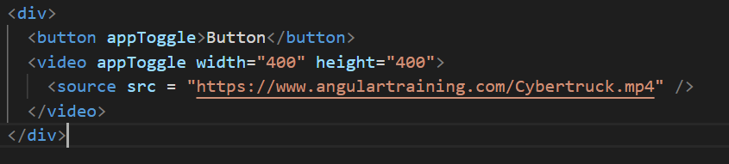
toggle.directive.ts
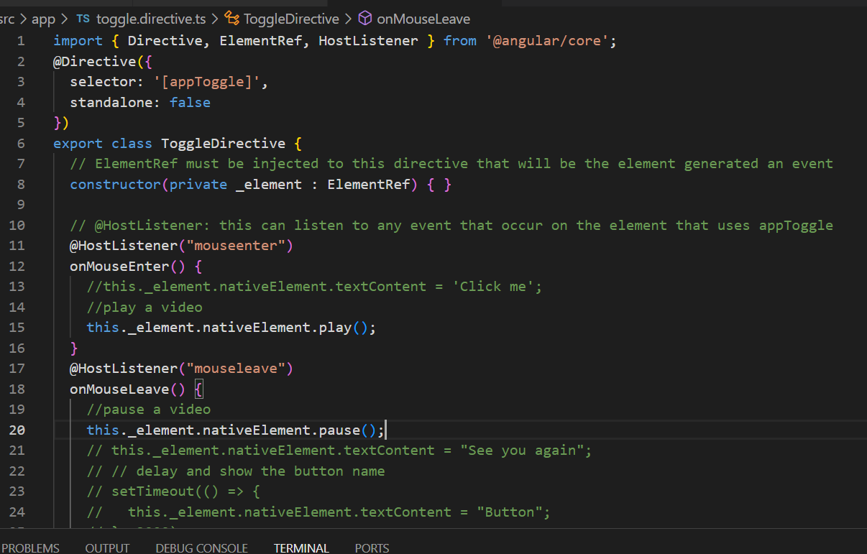
Once you place mouse over a video it plays & pauses when you leave the video
How to configure 3rd party styles in angular
Important Note: Always download the libraries and add the path in the angular.json file, don’t use CDN link, if you add the path in angular.json the downloaded library also built as a part of build file when you build the application
How to install bootstrap.css
npm install bootstrap --save
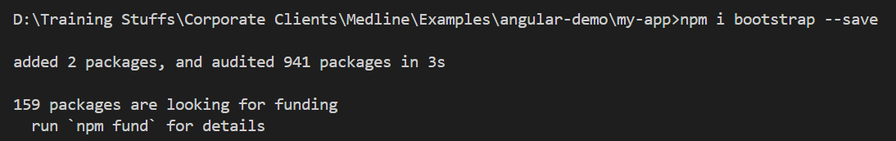
update styles.css
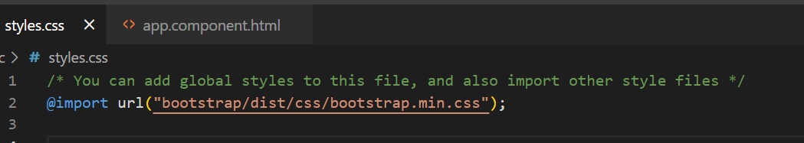
@Input & @Output decorator
These are used to share the data between the components from parent to child & vice versa
@Input(): This is used written in the child component to read the values from the parent component
Parent component must use the child component selector and pass the value using property binding syntax
parent.component.ts:
item = “laptop”;
parent.component.html
<child [itemName] = “item”></child>
child.component.ts
@Input()
itemName = “”;
app.component.html
<app-parent></app-parent>
Example:
ng g c parent
ng g c child
app.component.html
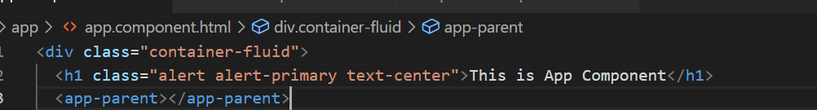
parent.component.html
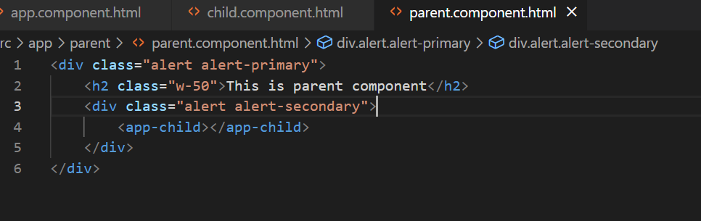
Final code to share the data between parent to child
child.component.ts
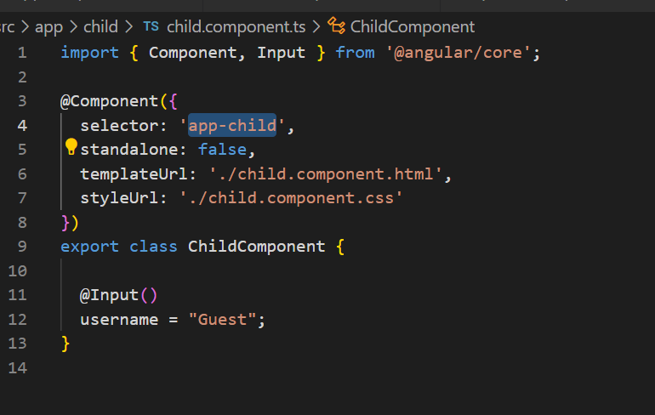
child.component.html
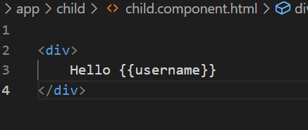
parent.component.ts
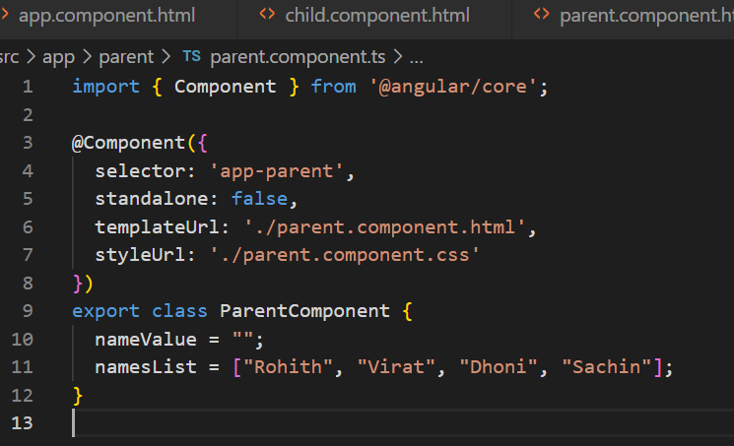
parent.component.html
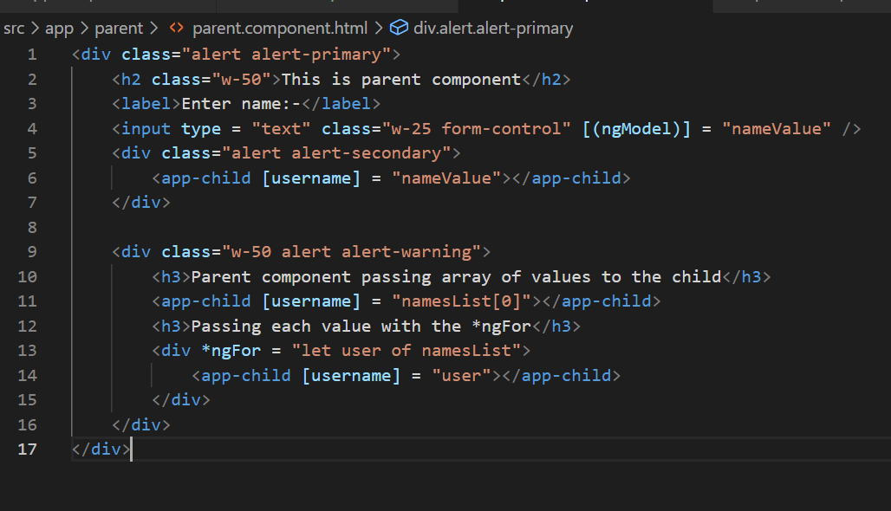
Output:
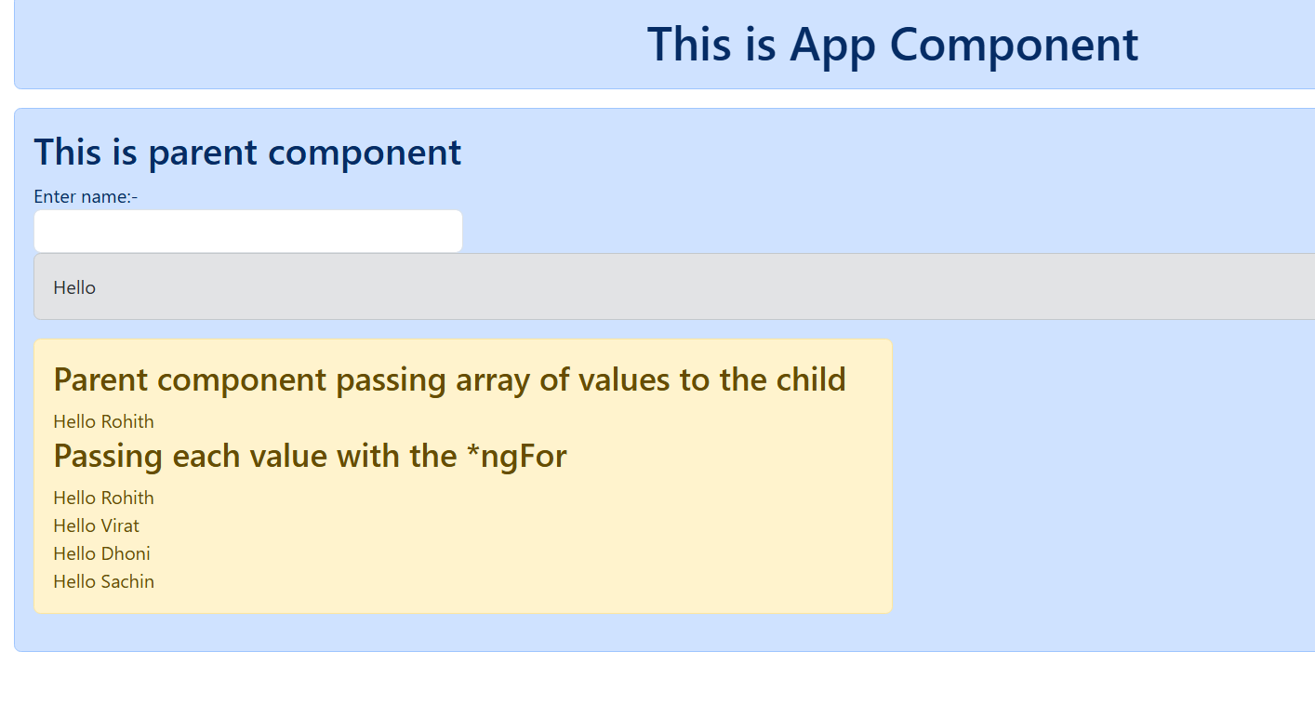
Customization we can do for the @Input() decorator
@Input({required = true}): parent component must pass data to the child component
username : string = “Guest”;
parent.component.html
<app-child></app-child> <!-- error -->
<app-child [username] = “nameValue”></app-child> <!-- works fine -->
transform: This is used to transform the value you are passing to the property having @Input()
you must create a function that is outside the component & use it in the @Input(transform: fun_name)

child.component.ts
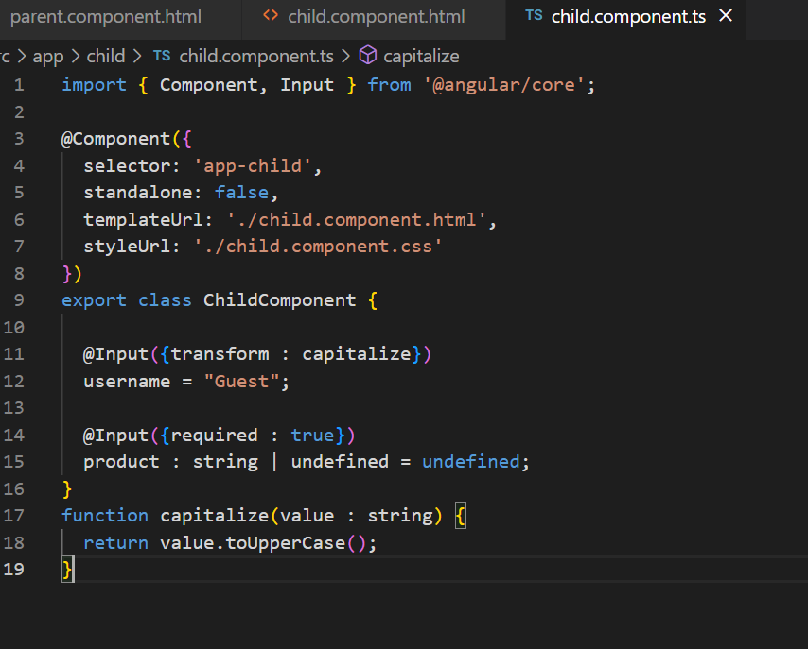
child.component.html
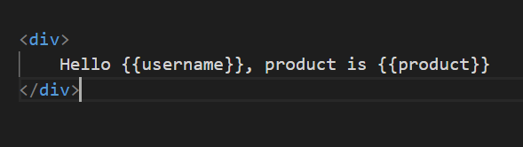
parent.component.html
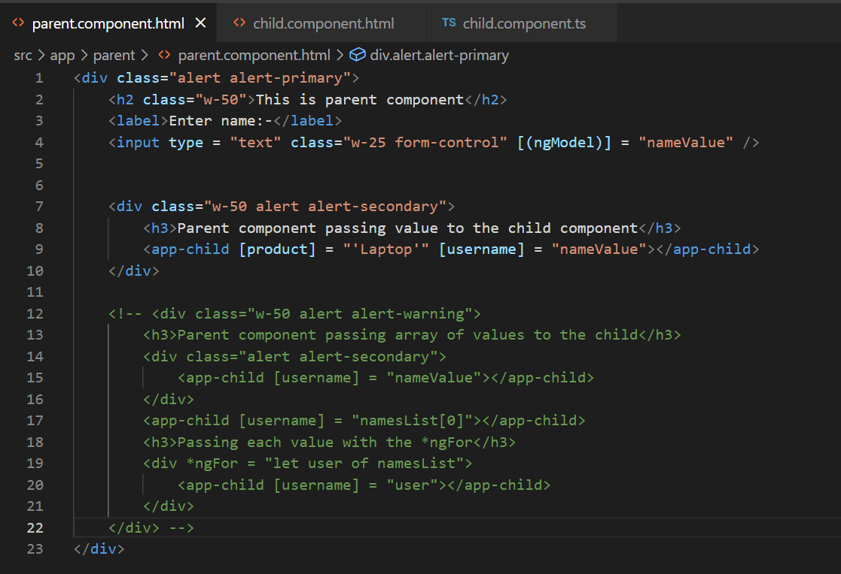
Output:
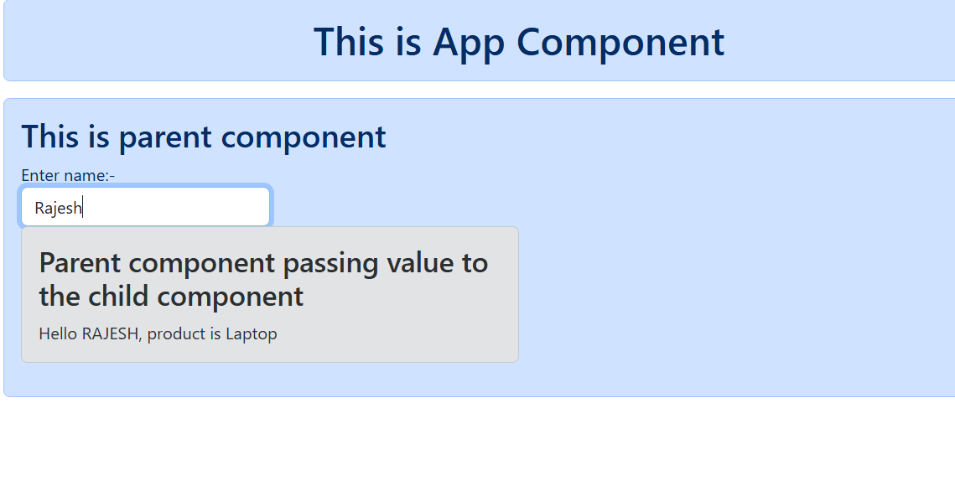
@Output()
It is used to share the data from child to parent component, here the child component must emit the data using EventEmitter object and $event is the variable that stores the emitted data which you can assign to the parent component.
child.component.ts
@Output()
numberEmitter : EventEmitter<number> = new EventEmitter<number>();
handleClick() {
this.numberEmitter.emit(250);
}
parent.component.ts
childValue : number = 0;
handleData(value : number) { }
parent.component.html
<app-child (numberEmitter) = “childValue = $event”></app-child>
or
<app-child (numberEmitter) = “handleData($event)” />

Create 2 components
ng g c parentTwo
ng g c childTwo
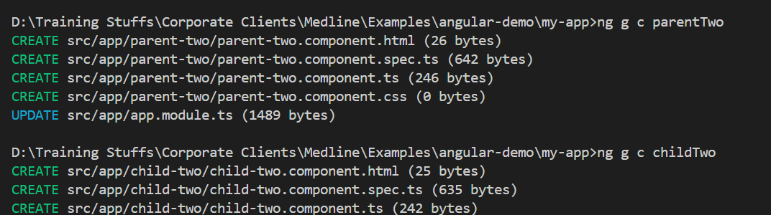
Add the parentTwo in the app.component.html
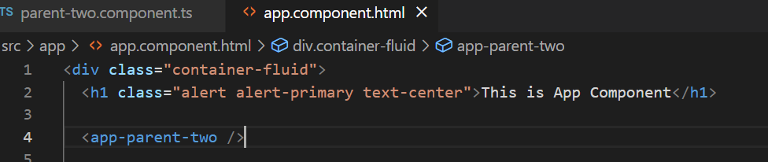
Steps to perform
- In the child component ts file create an EventEmitter that emits some counter
- In the child component html file call the function to emit the value
- In the parent component ts file create a variable that gets the value from the child component
- In the parent component html file use (event) binding syntax that triggers when event emitter emits the value
child-two-component.ts
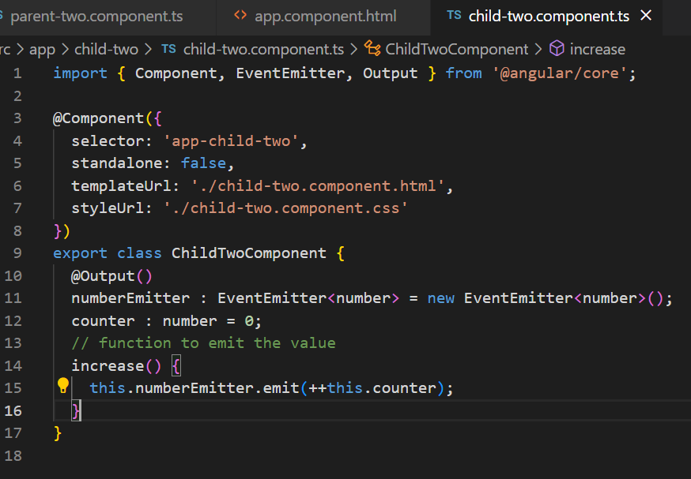
child-two.component.html
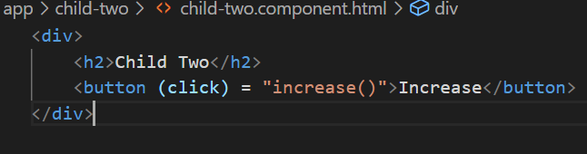
parent.component.ts
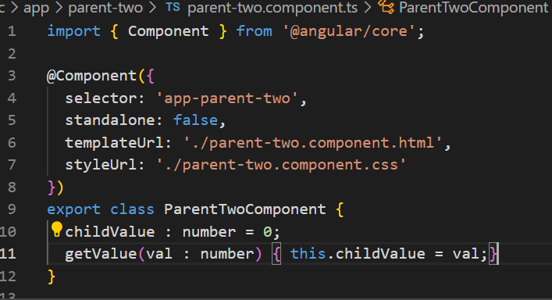parent-two.component.html
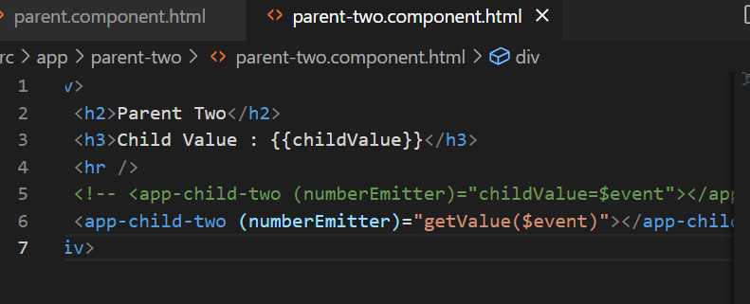
Output:
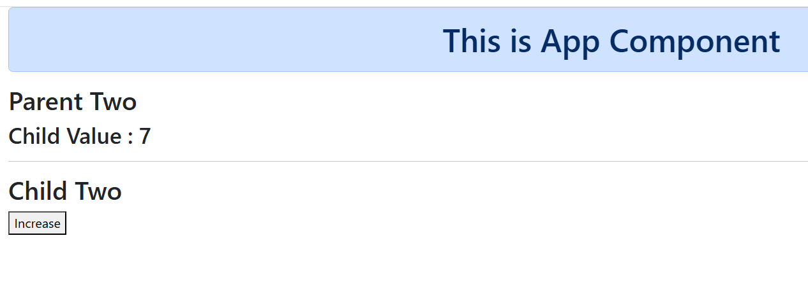
Content Projection
It enables the insertion or projection of HTML content from a parent component to the child component template.
<ng-content> is the placeholder that can render the projected content.
child.component.html (app-child)
<ng-content></ng-content>
parent.component.html(app-parent)
<app-child>
<h2>Some Title</h2>
</app-child>
Now the content of <h2> is passed to the <ng-content> of child component
parent2.component.html(app-parent2)
<app-child2>
<h1 text>Some headings</h1>
</app-child2>
<app-child2>
<p desc>Description</p>
</app-child2>
child2.component.html
<ng-content select = [text]></ng-content>
<ng-content select = [desc]></ng-content>
Example
ng g c parent3
ng g c child3
app.component.html
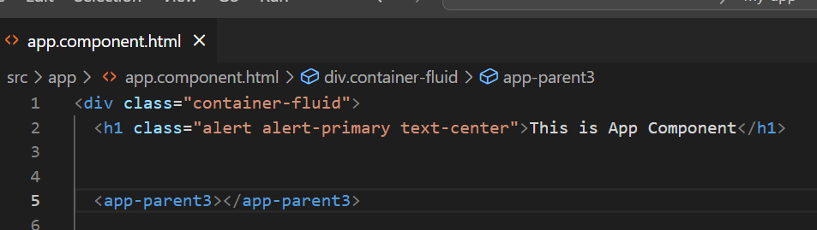
child3.component.html
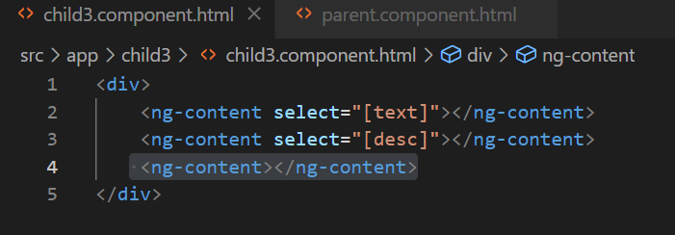
parent3.component.html
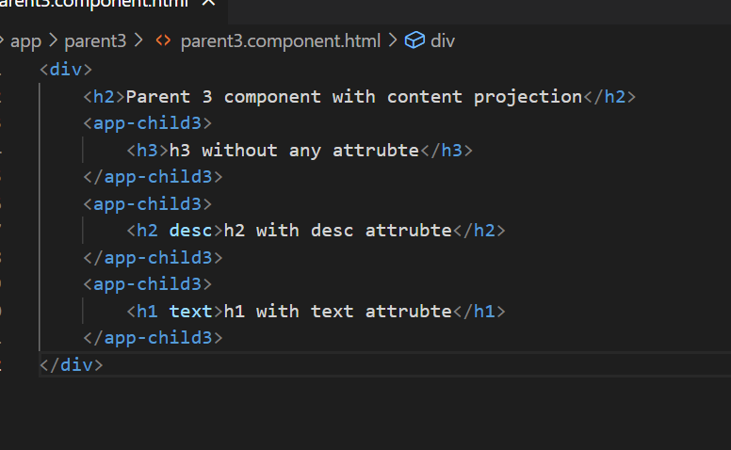
Output:
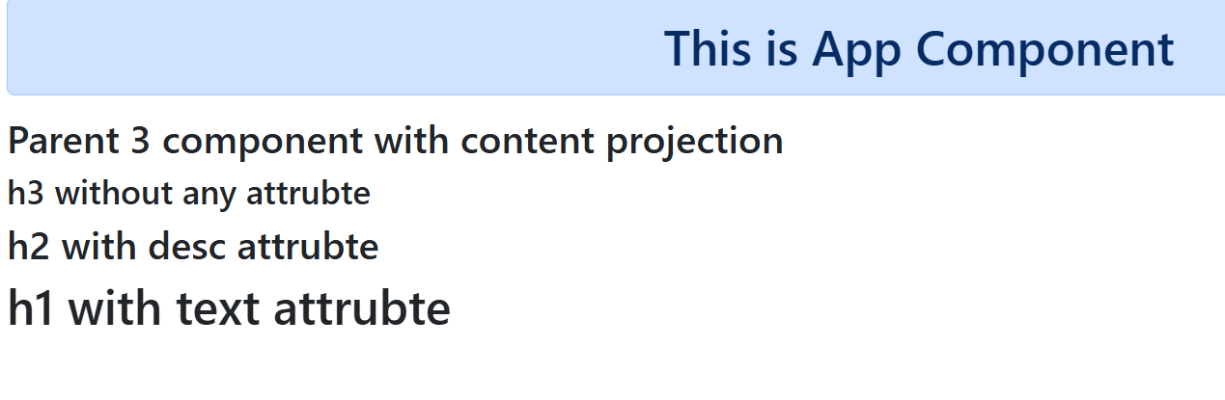
Real time example
- Questions
  - Option 1
  - Option 2
  - Option 3
  - Option 4
Component Life Cycle Hook
These are sequence of steps that happen between the components creation & its destruction, in angular we must implement the interfaces that have the life cycle methods which are automatically called by the angular
Note: Understand the life cycle methods sequence & the utilize it in your project
List of life cycle hooks
Interface | Methods | Summary
OnInit | ngOnInit() | Called once the component is constructed, after constructor()
OnChanges | ngOnChanges(SimpleChange) | Called when @Input() property changes, you can get its previous & current value
OnDestroy | ngOnDestroy() | Called when component is destroyed
DoCheck | ngDoCheck() | Called every time the component is checked by the change detection
There are other methods which are related to the updates in the components or view
- ngAfterContentInit - called when the content is initialized
- ngAfterContentChecked - Runs every time the component content has been checked for the changes
- ngAfterViewInit - runs after the component view is initialized
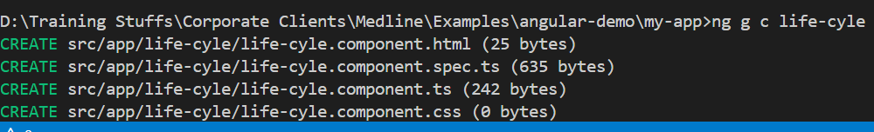
Add this to the root component
app.component.html
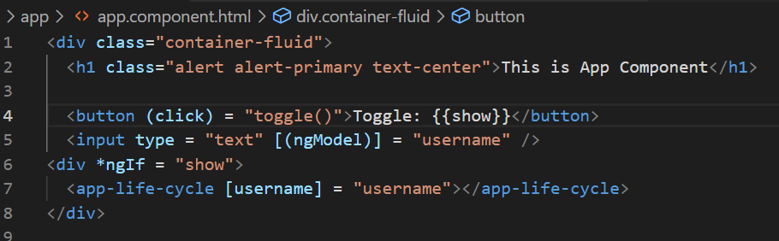
app.component.ts
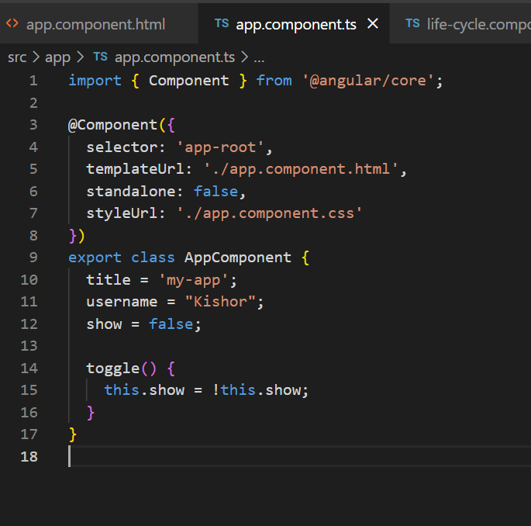
life-cycle.component.ts
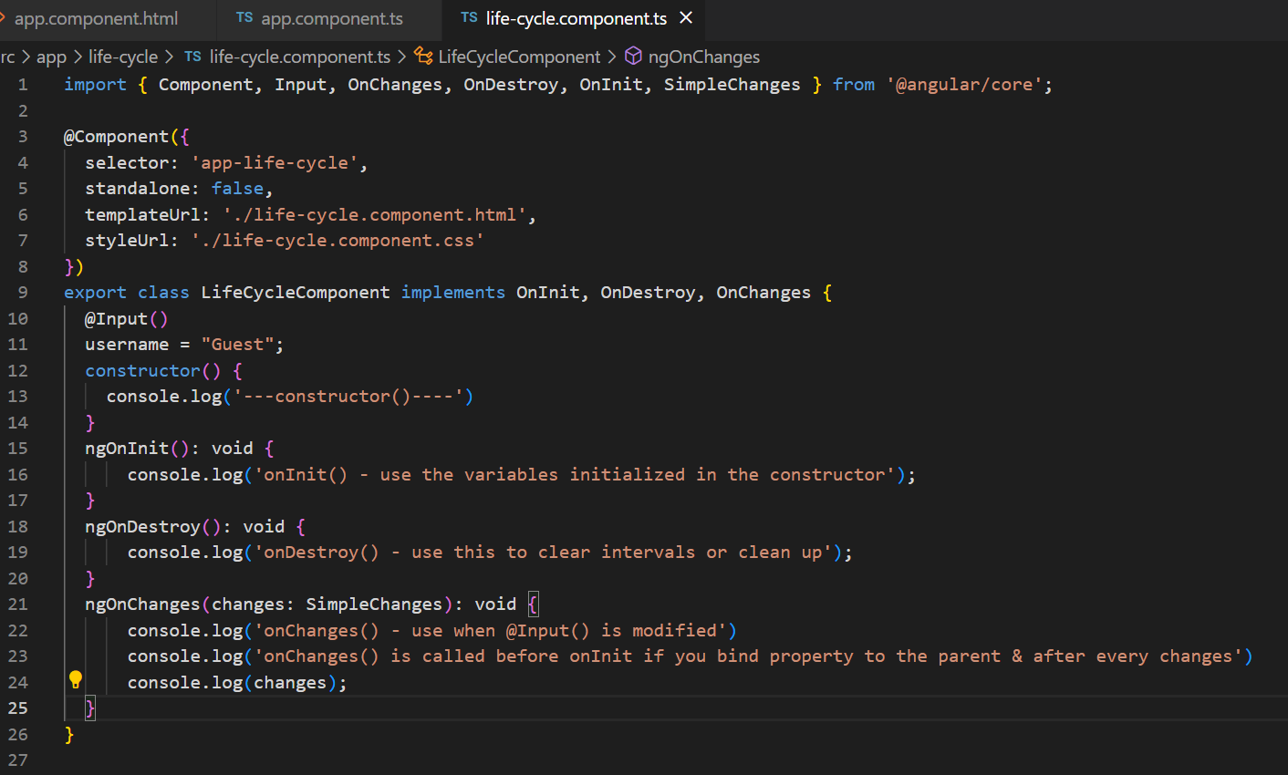
Output:
ngOnChanges() is called before ngOnInit() if @Input is used
ngOnChanges() is called on each change in the @Input()
destroy() is called when the component is removed.

Angular Forms & Validations
- Template Driven Forms - you handle form control data & validations in HTML with the help of two way data-binding - [(ngModel)]
- Model Driven Forms - you handle form data & validations in the component class - ReactiveForms

tdf-demo.component.ts
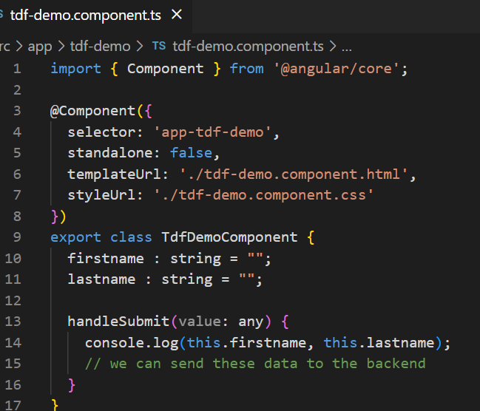
tdf-demo.component.html
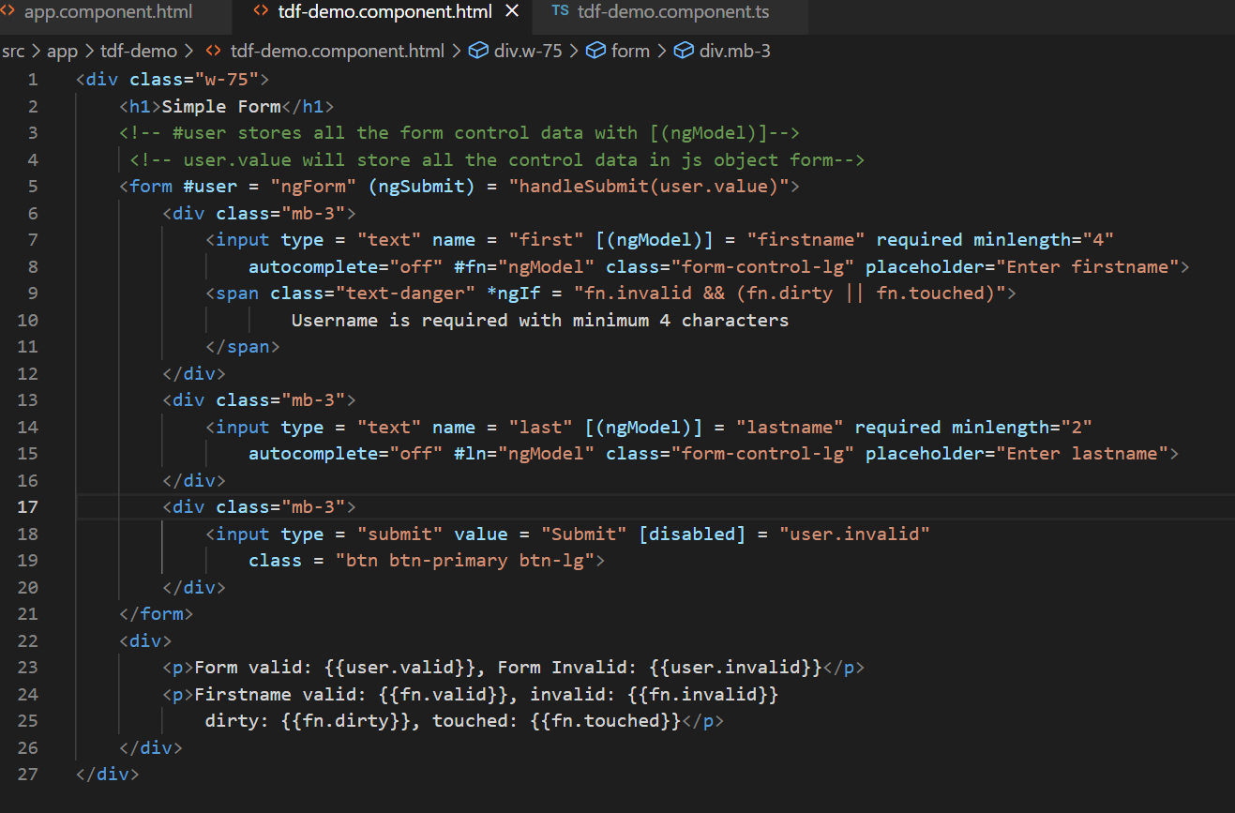
Output:
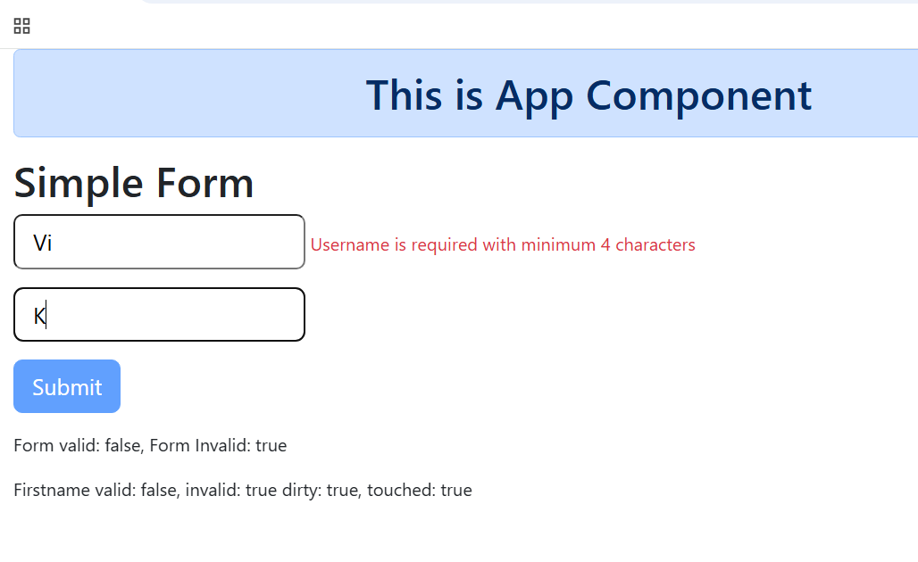

Model Driven Form or Reactive Form
Here the form control data will be entirely handled in the typescript code, even you can create validator’s in the typescript code, this makes the form more dynamic in nature compare to template driven
ex: you want to pop up some fields while entering values to some other field this needs control of forms within the code
Note: ReactiveFormsModule must be imported in NgModule, to use the ModelDrivenForm
Note: For TemplateDrivenForm you must import FormsModule

app.module.ts
import { FormsModule, ReactiveFormsModule } from '@angular/forms';

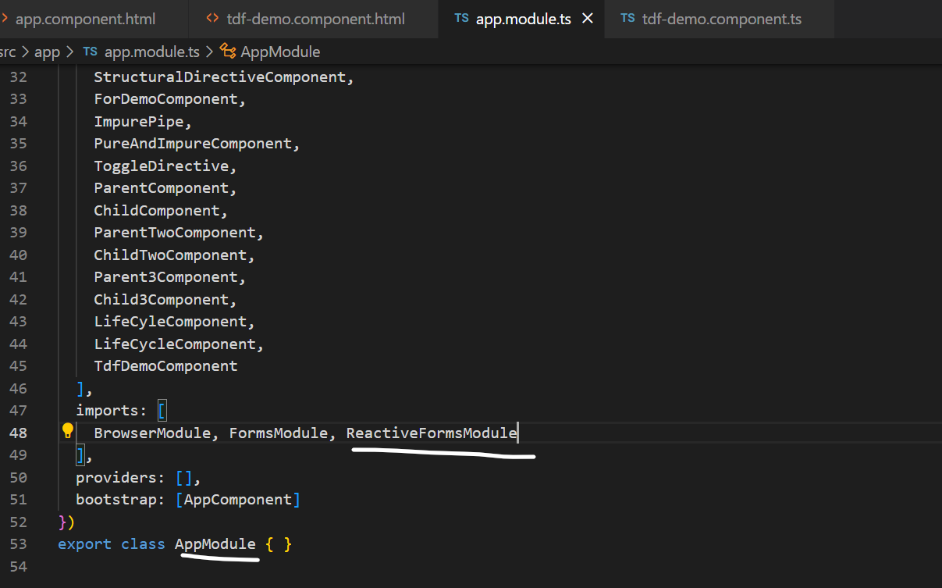
Generate the component mdf-demo
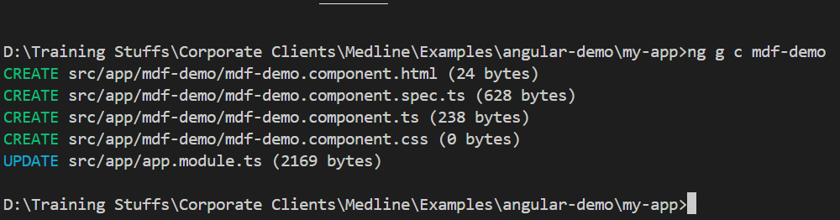
FormBuilder: It is one of the service that helps you to create from-controls in an easier way, you must use this object with the help of inject(FormBuilder)
builder = inject(FormBuilder);
mdf-demo.component.ts
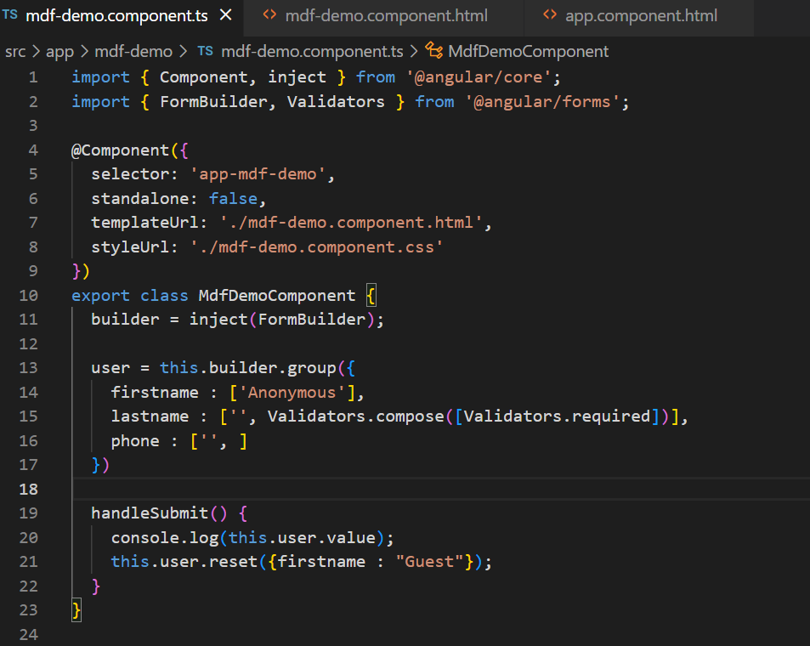
mdf-demo.component.html
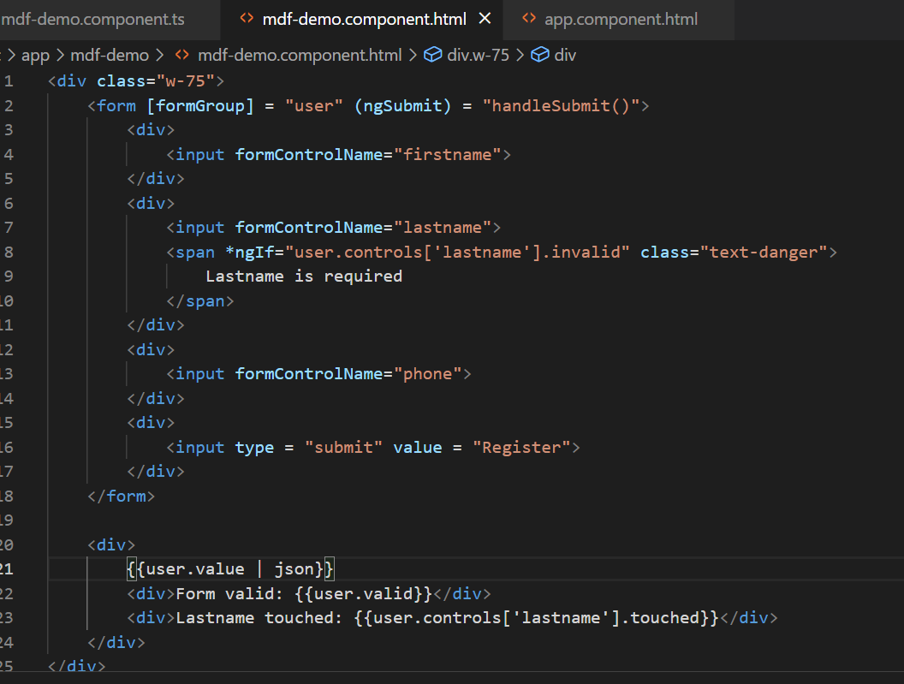
Output:
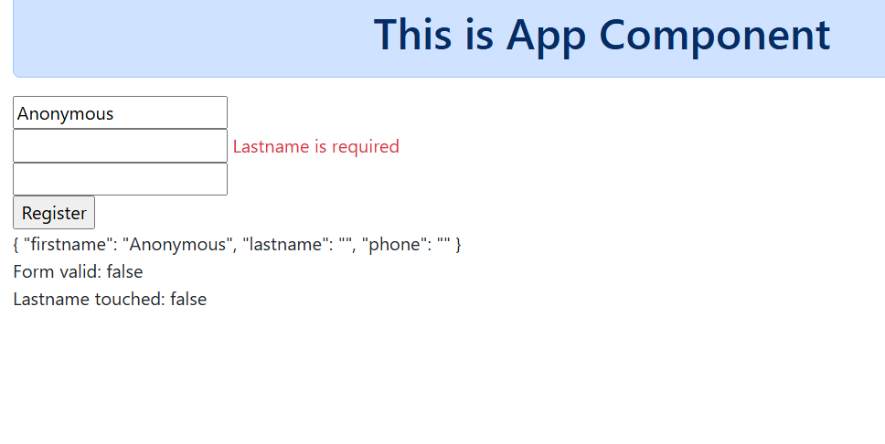
Angular Dependency Injection(DI) & IOC
IoC (Inversion of Control): Object creating & managing is taken care by the framework, IOC is a container to maintain the objects and these objects are delivered to other object which need them, this process of delivering an object to another object is called as Dependency Injection
Angular use different types of Injector system
- Root injector - injecting the object that is available throughout the application
- Component injector
- Module injector
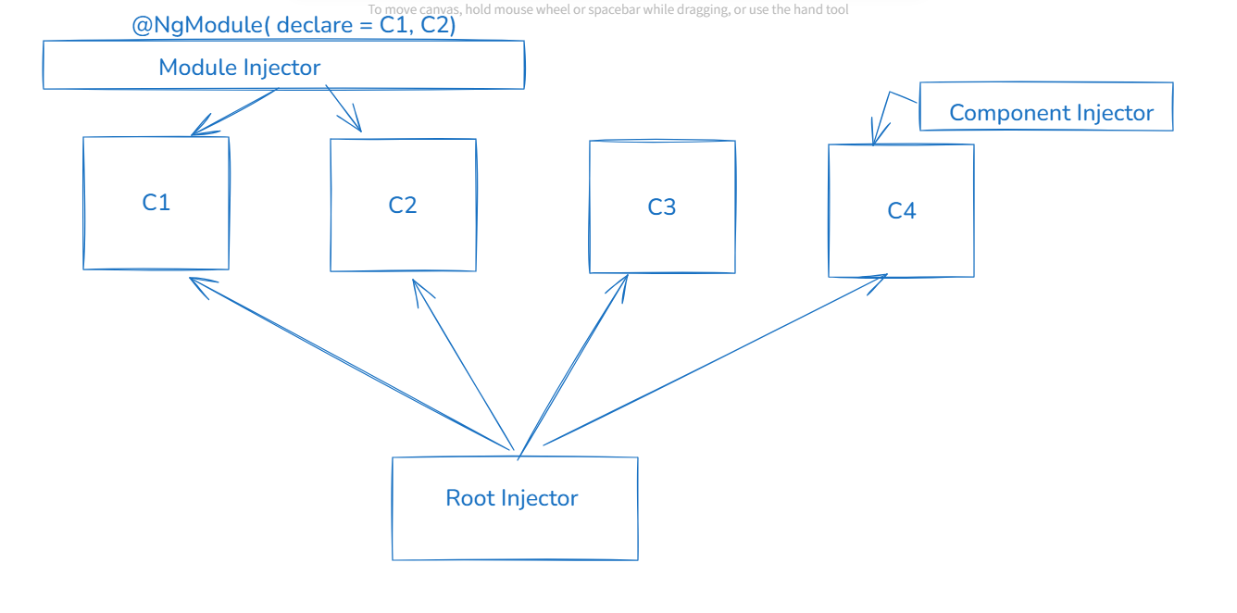
All these systems use same kind of DI providers, below are some of the providers angular use
@Injectable({
providedIn : ‘root’ // UserService is available throughout the application
})
class UserService { …. }
@Component({
})
class UserComponent {
service = inject(UserService); // UserService is supplied to the UserComponent
}
Angular Service: These are reusable classes which can have the logics that are not part of the components (view related logics, form handling logics)
You can use Angular Service to write logics like accessing the backend or logging
Angular provides a command to generate the service class
i.e., ng generate service service-name [or] ng g s service-name
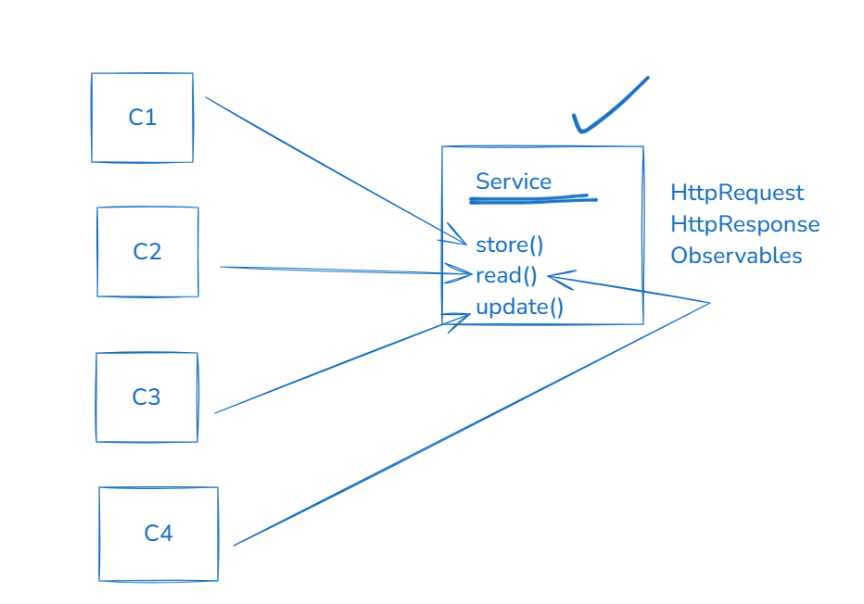
Create a DI scenario for UserListComponent that will access the UserService which will have Observables that can emit some fake user data, UserListComponent must subscribe to get those data & unsubscribe to stop getting the data from observable
Steps
- user.ts: store some fake user objects in an array and export it & also create a User type so that Observables can emit that type of data
ex: export const USERS = [ {….}, {…}, {…} ]
- UserService: create a method that will have Observables & emit the user from the above array, emit the value for every 1s using setInterval or interval method of rxjs
- UserListComponent: subscribe to the Observables and unsubscribe to stop getting the values

user-mock.ts
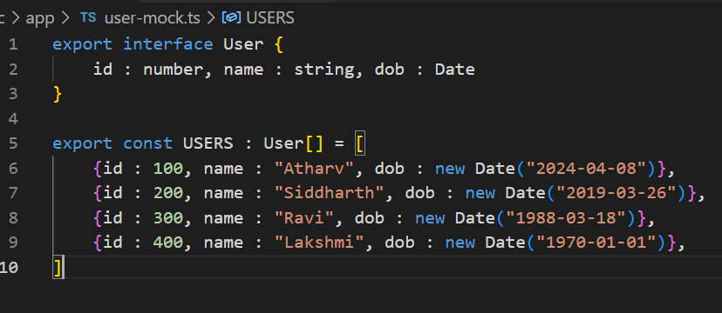
Generate the service class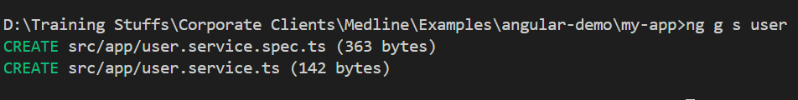

user.service.ts
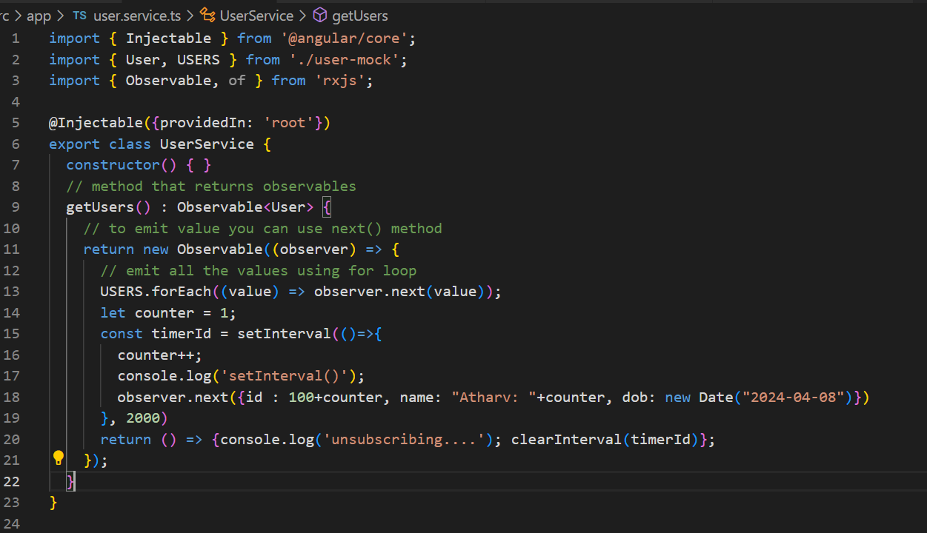
user-list.component.ts
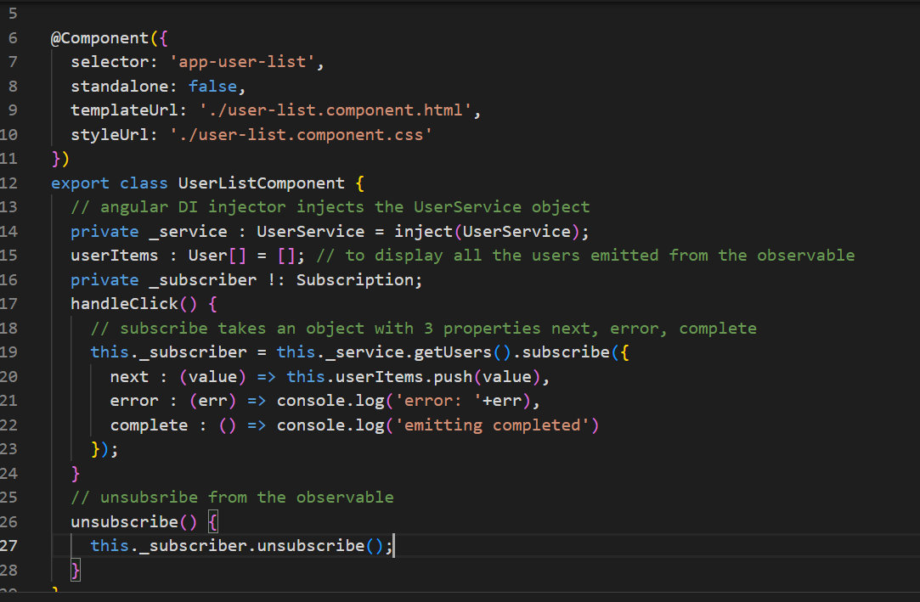
user-list.component.html
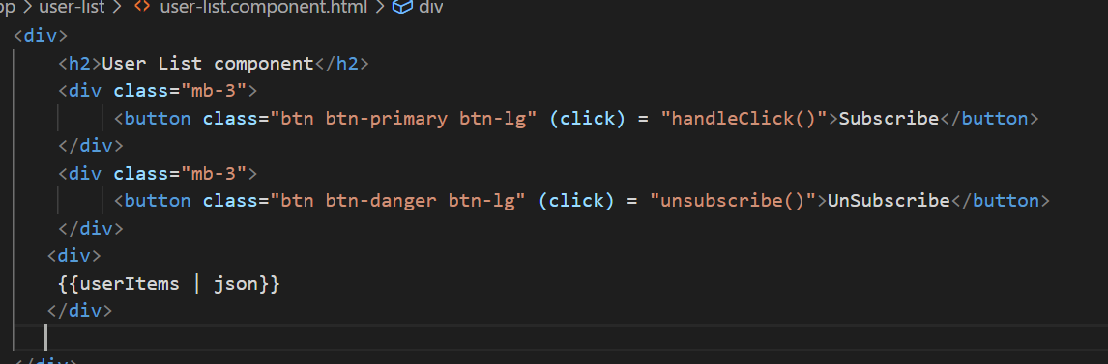
Output:
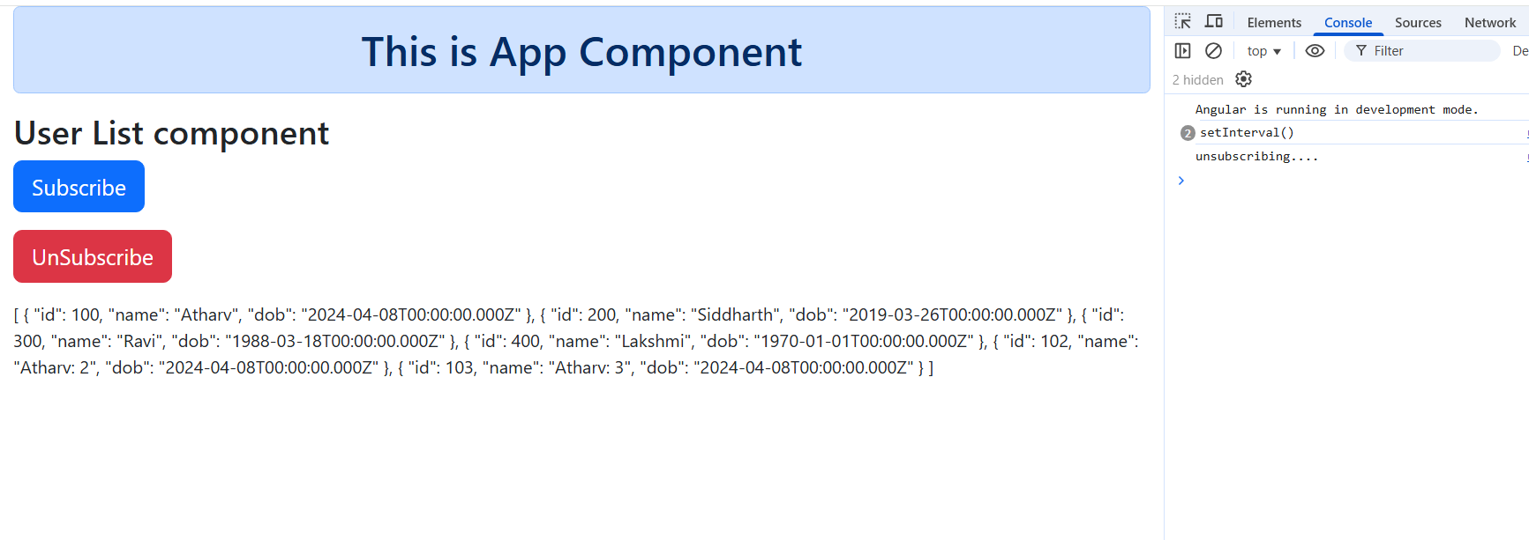
Promises
Promise can perform asynchronous operations just like Observables but it completes once it gets the values, you can make use this async/await as well in case of promises
Note: we can use promises and observables together, and also you can use Promises inside the observables if you want to achieve async/await mechanism
user.service.ts
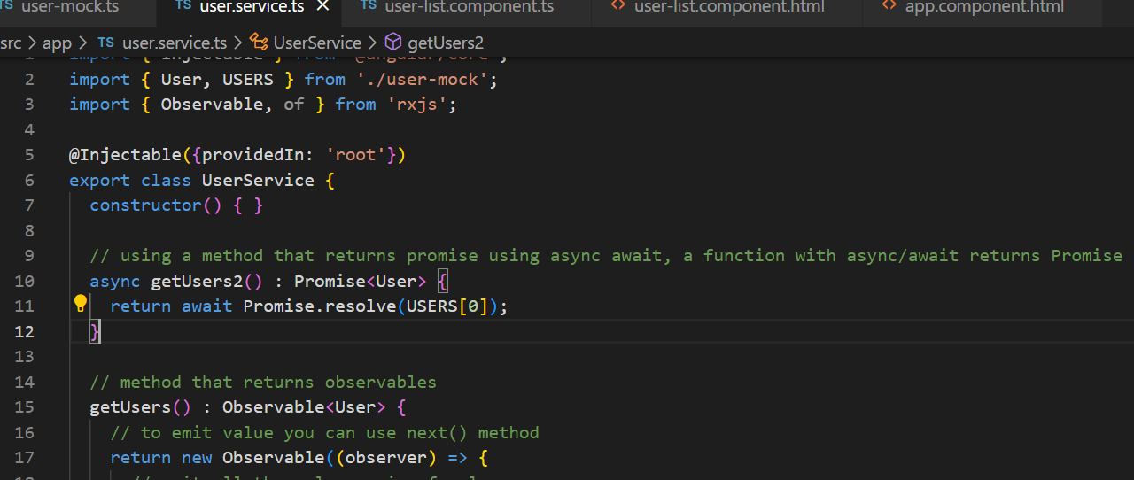
user-list.component.ts

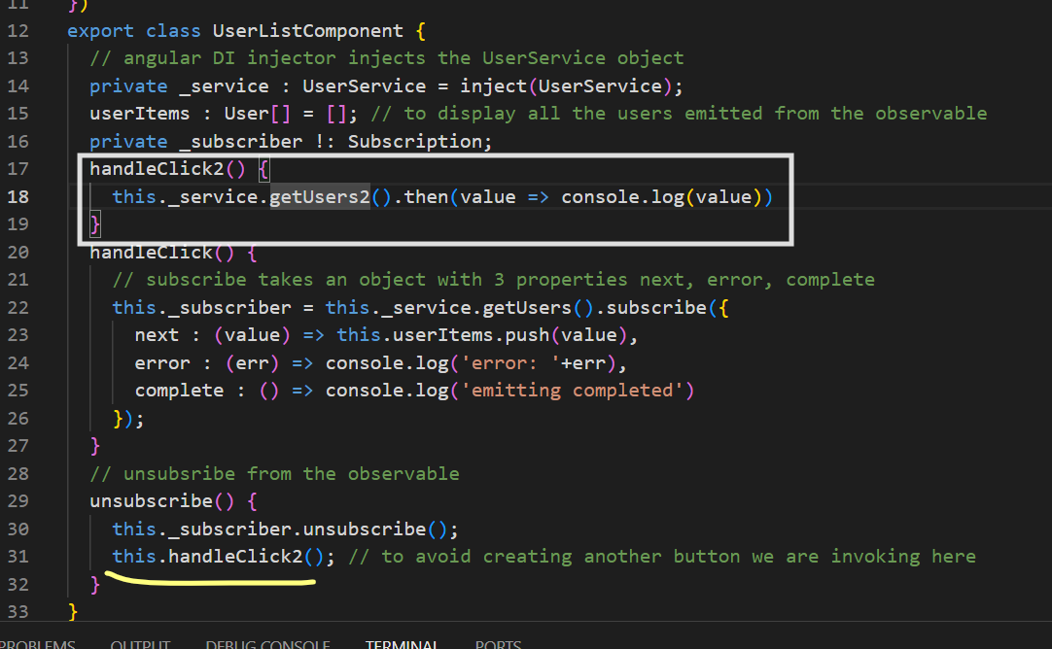
HTML storage objects can be used in angular
- localStorage: Will be available even after the browser is closed
- sessionStorage: Will be available till you close the browser or clear using program
Both object has common methods to store, remove or read
- setItem(key, value): // value must be always string, if JS object convert to JSON
- getItem(key); // returns a string
- removeItem(key); // removes the key & value
Scenario: Create a todo list that adds a task & retrieves the task from the session or local storage
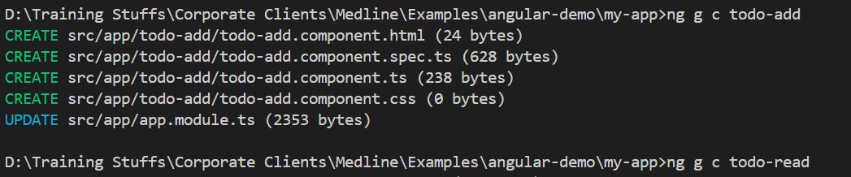
Generate a service that maintains the todo tasks in the storage
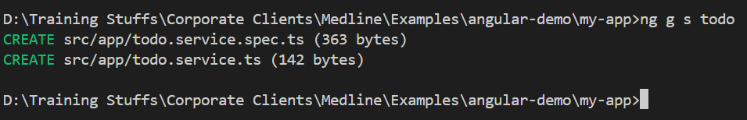
Add the add and read todo components in the root component
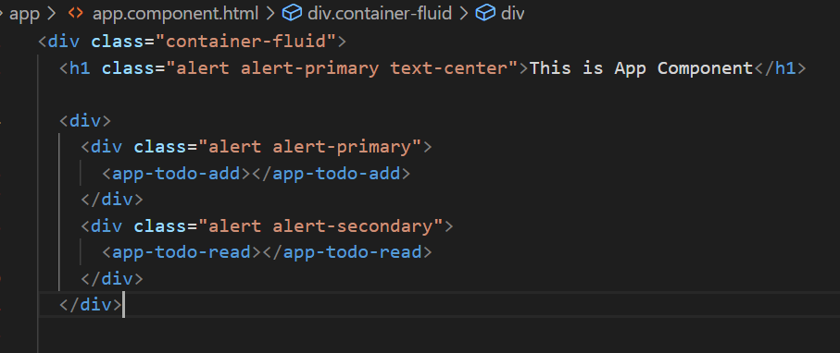
Requirement
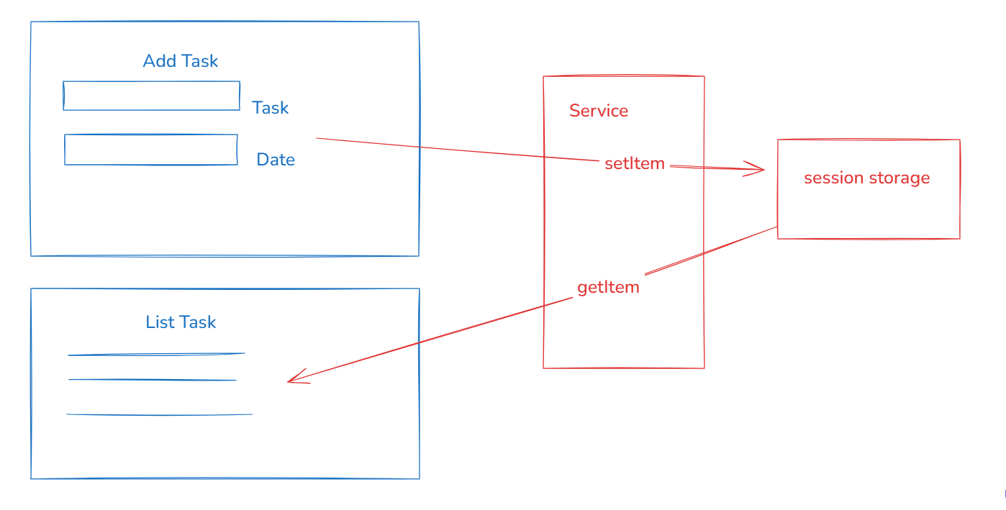

In the service we can create save & fetch methods to store & retrieve the todo
Use this below code in the service to add the todo task in the sessionStorage
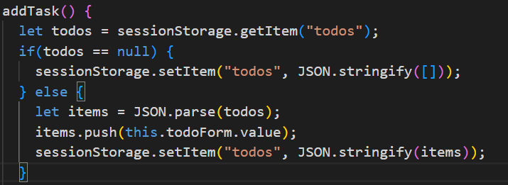
Similarly create getTasks() function in the service which would read all the todo tasks from the session and component would display all those tasks.
HttpClient:
It is an object that will help you to make HTTP requests to the backend service, it provides http methods to perform various operations like
- get(url) : Observable<T>
- post(url, data) : Observable<T>
- put(url, data): Observable<T>
- delete(url, data) : Observable<T>
Angular takes care of creating & delivering the HttpClient object, however you must mention the provider of HttpClient i.e., HttpClientModule (deprecated), you must use provideHttpClient() Angular 14+ on wards
Before Angular 14
@NgModule({
providers : [HttpClientModule] // so that HttpClient can be injected any where
})
Angular 14+ onwards
@NgModule({
providers : [HttpClientModule] // its deprecated, use this till Angular17
providers : [provideHttpClient()] // this must be used if its not a standalone, for standalone the @NgModule file wouldn’t be there, use this from Angular17+ onwards
})
Once you mention the provider you can inject the HttpClient in the service class
private _http : HttpClient = inject(HttpClient) ;// HttpClient instance will be supplied
_http.get(“http://ip:port/api”)
_http.post(“url”, data)
Steps to interact with the backend
- Install json-server using npm install -g json-server
- Create a json file with some JSON data
- Run the json-server to watch the json file
- From angular you can send HTTP requests using http methods
Installing json-server
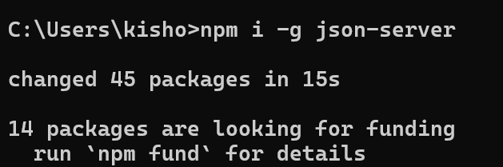
Creating the json file
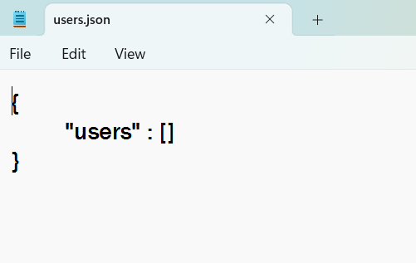
Run the json server to watch users.json file
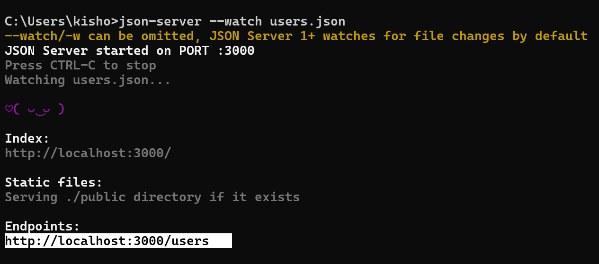
Note: Here the url having localhost:3000/users is because of the key users inside the users.json file
Now angular / any client programs can make an HTTP request to this end point
How to use HttpClient in angular
- configure provideHttpClient() in the app.module.ts if its not a standalone project, if its standalone you need to configure this in app.config.ts
- Inject HttpClient in the service class
Configuring the providehttpClient in the @NgModule.providers of app.module.ts

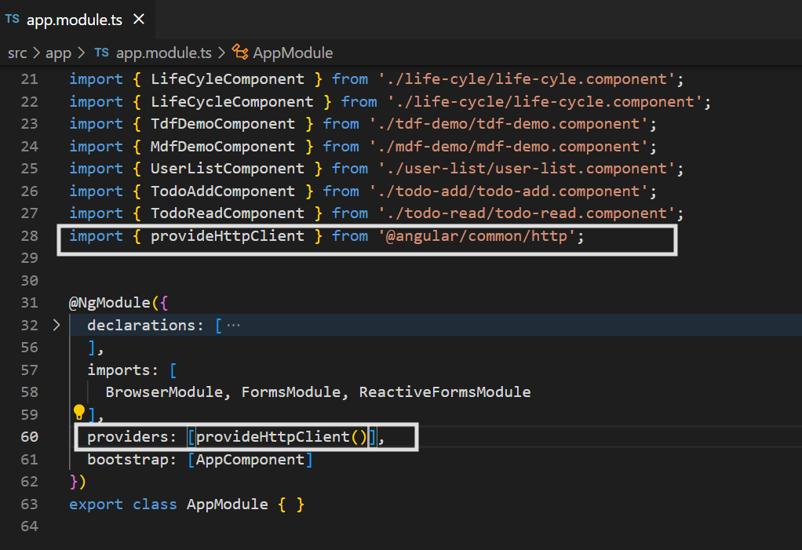
Implement the service class that can store, update, delete and read the user details
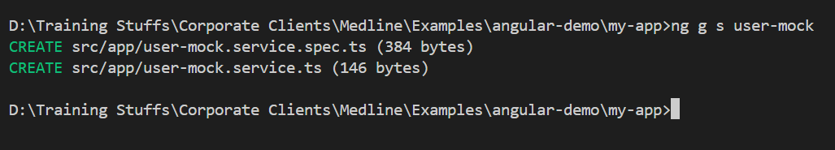
user-mock.service.ts
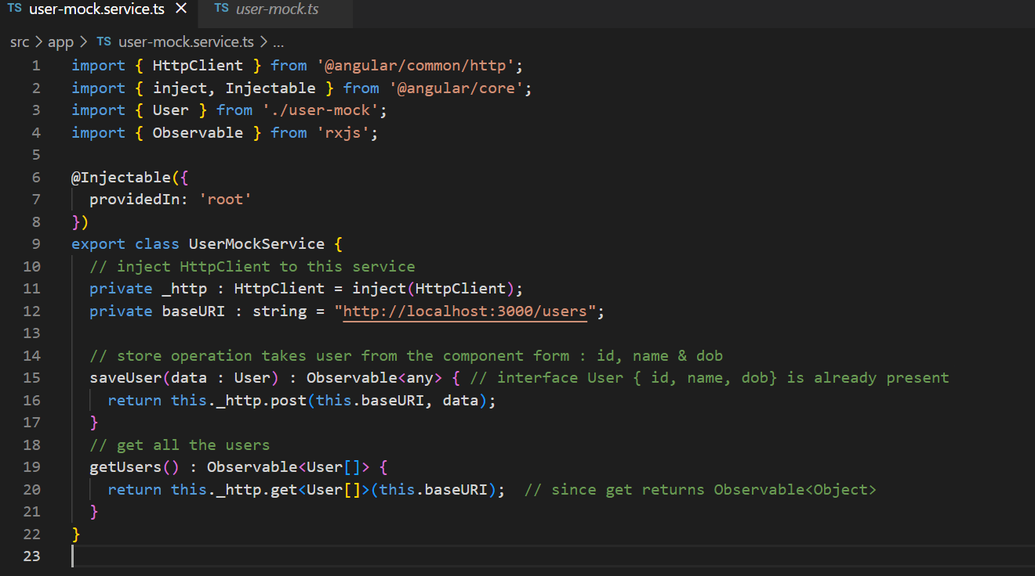Create a user-store component
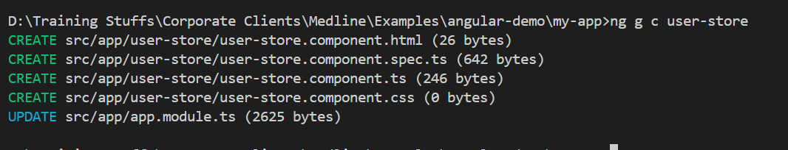
Add this to the app component
app.component.html
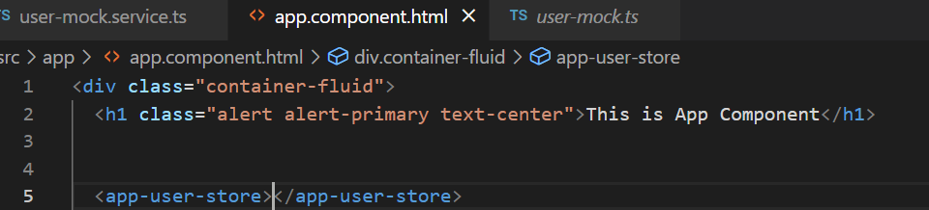
user-store.component.ts
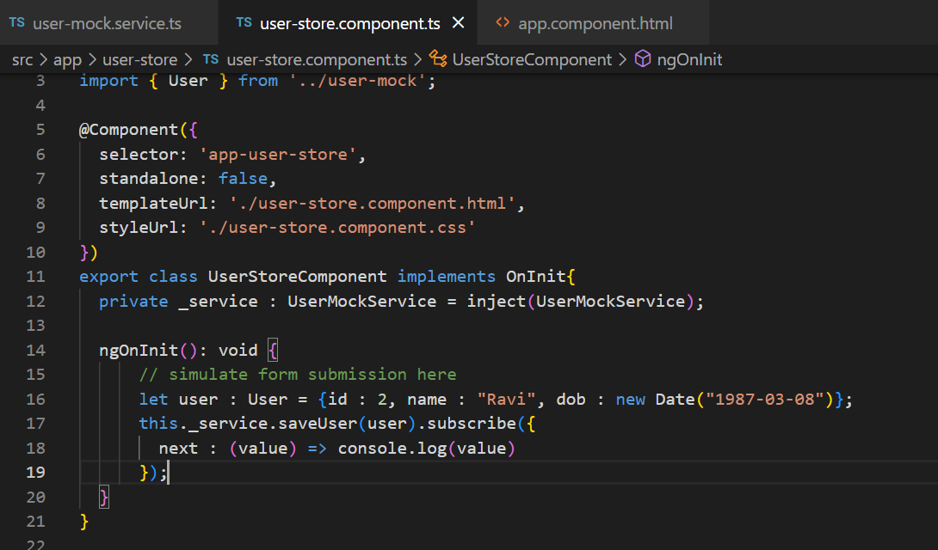
Note: We are not creating a form to save time, we are just simulating the data and passing to the saveUser
Create a user-read component and display all the data
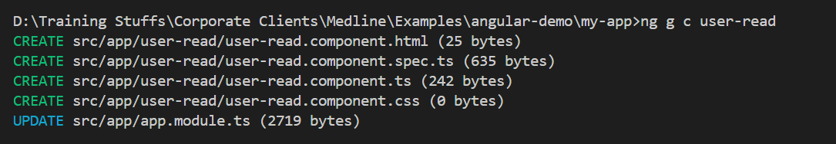
Update the user-read component in the root component
app.component.html
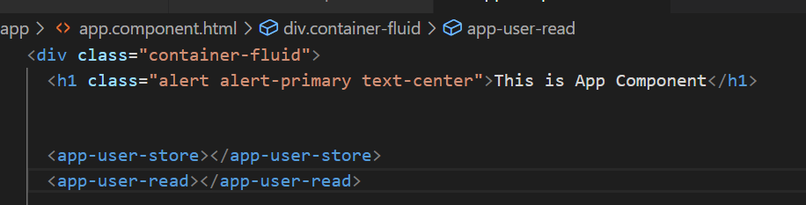
user-read.component.ts
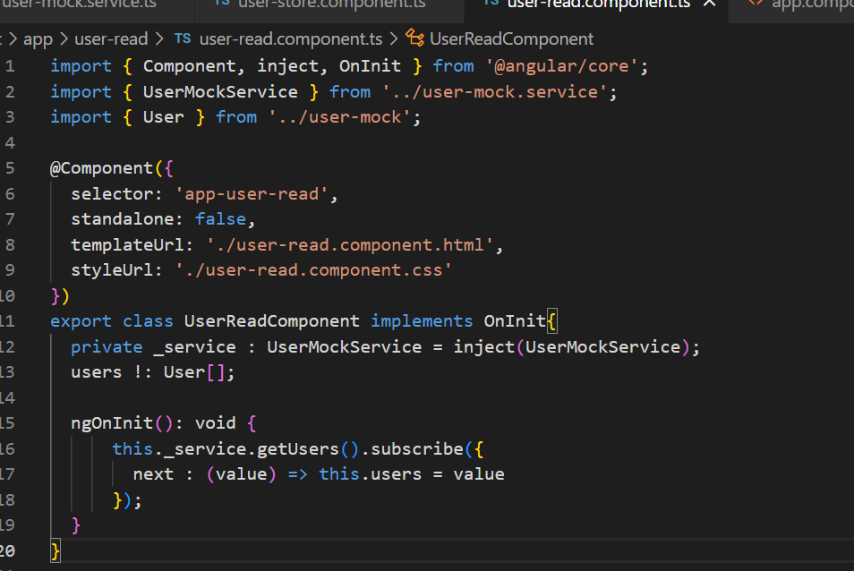
user-read.component.html
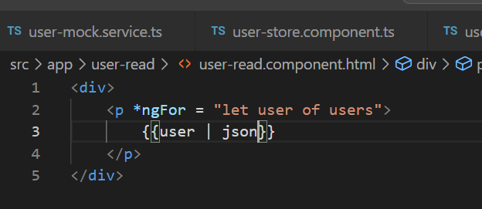
Output:
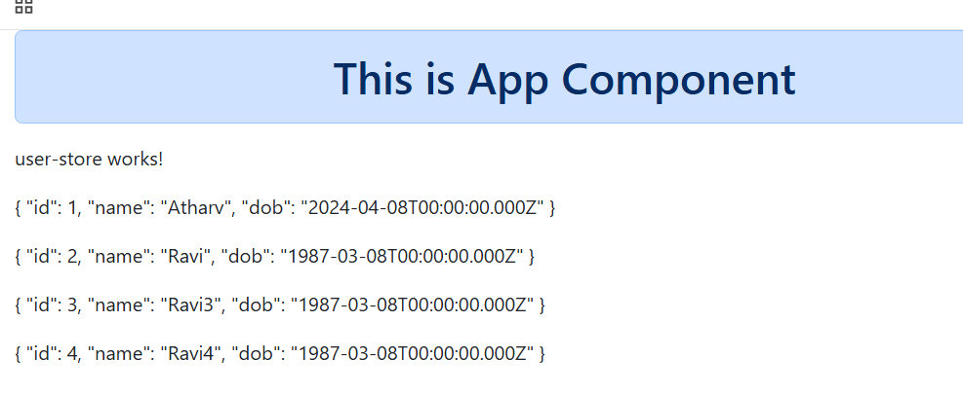

Activity:
Send HTTP put request to update the dob based on the id
Send HTTP delete request to delete the user based on id
Send HTTP get request to get the user based on the id i.e, /users/1, /users/2 to read the users based on the id
Note: If you use /users/1 -> json server can delete the users having the id 1, but make sure the property is “id” itself in the JSON file
Angular 14 onwards NgModule became optional
Standalone components: These are the components which can work themselves without mentioning what they use in the NgModule,
NgModule was just like a container to have everything of the application like components, pipes, directives, but there was lot of performance issue with NgModule because at the time of building the build tools had to remove lot of unused imports which was taking more time to check every component.
Angular by default creates a project that are going to have standalone components, in this it doesn’t create app.module.ts file
Note: If you use <p> {user | json} </p> in any component it works only if you import the JsonPipe, similarly if you want to use [(ngModel)] in any component then that component must import the FormsModule
@Component({
imports : [ FormsModule, JsonPipe ]
})
From Angular 14 onwards the projects wouldn’t have app.module.ts file, you get app.config.ts file to declare any application level configurations like HttpClient, Routes, Pipes and so on
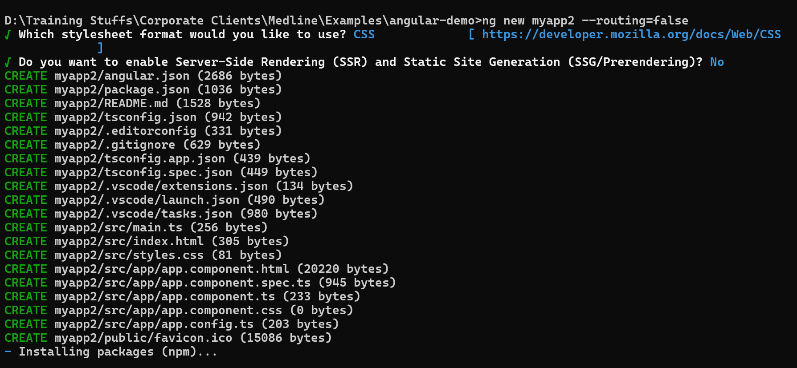
Folder structure of standalone component project
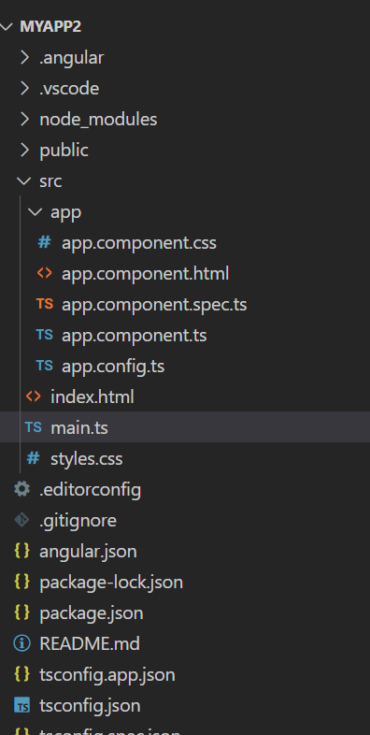
Notice you don’t see the app.module.ts file, however the main.ts file now bootstraps the AppComponent and ApplicationConfig instead of bootstrapping AppModule
Adding bootstrap.js to the project
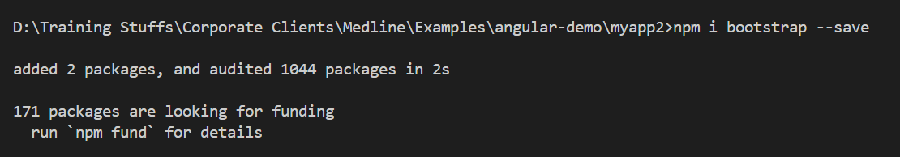
Update angular.json or styles.css file to include bootstrap.css
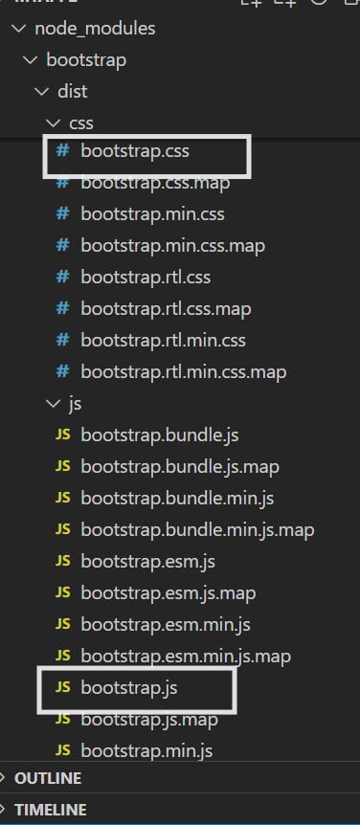
angular.json
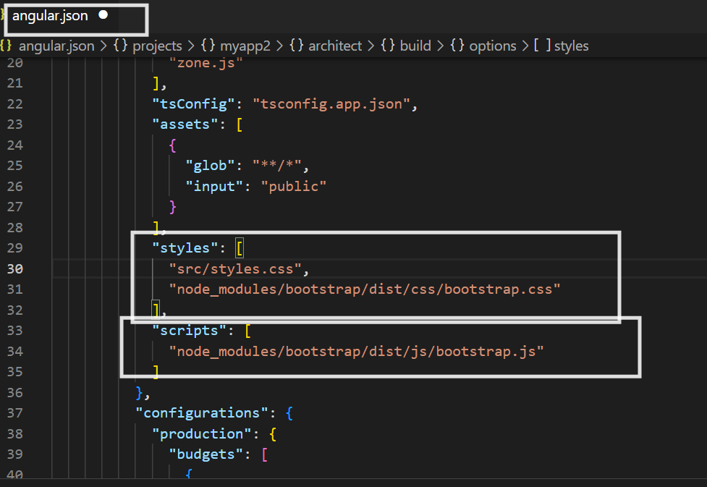
Note: You must rerun the application
or in an easiest way you can add bootstrap.css in the styles.css
In case you want to use *ngIf, *ngFor, date pipe, json pipe, upper case pipe you must import them in the component they wouldn’t be available by default
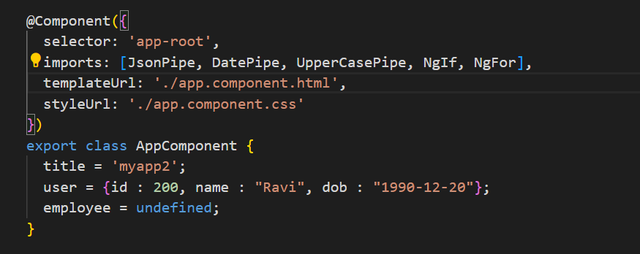
Then only you can use json, date, uppercase, *ngIf in the app.component.html
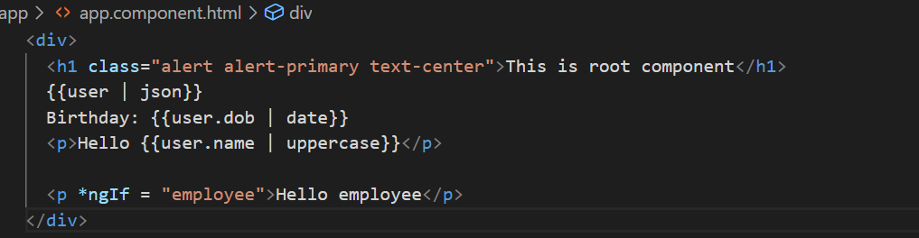
We can remove user, & other templates from the HTML because we want to use router-outlet

Angular routers
Routers are the backbone to create a single page application in the angular, because it helps you to navigate from one component to another component without reloading the pages
Angular provides some inbuilt router components to dynamically load the components you create, in that <router-outlet> is one of the main component which is like a placeholder to load the components at runtime
routerLink: This is going to provide a path to the router so that router understands what is the path and loads the component
routes : Routes = [
{path:’login’, component: LoginComponent},
{path:’register’, component:RegisterComponent},
{path: ‘success’, component: SuccessComponent}
]
<a routerLink = “login”>Login</a>
<a routerLink = “register>Register</a>
<router-outlet></router-outlet>
Note: <a routerLink> gives the static path, however you can also programmatically navigate using Router instance
router : Router = inject(Router);
if(…) { router.navigate([“success”]) }
else { router.navigate([“login”]) }
Note: You can also create a child router which is a <router-outlet> inside another <router-outlet>
Steps:
- Create 4 components, login, register, success, pageNotFound
- Configure the routes in the app.routing.ts file which will have path & component configuration
- In the app.component.html we can have the <router-outlet> that can show the login, success or register component
- We can also create <a routerLink> to load the components dynamically in the app component.

Generating 4 components
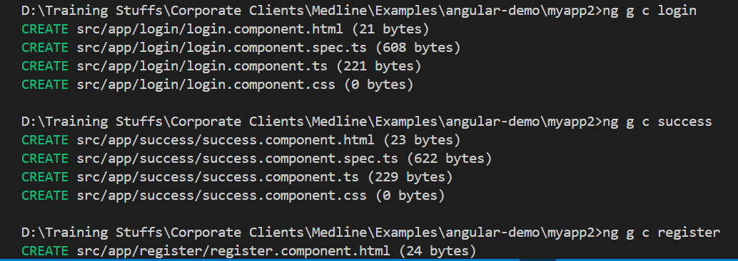
Note: Since we have created a project with standalone component feature, every component must specify what it needs because we are not having @NgModule.

create src/app/app.routing.ts
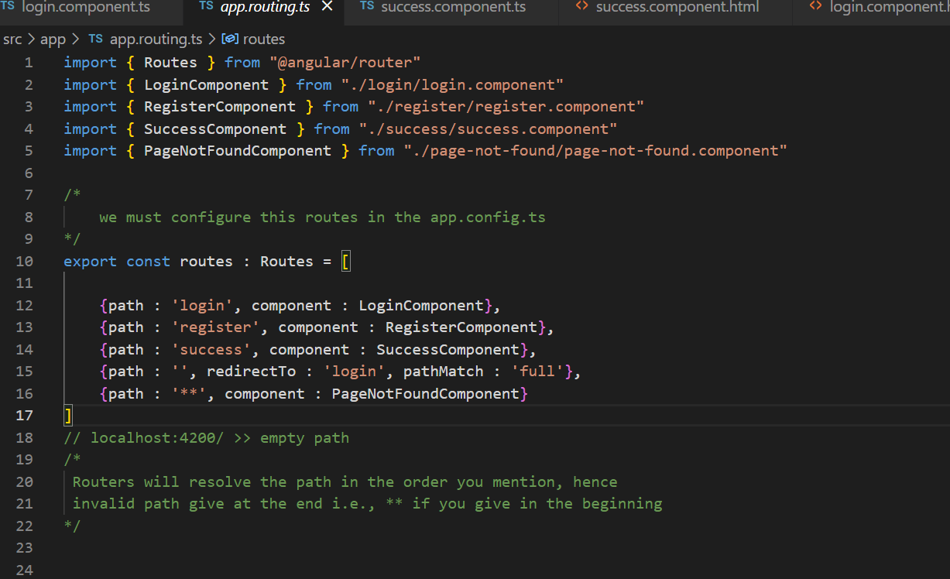
in the app.config.ts include this routes in the provideRouter
app.config.ts
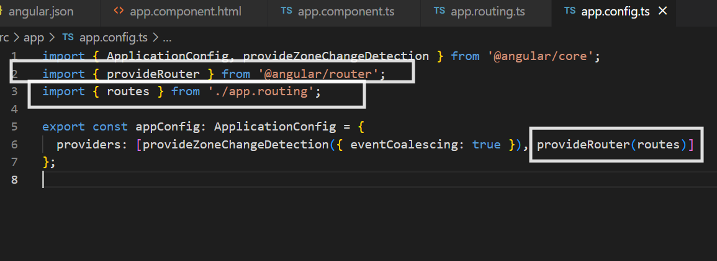
Now you can use the <router-outlet> with <a routerLink> in any component, but that component must import [RouterOutlet, RouterLink] as it’s a standalone.
app.component.ts 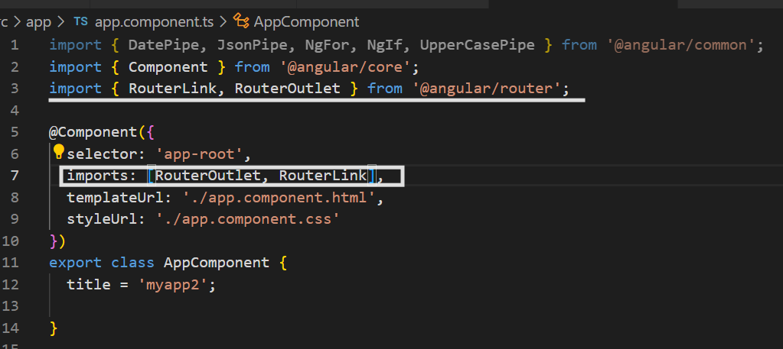
app.component.html
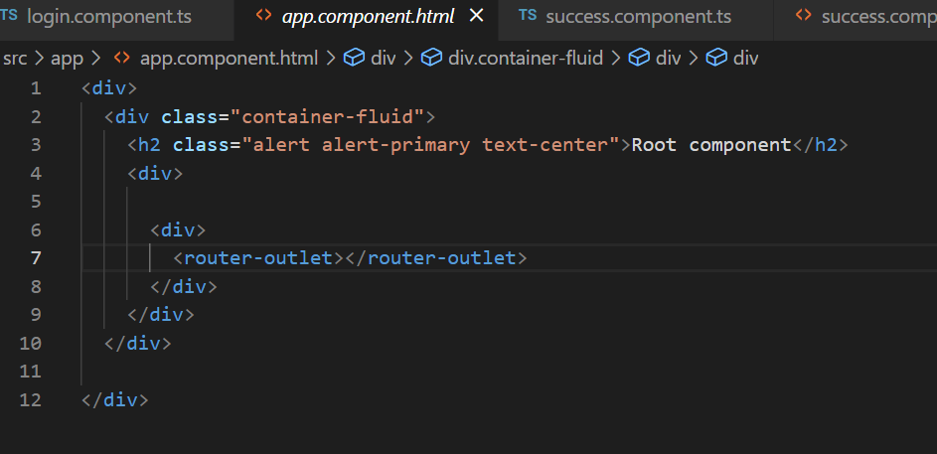
login.component.ts
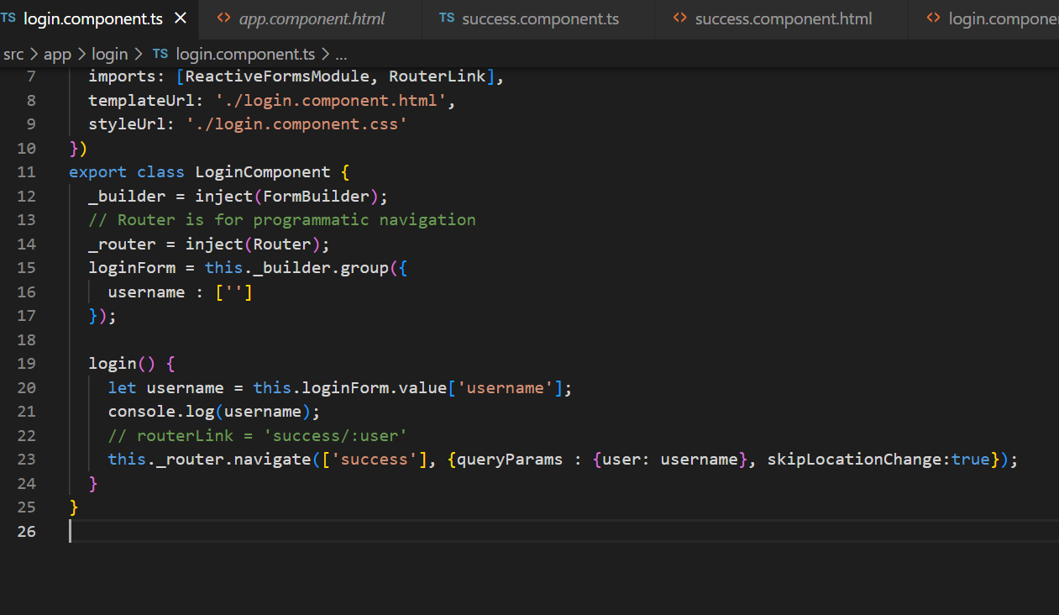
login.component.html
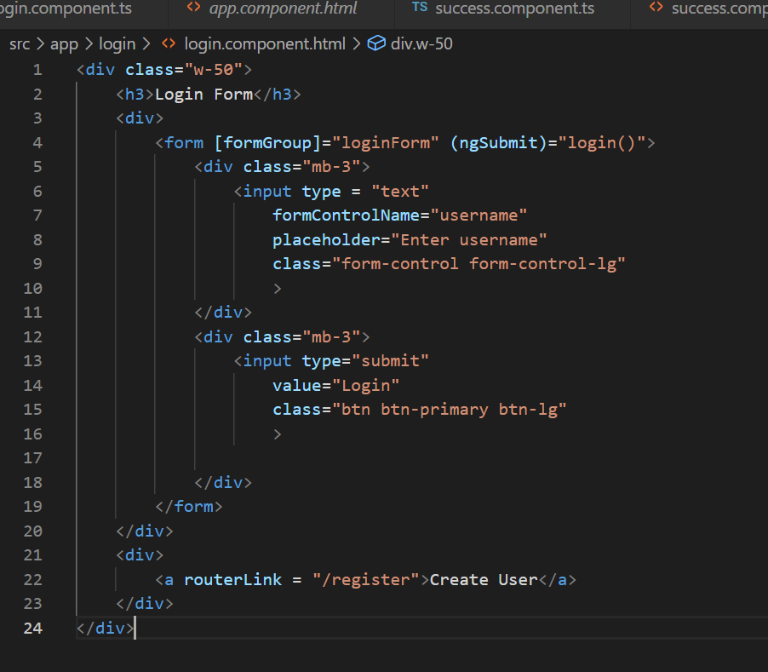
register.component.ts
This component doesn’t work, only link to the login works
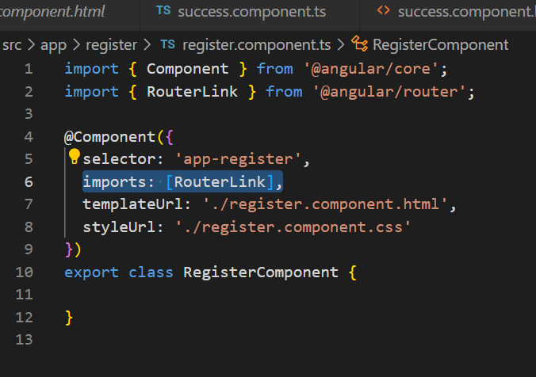
register.component.html
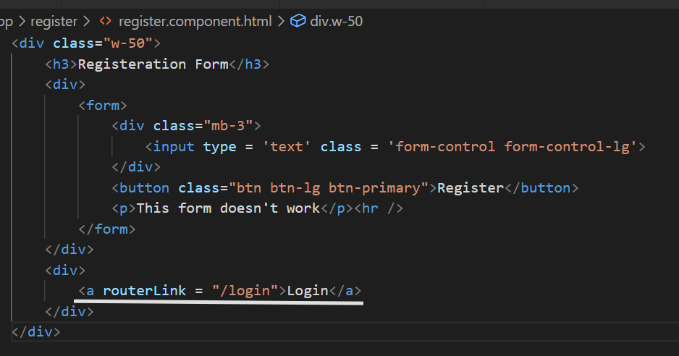
Output:
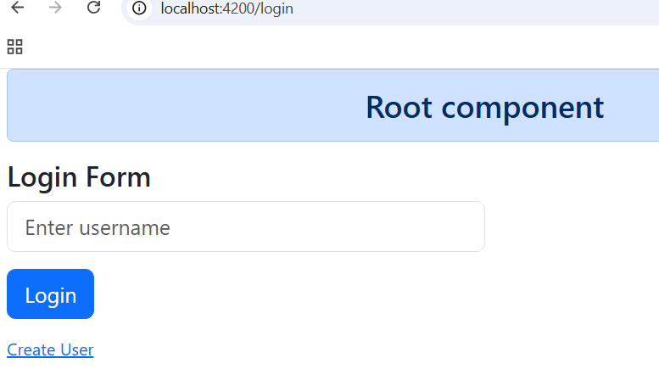
You can navigate to the Registration page
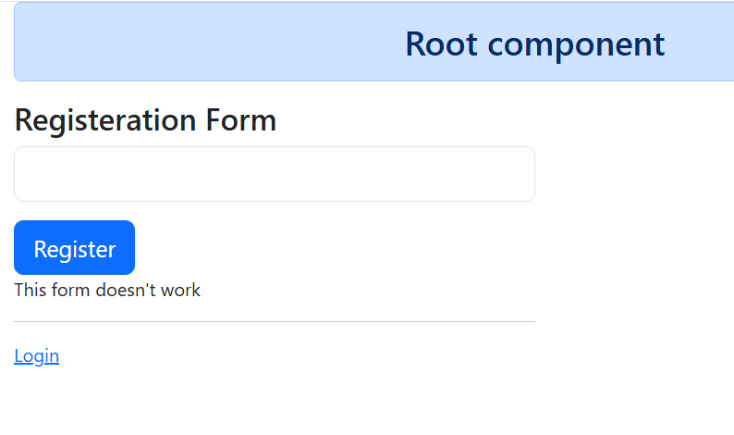
Here a single page can show both login & register pages
However if you click on Login button by enter the username you will see success component
success.component.ts
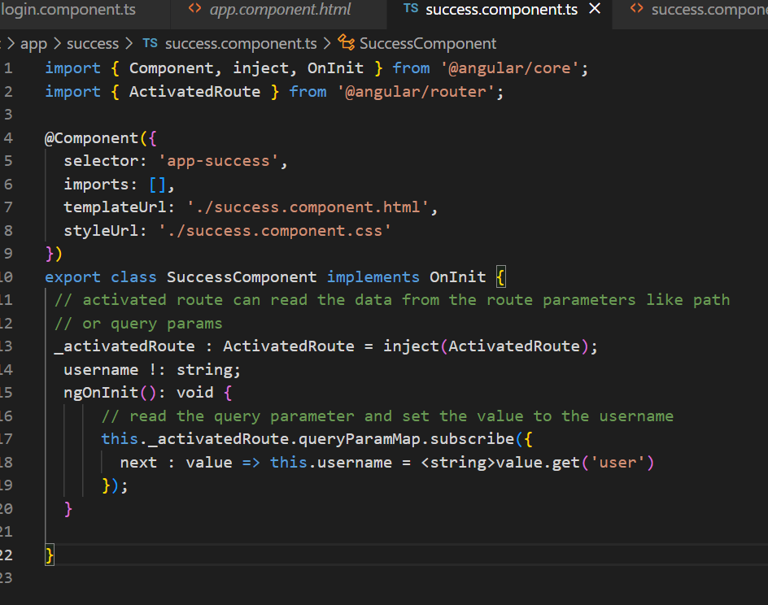
success.component.html
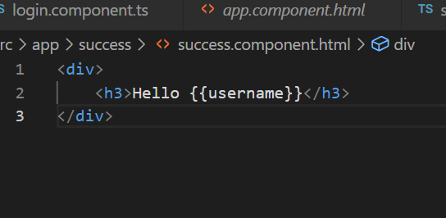
Output:
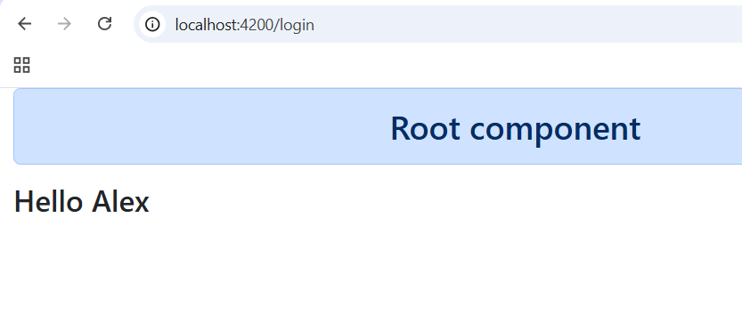
Child routing
You can nest the <router-outlet> that will load multiple components within a parent router.
In order create child routing we must chose a component that is loaded in the parent router, and configure the child routes in the router file using children properties
To load multiple components inside the success component we will generate few components
ng g c dashboard
ng g c home
ng g c profile
ng g c settings
Screen shot of the components created
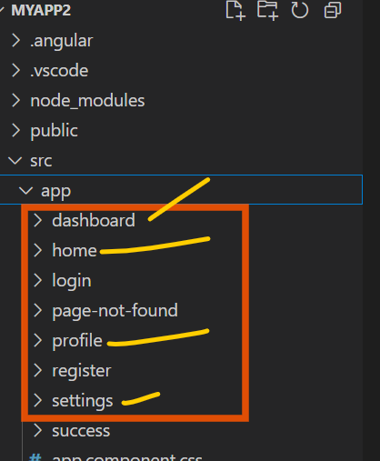
app.routing.ts
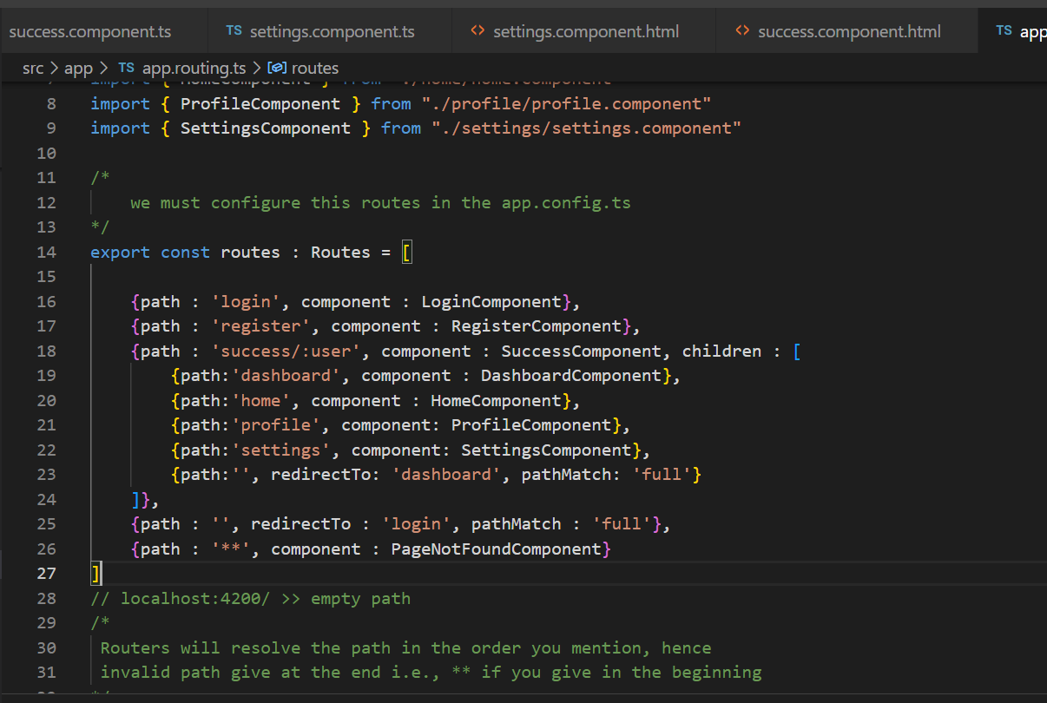
Now you can navigate to the success/:user with any url like success/Kishor, success/Atharv and etc.
Change the navigate method in the login.component.ts
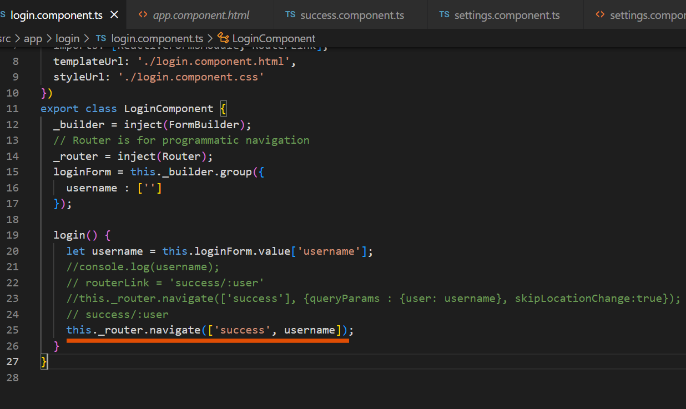
Modify success.component..ts to get the data from the path parameter
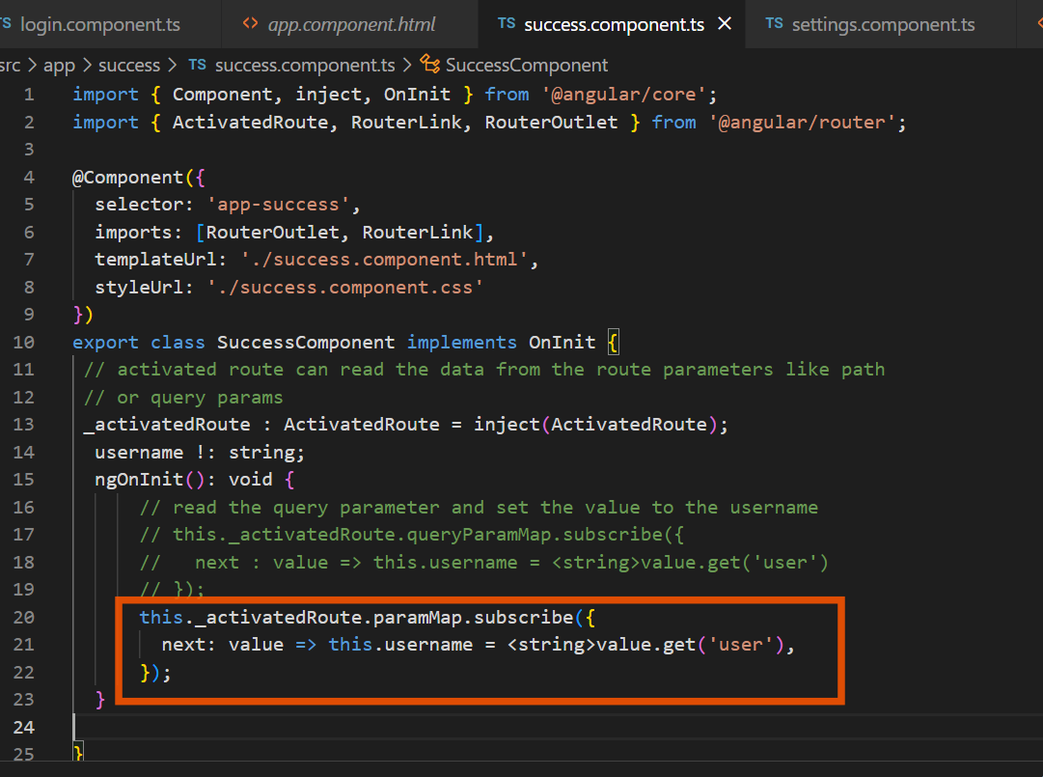
success.component.html
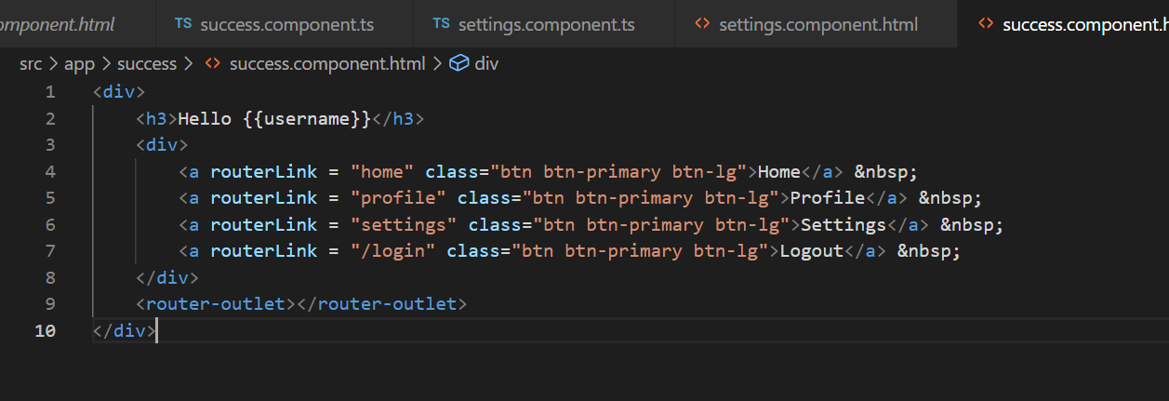
Modify the child route component to read the parent path parameter settings.component.ts
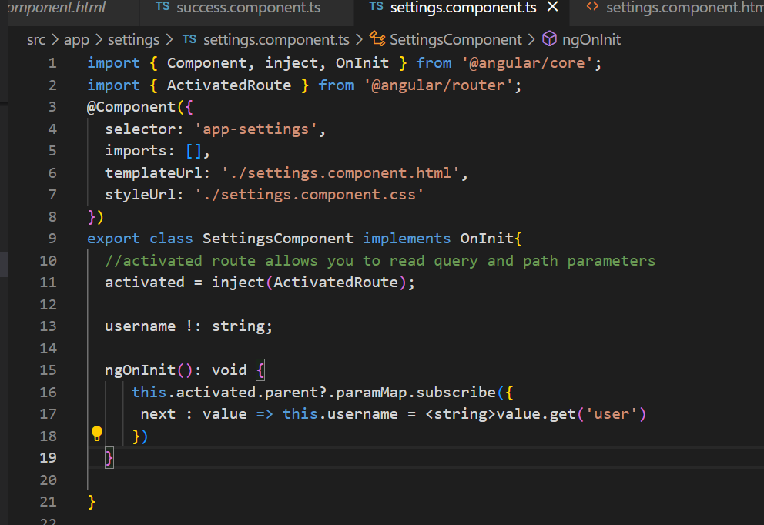
settings.component.html
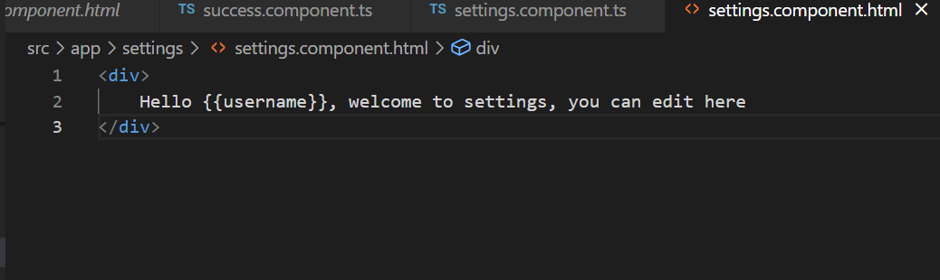
Output:
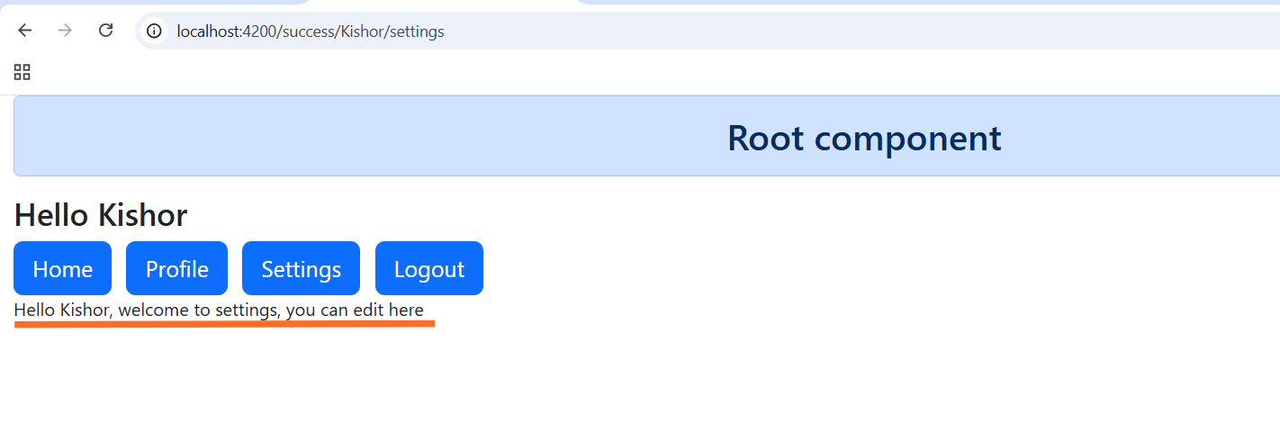
Here there’s a problem where anybody can enter the URL and navigate to the success component
Solution: we need to stop user to enter the URL to see some page without logging in, we must use route guards which are also called authentication guards.
We have a command to generate the authentication guards, it has a method called canActivate() that is called when you navigate to a particular URL, inside this method you must write the logic whether user is allowed to visit or denied.
ng generate guard auth or ng g g auth
>> command asks you to select the method >> choose canActivate.
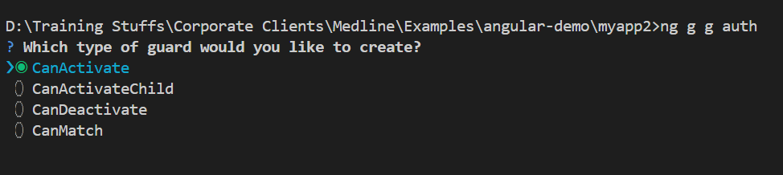
Below is the code you see in the auth.guard.ts
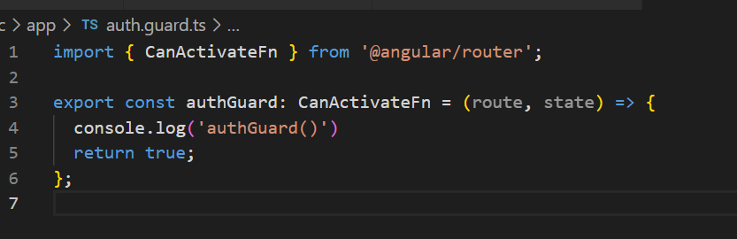
The authGuard() is called only if you configure in the routes
app.routing.ts
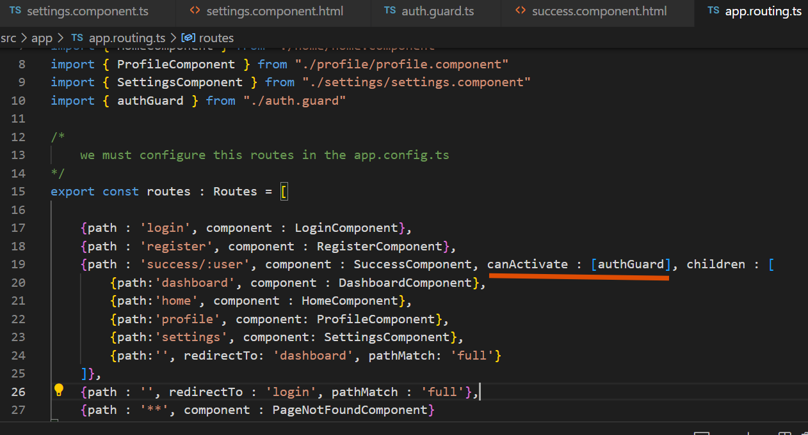
We must return false in case we don’t want to allow the user to enter the success/:user route, we must return true to allow user to enter the success/:user
auth.guard.ts// we are retrieving the sessionStorage data to validate
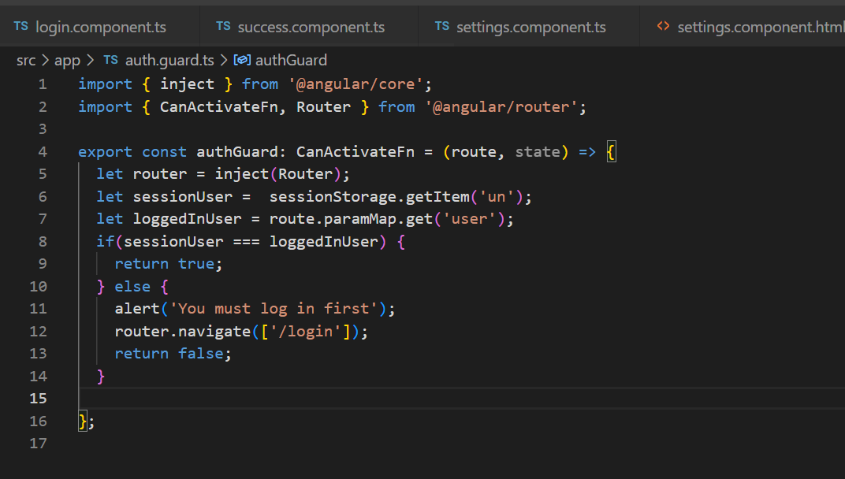
login.component.ts // can store the data in the sessionStorage
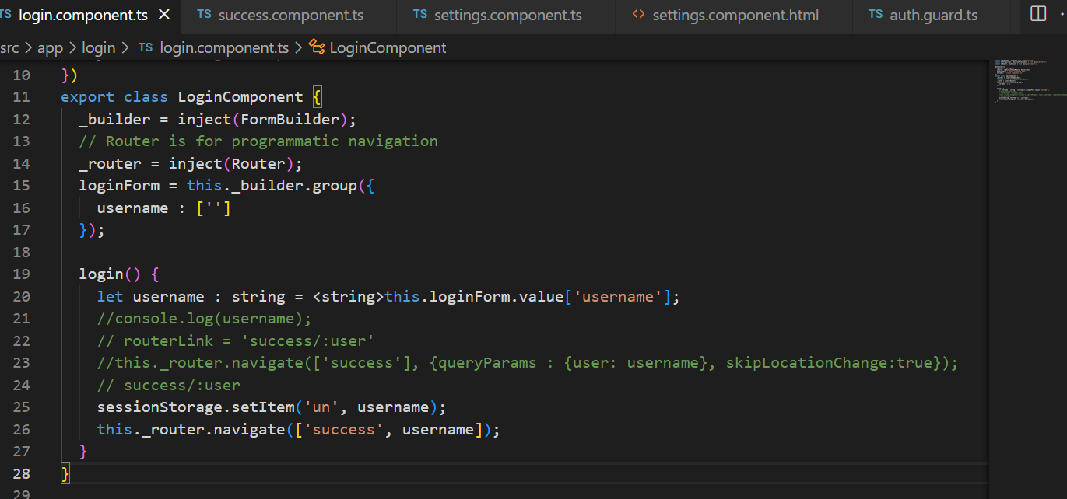
Output: // if you enter the URL without logging in or if the session is not created for you then you get error as below
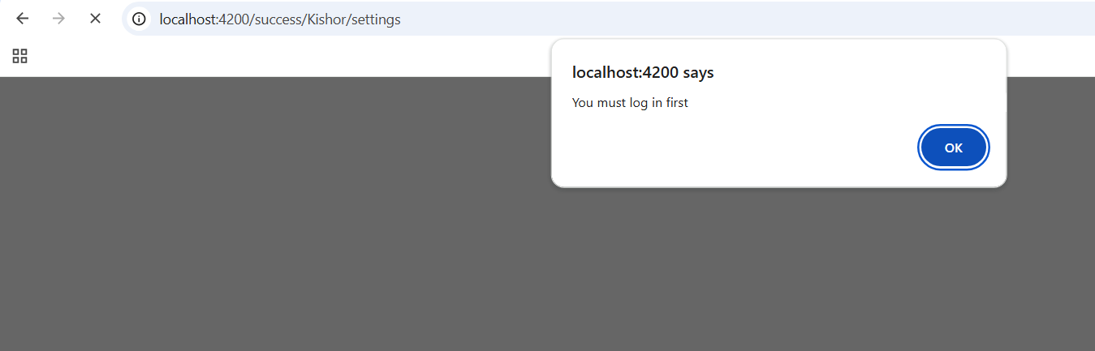

Ionic Framework
It is an open source UI toolkit which helps you to develop & deploy the apps across various platforms like native iOS, Android or web, it uses web technologies like HTML, CSS & Javascript
Ionic is very easy to understand as its not a new language if in case you know any one of the technology like
- Angular
- React
- Vue.
Setup
- Node.js
- VS Code
- Ionic CLI
Installation: npm install -g @ionic/cli
Verify: ionic --version
Creating project ionic start app-name blank --type angular # this create angular type project
blank can be replaced with templates for mobiles like tabs, side menu
Running the application: ionic serve
Creating the ionic application for angular with standalone
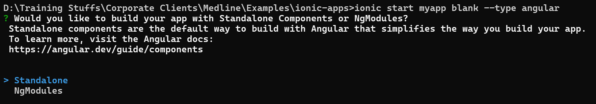
Progressive Web App
Progressive Web Apps (PWAs) are web applications built with modern web technologies that offer an app-like experience to users, including installability, offline capabilities, and the ability to run on multiple platforms from a single codebase. They combine the reach of web apps with the capabilities of platform-specific apps.
Service worker is a script that must be added to make your angular application into a PWA.
Note: Follow the official documentation whenever you want to turn your app to PWA
Steps to create your app a PWA
- ng add @angular/pwa
- ng build >> your application will be built and stored in dist folder
- npx http-server -p 8080 -c-1 dist/app-name/browser

Migrating the project
V15 to V19
Step by step
V15 -> V16 -> V17 -> V18 -> V19

